



Accenture iOTC  
User Manual Version 1.1

目录

Table of Contents

1. Basic Operation 6

1.1. Login 6

1.2. Home Page 8

2. Change Password 9

2.1. Change Password 9

3. Aging Report 10

3.1. Aging Report Query 10

3.2. Aging Report Export 11

4. Dispute Report 13

4.1. Dispute Report Query 13

4.2. Dispute Report Export 14

5. Over due Report 17

5.1. Over due Report Query 17

5.2. Over due Report Export 18

6. Collection Period 20

6.1. New Collection Period 20

6.2. Edit Collection Period 22

6.3. Delete Collection Period 23

7. AR Analysis 25

7.1. Re-Analyse 25

7.2. Query the CustomerAssessment data according to “Legal Entity” and “Assessment Date”. 26

7.3. Query the CustomerAssessment data according to “Legal Entity” and “Assessment Date” and conditions. 27

7.4. Save “Customer Class” 28

7.5. Export CustomerAssessment Data 29

8. Customer Master Data 30

8.1. Query the customer master data according conditions. 30

8.2. Delete any customer master data. 30

8.3. Import Customer Master Data. 31

8.4. Export Customer Master Data. 34

8.5. Add Customer Master Data. 35

8.6. Edit Customer Master Data. 45

9. User initialization 46

9.1. Grant Mail Access 46

9.2. Set signature. 46

10. Dashboard 47

10.1 Confirm PTP 47

10.2 Reminding PTP 47

10.3 Over Due Follow Up 48

10.4 Dispute 49

10.5 Mail box 49

10.6 Miss Collector 50

10.7 Miss AR Report 50

11. Data preparation 50

11.1 Account Level File and Invoice Level File Upload 50

11.2 Invoice Detail File Upload 54

11.3 VAT File upload 56

11.4 Customer Locailize Upload 58

11.5 Upload History 59

12. Collection 60

12.1 Mail Box 60

12.2 Follow Up 64

12.3 Dispute 73

12.4 All Invoices 76

12.5 All Accounts 77

13. DSO Report 79

Modify of History

|  |  |  |  |  |  |  |
| --- | --- | --- | --- | --- | --- | --- |
| **Ver.** | **Create Date** | **Author** | **Approve Date** | **Approver** | **Implement Date** | **Modify Content** |
| 1.0 | 2017/12/20 | Yang Yang |  |  |  | Create |
| 1.1 | 2018/01/16 | Zhang Qiang |  |  |  | Append Collection Chapter |
| 1.2 | 2018/04/09 | Fujie.Wan |  |  |  | Append DSO Report |
|  |  |  |  |  |  |  |
|  |  |  |  |  |  |  |
|  |  |  |  |  |  |  |
|  |  |  |  |  |  |  |
|  |  |  |  |  |  |  |
|  |  |  |  |  |  |  |
|  |  |  |  |  |  |  |
|  |  |  |  |  |  |  |
|  |  |  |  |  |  |  |

## Basic Operation

## Login

1. Open browser

Recommendation Browser version: Chrome or Firefox, IE11

Production: <https://hksstpaap07p.ap.corp.arrow.com/Site/>

* Google Chrome

1. Open chrome and key in URL in address bar to visit system, then click “Advanced” as below

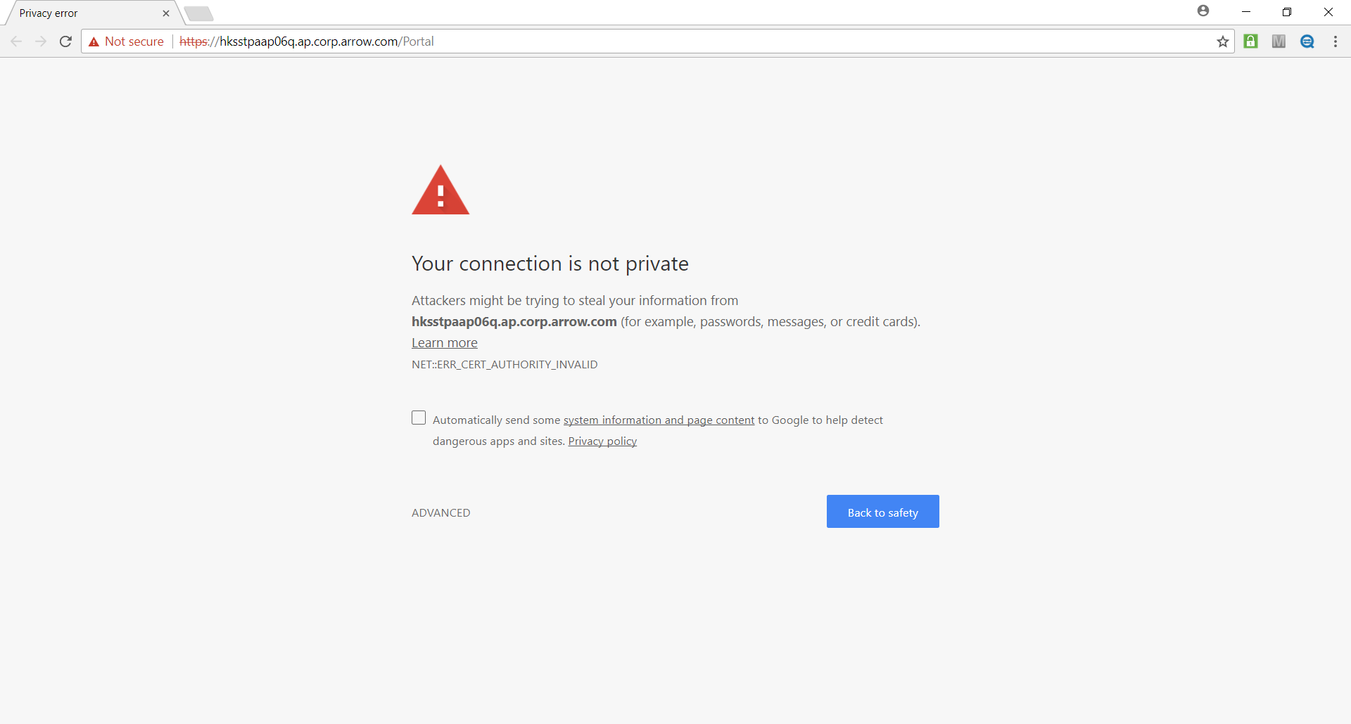

1. Then click “Proceed hksstpaap06q.ap.corp.arrow.com(unsafe)”

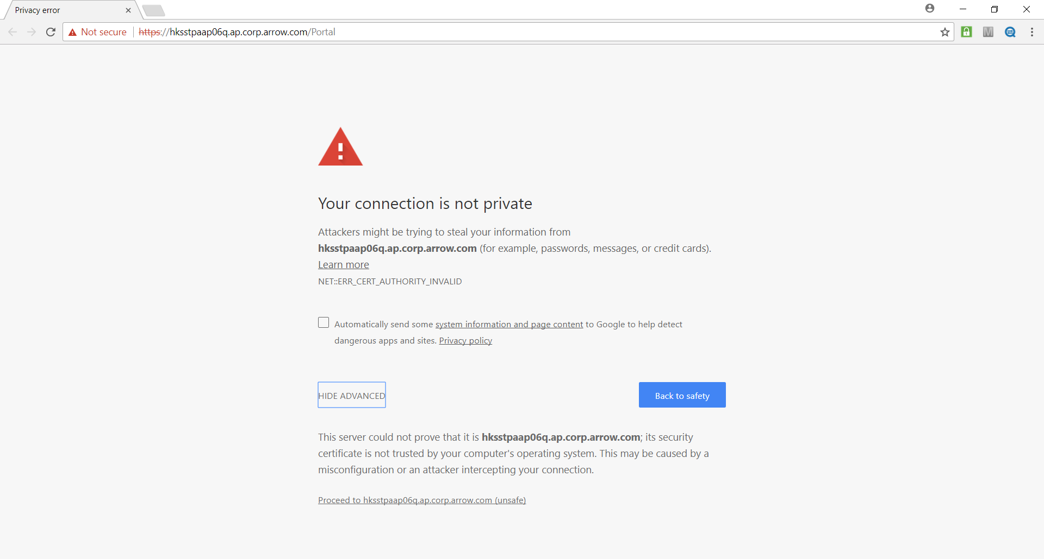

* IE 11

1. Open IE11 and key in URL in address bar to visit system, then click “More information” as below

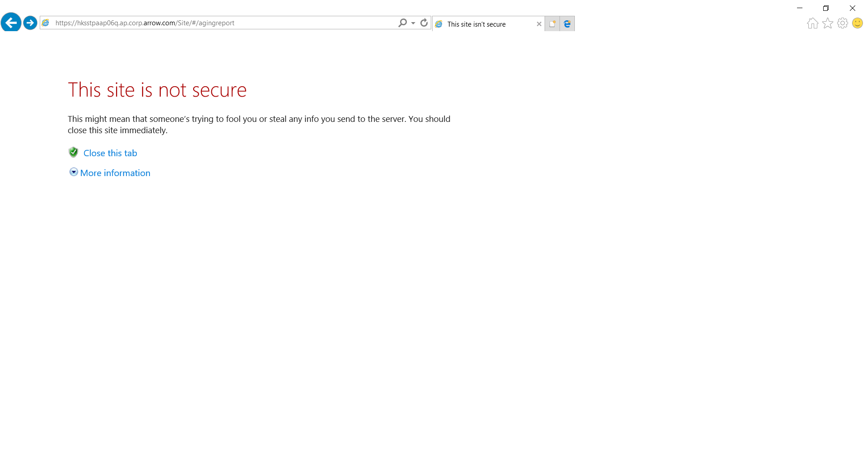

1. Then click “Go on the webpage(not recommended)”

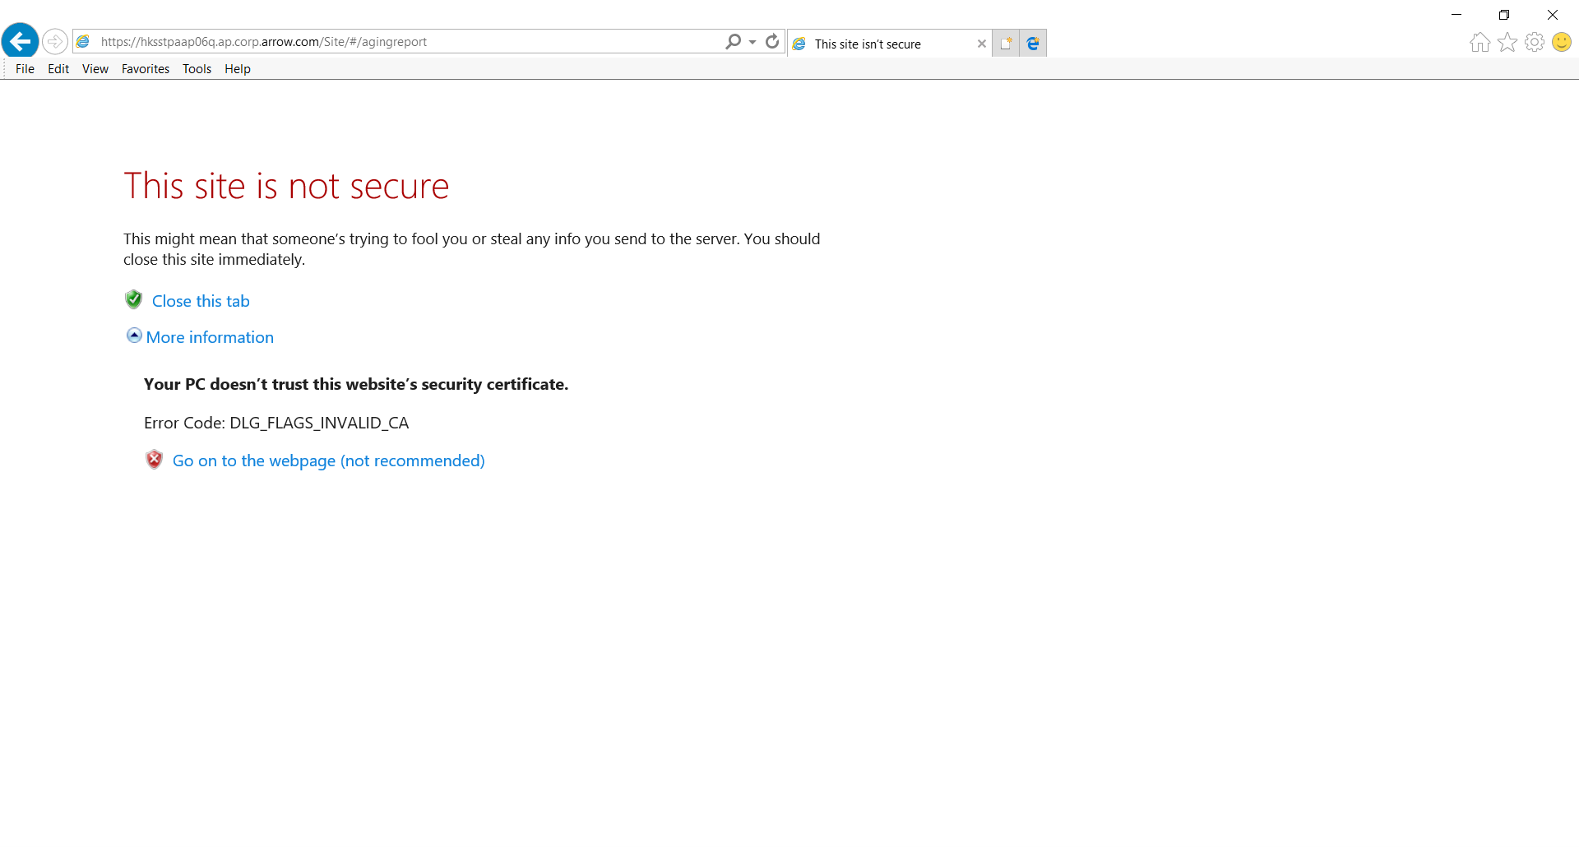

1. After the login page is displayed,input User ID and Password,click “login” button.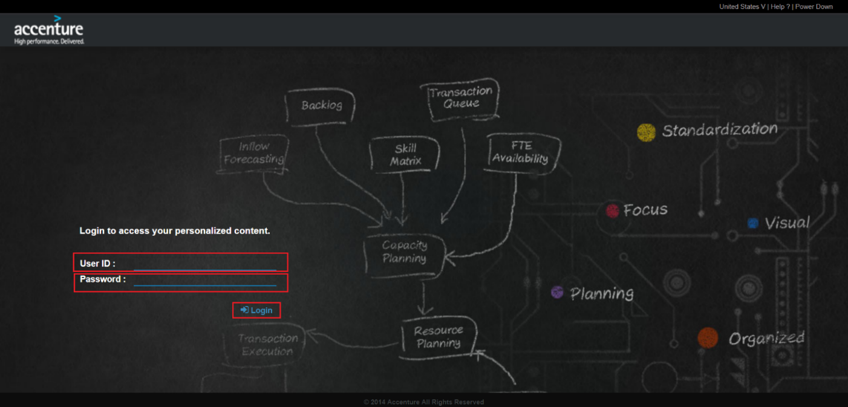

## Home Page

The login will display Home page.

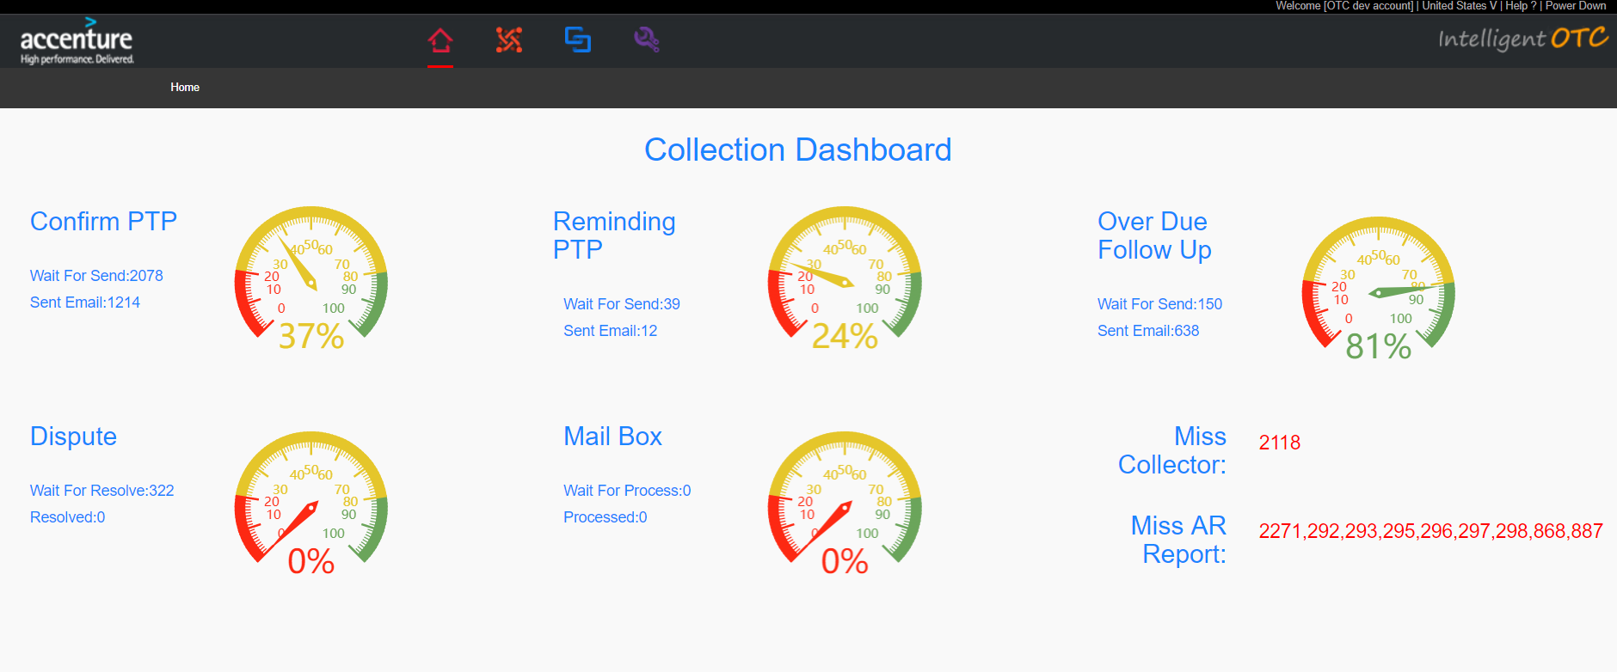

## Change Password

Change password，You can modify your login password according to your own needs.

### Change Password

1. Mouse over the red box section of the head menu,Click on “Change Password” in the drop-down. 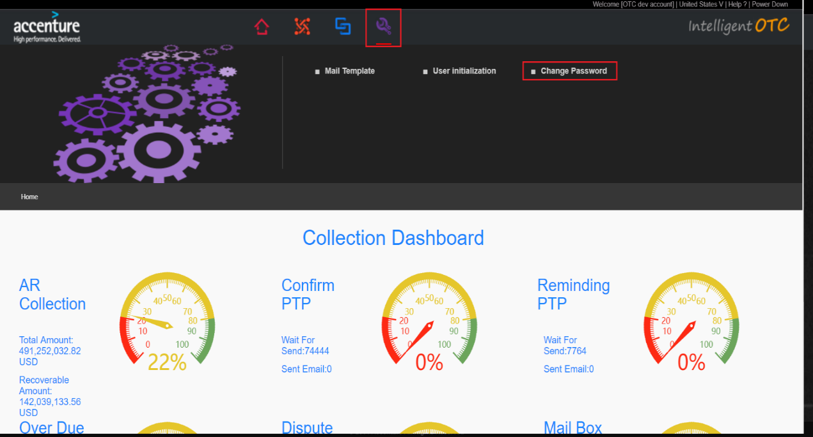
2. Enter the Change Password page.In Old password enter your current password.

New password enter New password you want to change.And Confirm Password enter New Password you want to change again.Click the Submit button to complete the change.User needs to change password every 75 days.

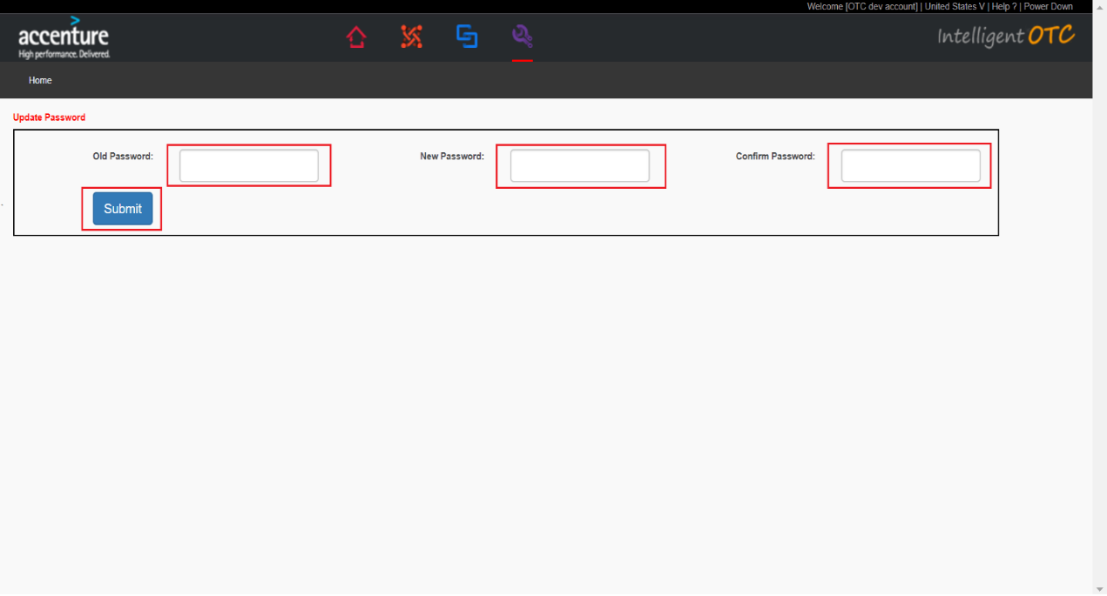

## Aging Report

Aging Report.

### Aging Report Query

1. Mouse over the red box section of the head menu,Click on “Aging Report” in the drop-down.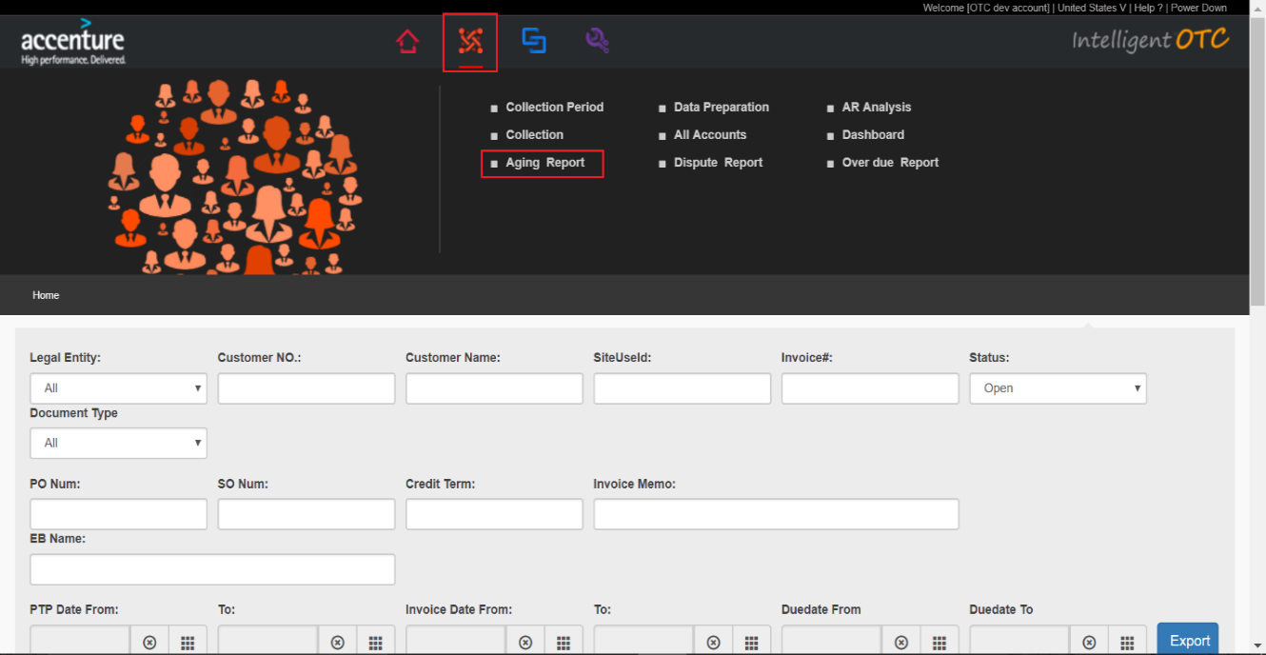
2. You can input query contions inluce: Legal Entity , Customer No. , Customer Name , SiteUseId ,Invoice# , Status,Document Type , PO Num , SO Num Credit Term ,Invoice Memo ,

EB Name,PTP Date From-To , Invoice Date From-To,Duedate From-Duedate To Query，

Click Search button after these conditions entered.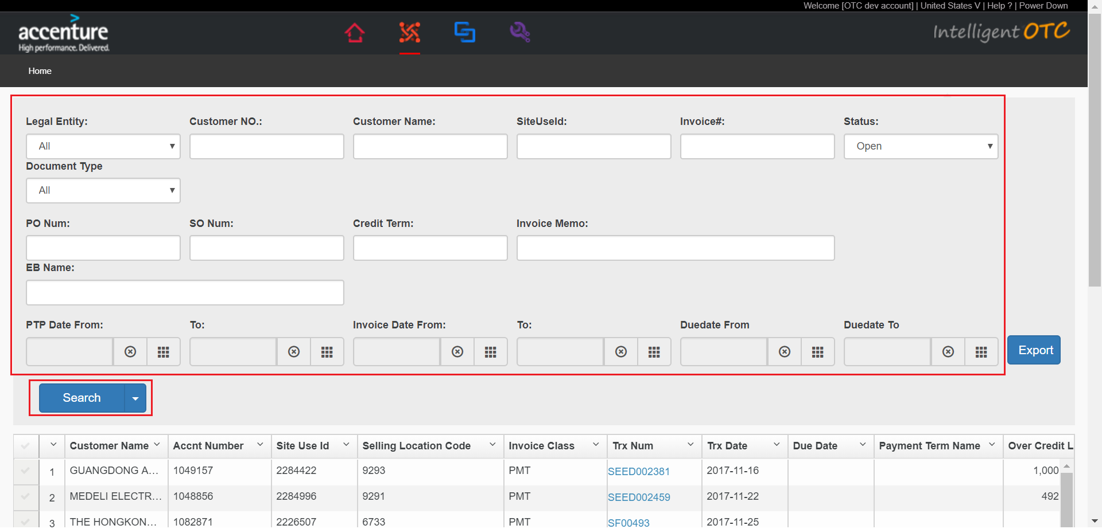

1. According to the picture,The corresponding data is shown in the list based on the query condition.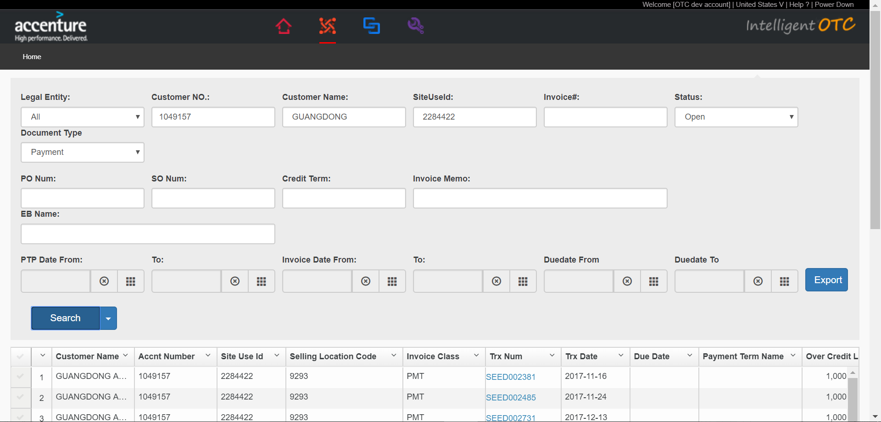

### Aging Report Export

1. Click Export button after these conditions entered.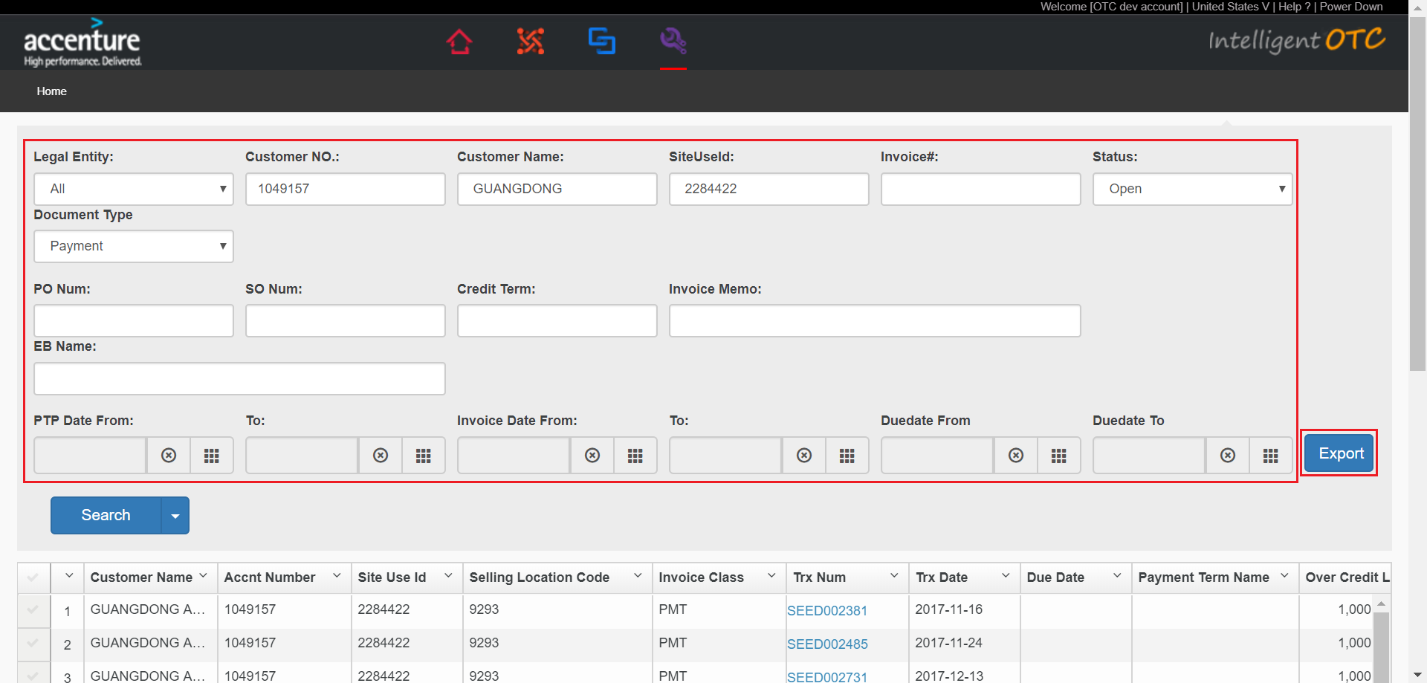
2. Page loading,pop-up box click OK button.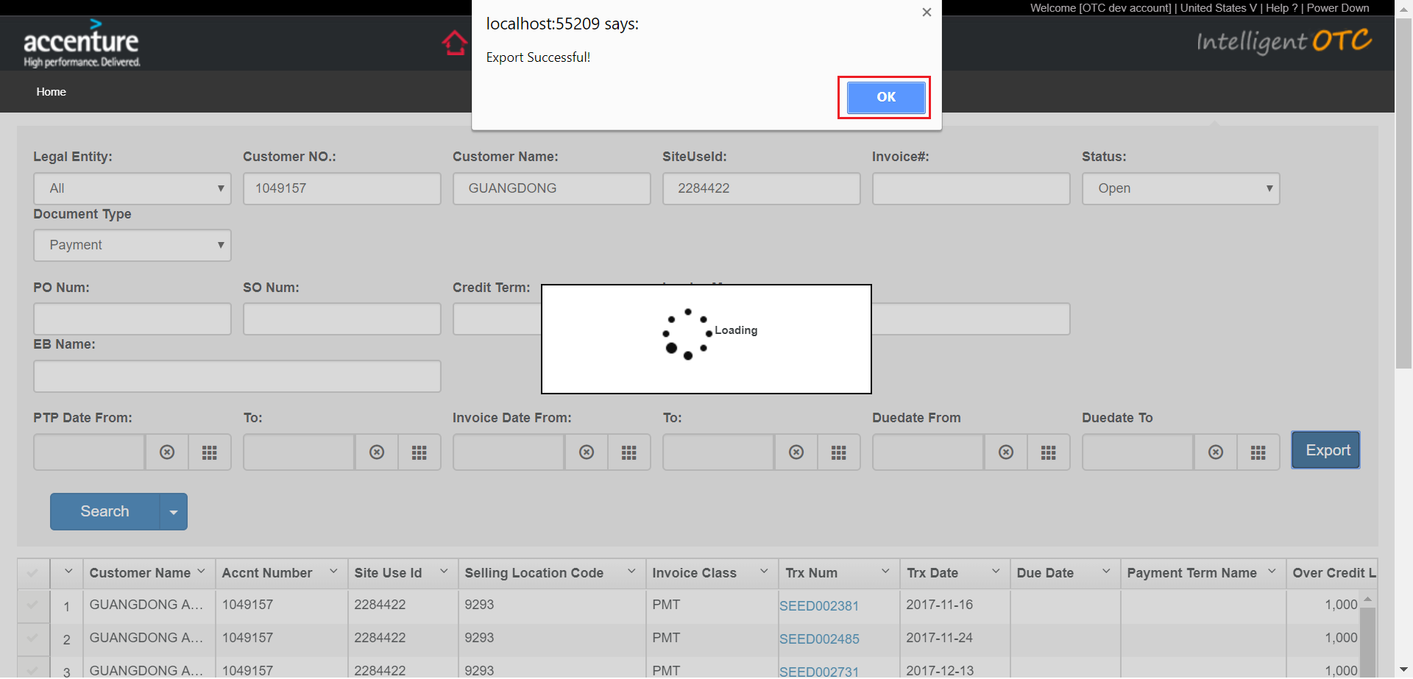
3. Click excel file in the red box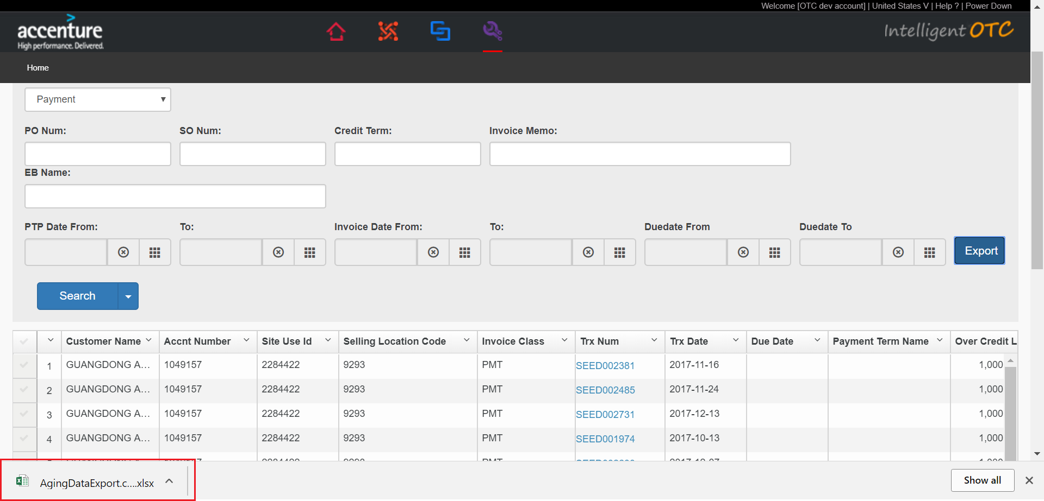
4. The corresponding data is shown in the excel file based on the input condition.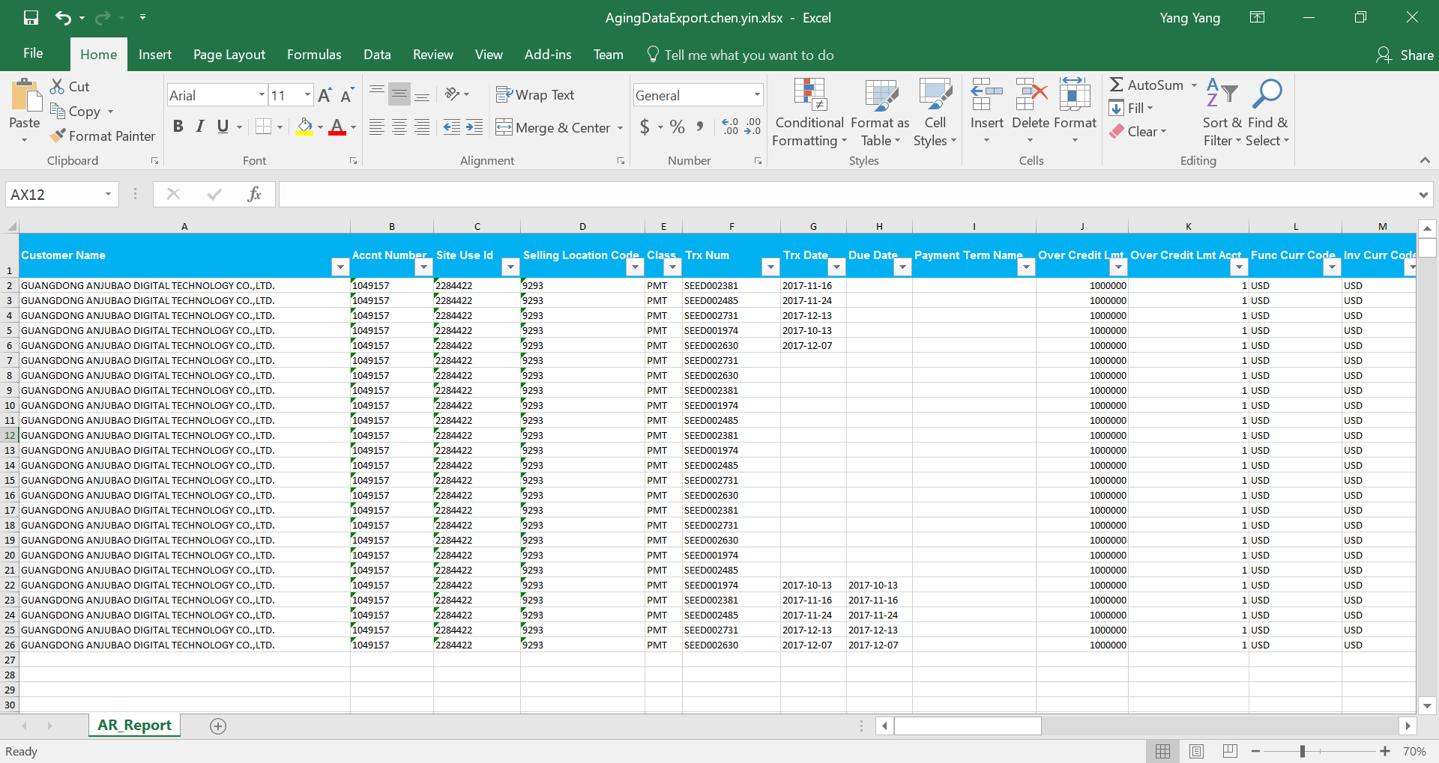

## Dispute Report

Dispute Report.

### Dispute Report Query

1. Mouse over the red box section of the head menu,Click on “Dispute Report” in the drop-down.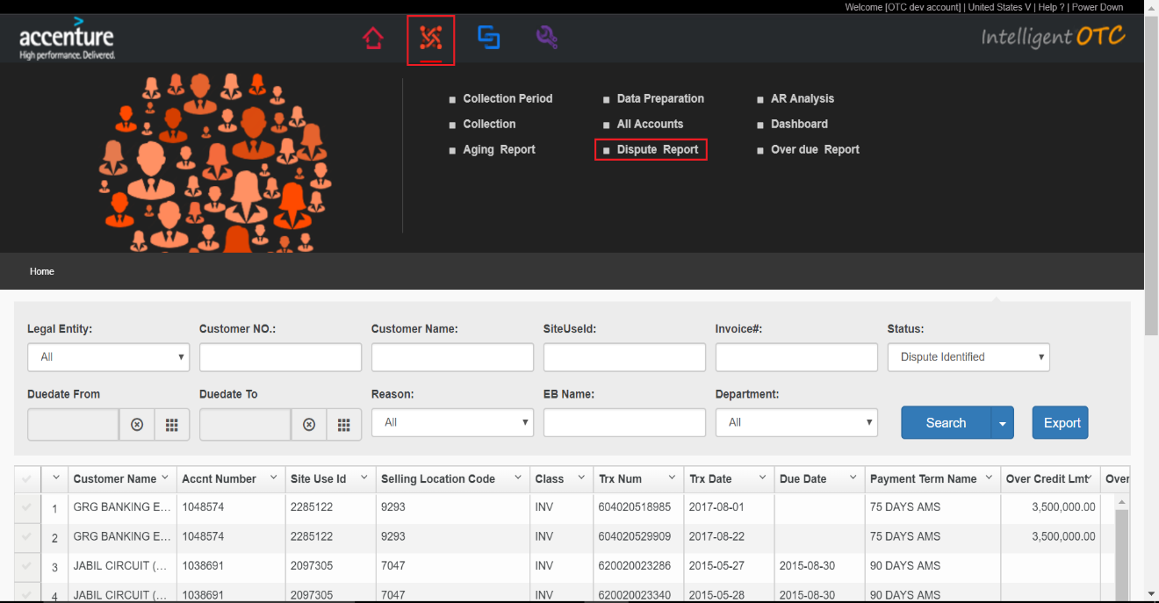
2. According to the picture, According to Legal Entity ,Customer No. ,Customer Name , SiteUseId ,Invoice# ,Status,Duedate From-Duedate To ,Reason ,EB Name ,Departmet.Click Search button after these conditions entered.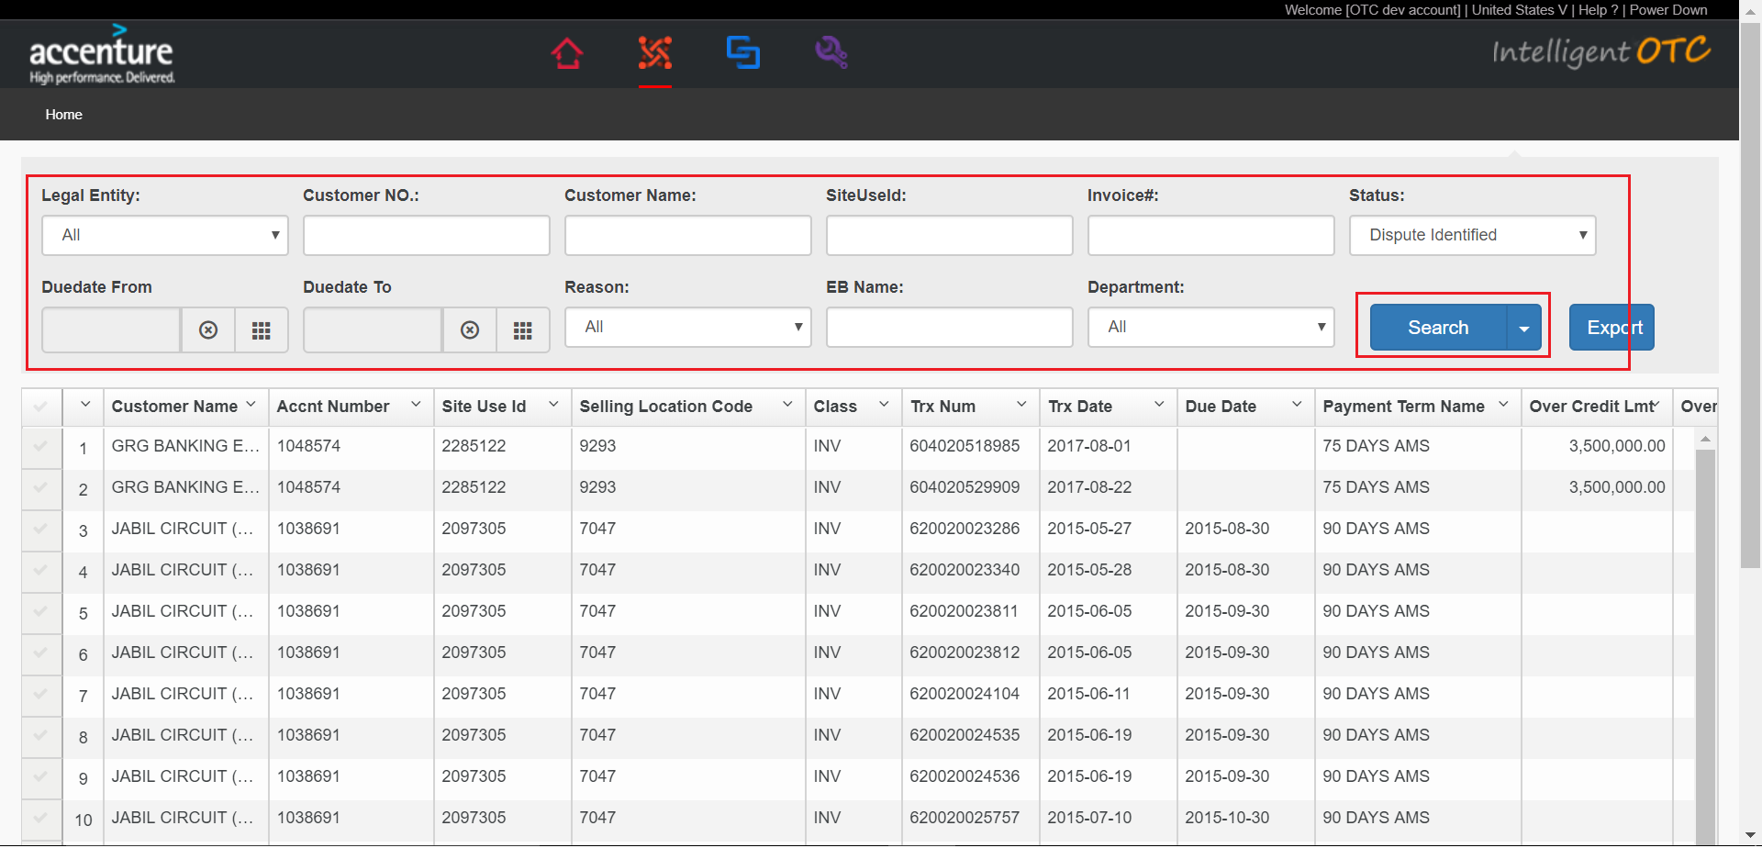
3. According to the picture,The corresponding data is shown in the list based on the input condition. 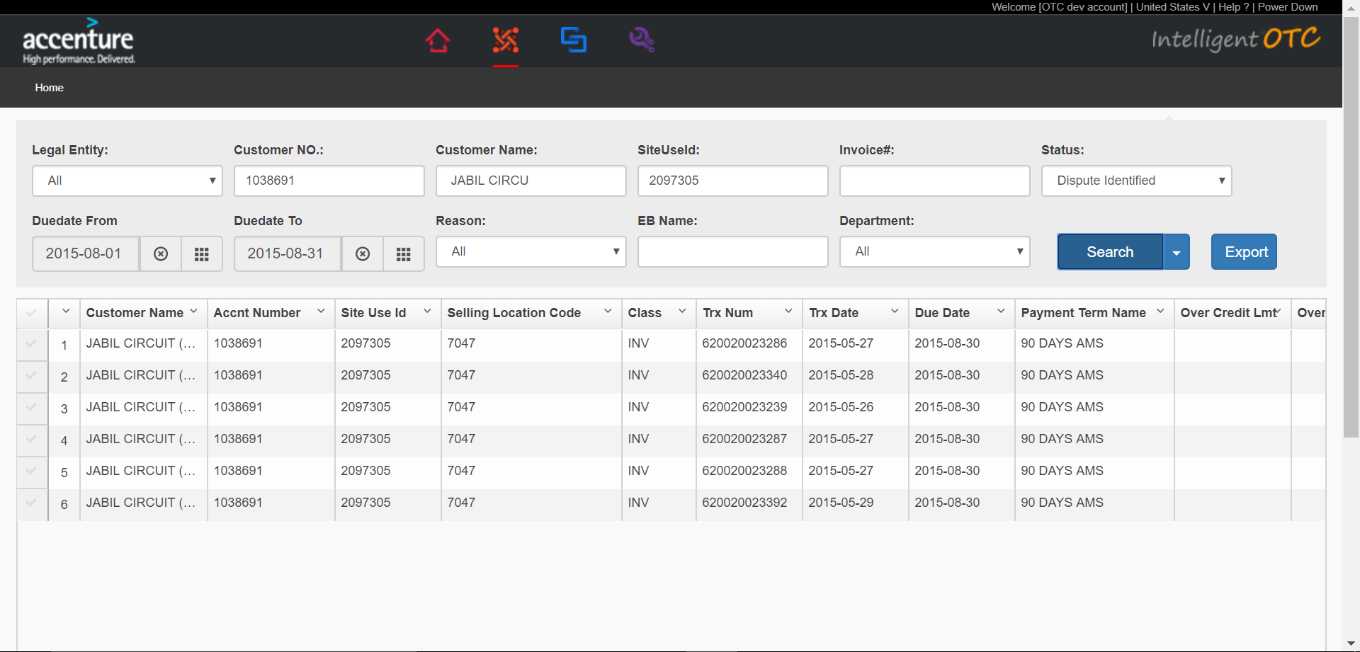

### Dispute Report Export

1. According to the picture, According to Legal Entity , Customer No. , Customer Name , SiteUseId ,Invoice# ,Status,Duedate From-Duedate To ,Reason ,EB Name ,Departmet,Click Export button after these conditions entered.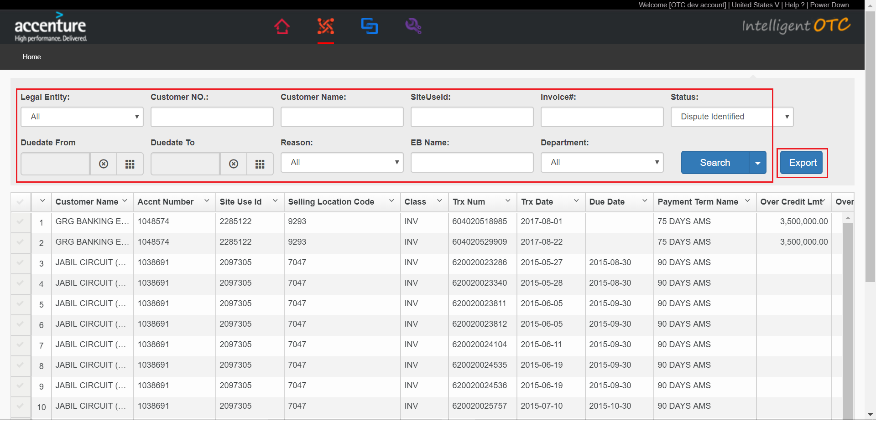
2. Page loading,pop-up box click OK button. 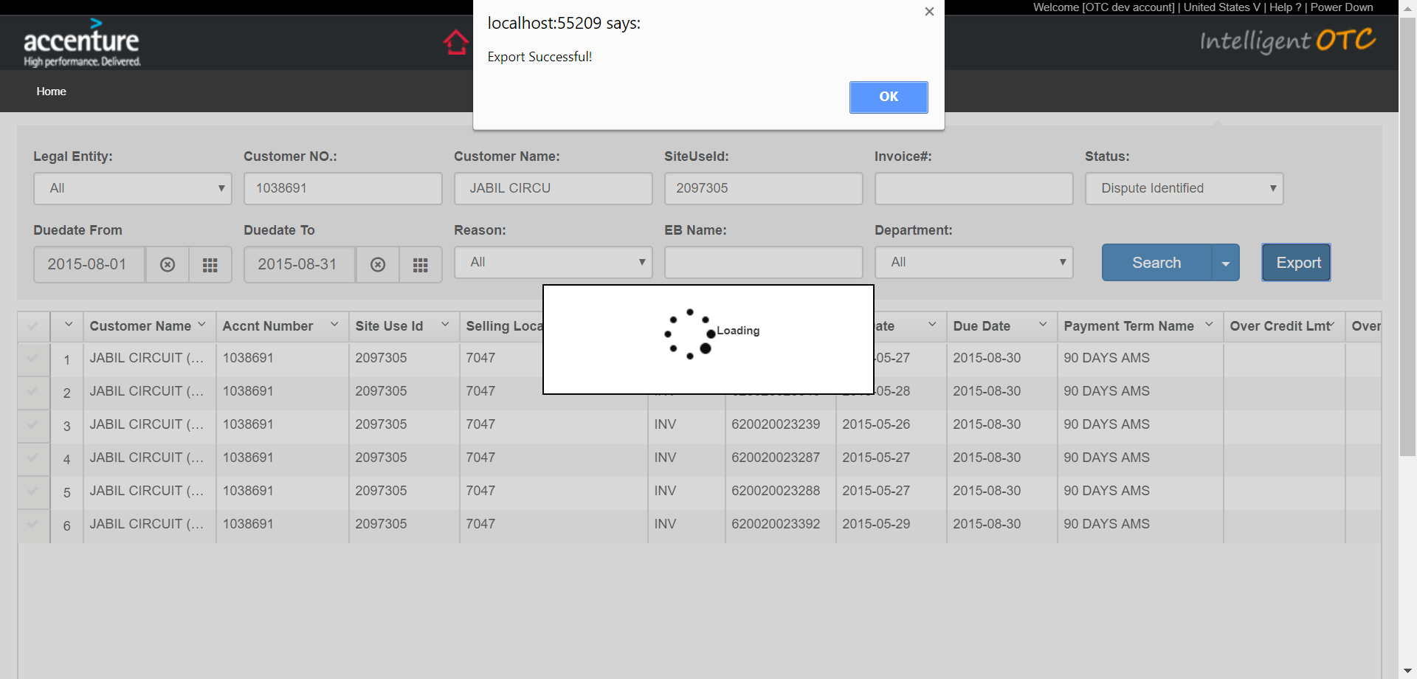
3. Click excel file in the red box.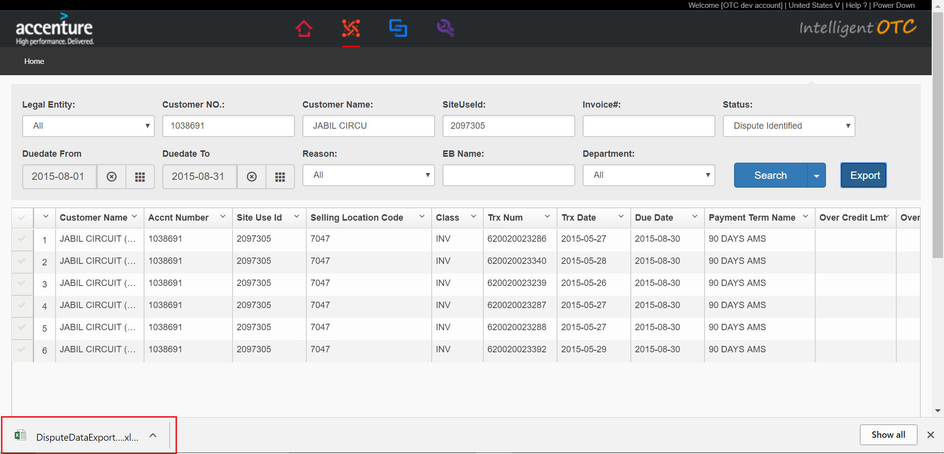
4. The corresponding data is shown in the excel file based on the input condition.

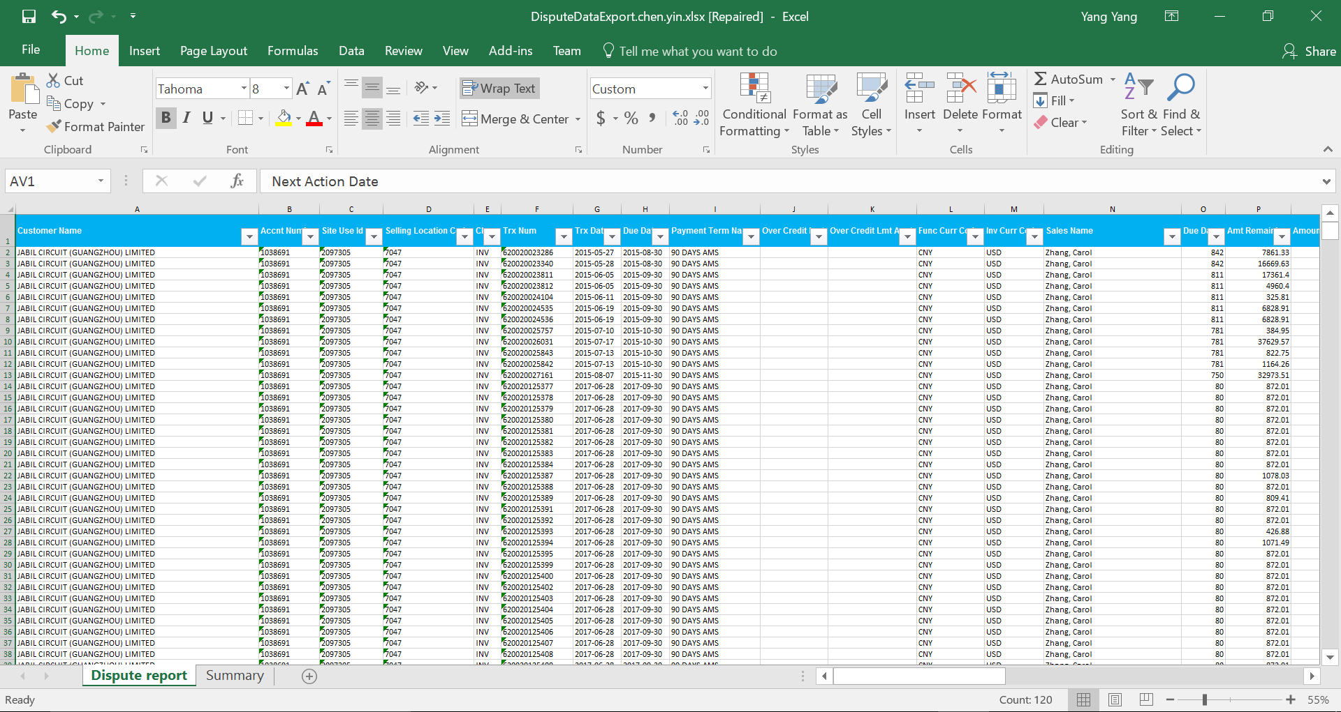

## Over due Report

### Over due Report Query

1. Mouse over the red box section of the head menu,Click on “Over due Report” in the drop-down.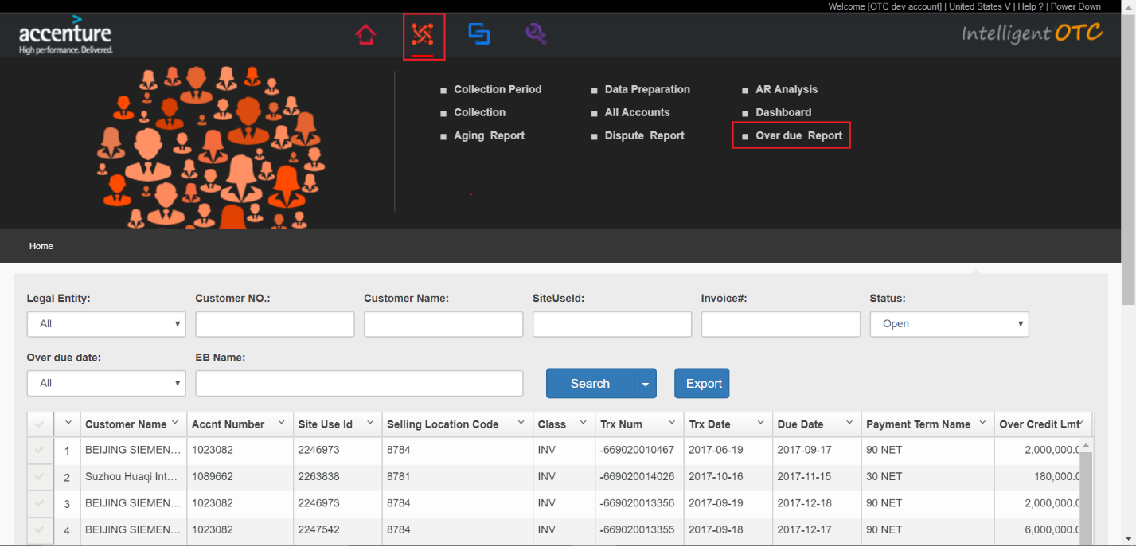
2. According to the picture, According to Legal Entity ,Customer No. ,Customer Name , SiteUseId ,Invoice# ,Status,Over due date ,EB Name ,Click Search button after these conditions entered.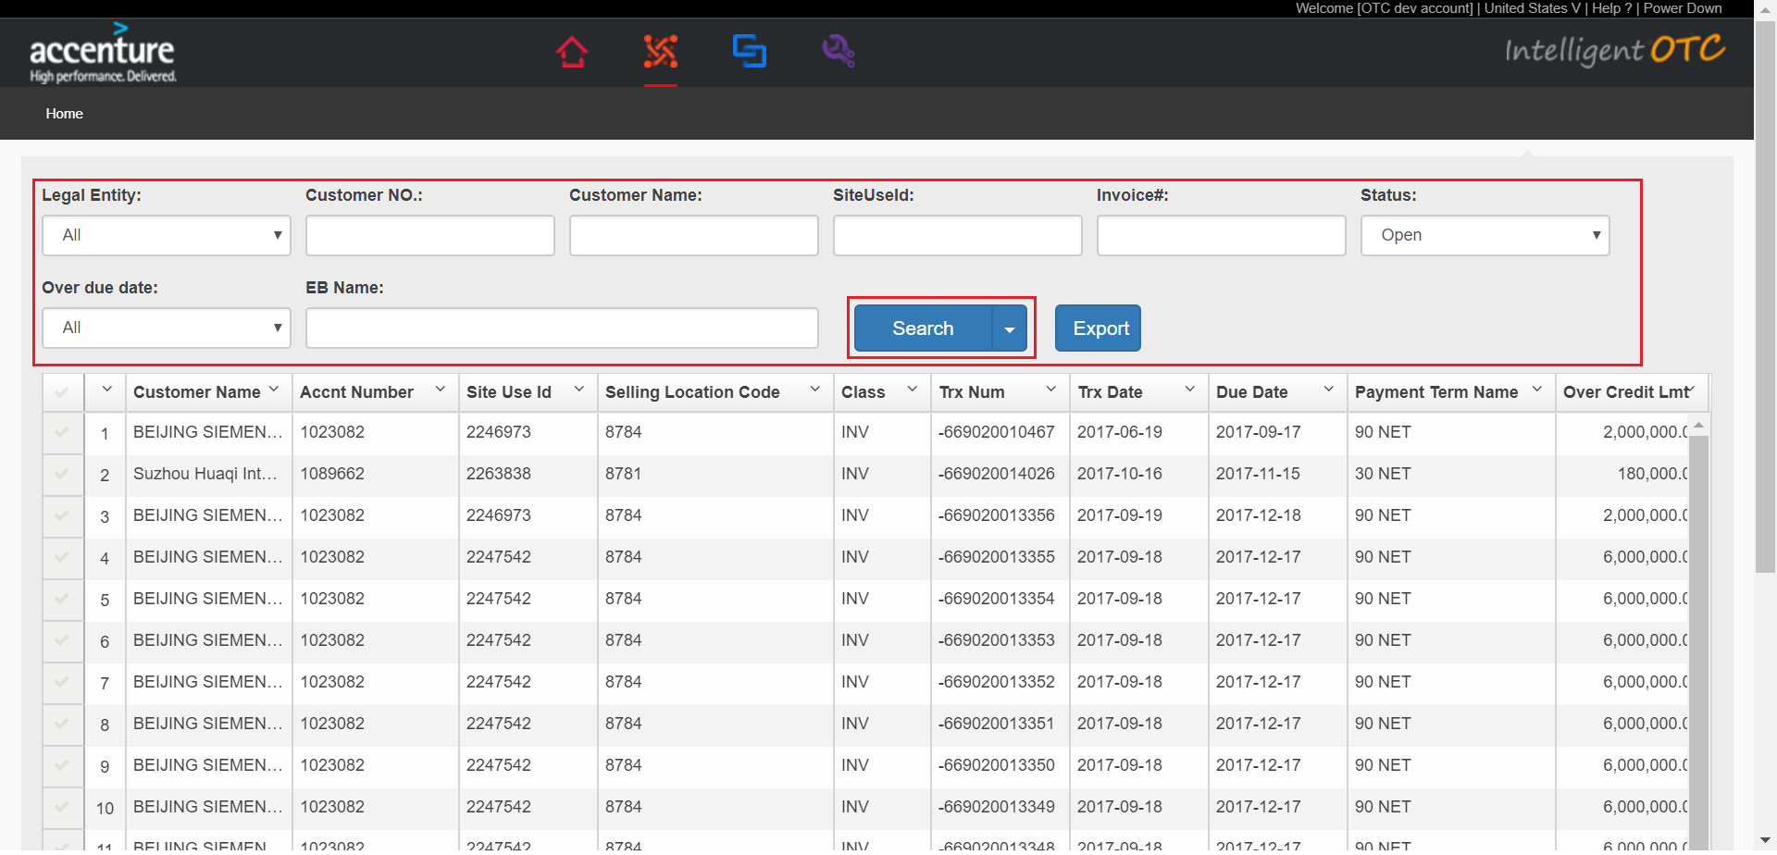
3. According to the picture,The corresponding data is shown in the list based on the input condition. 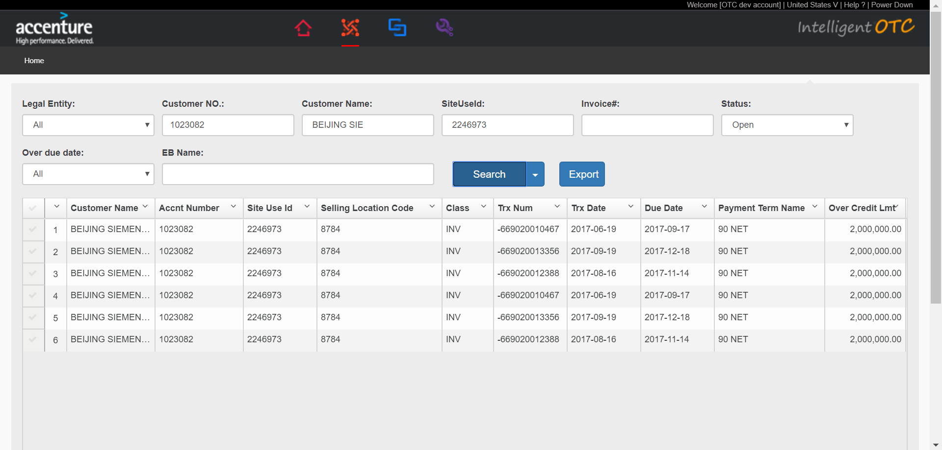

### Over due Report Export

1. According to the picture, According to Legal Entity ,Customer No. ,Customer Name , SiteUseId ,Invoice# ,Status,Over due date ,EB Name , Click Export button after these conditions entered.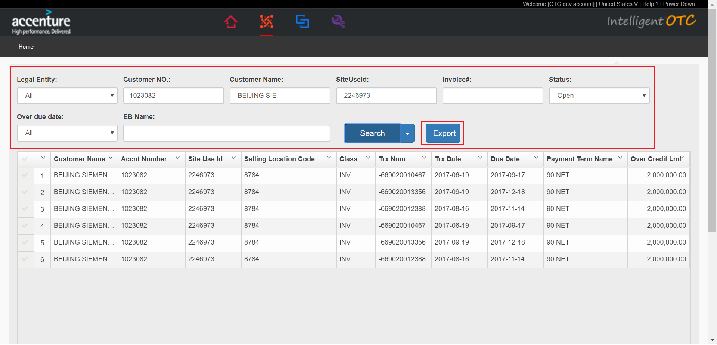
2. Page loading,pop-up box click OK button.

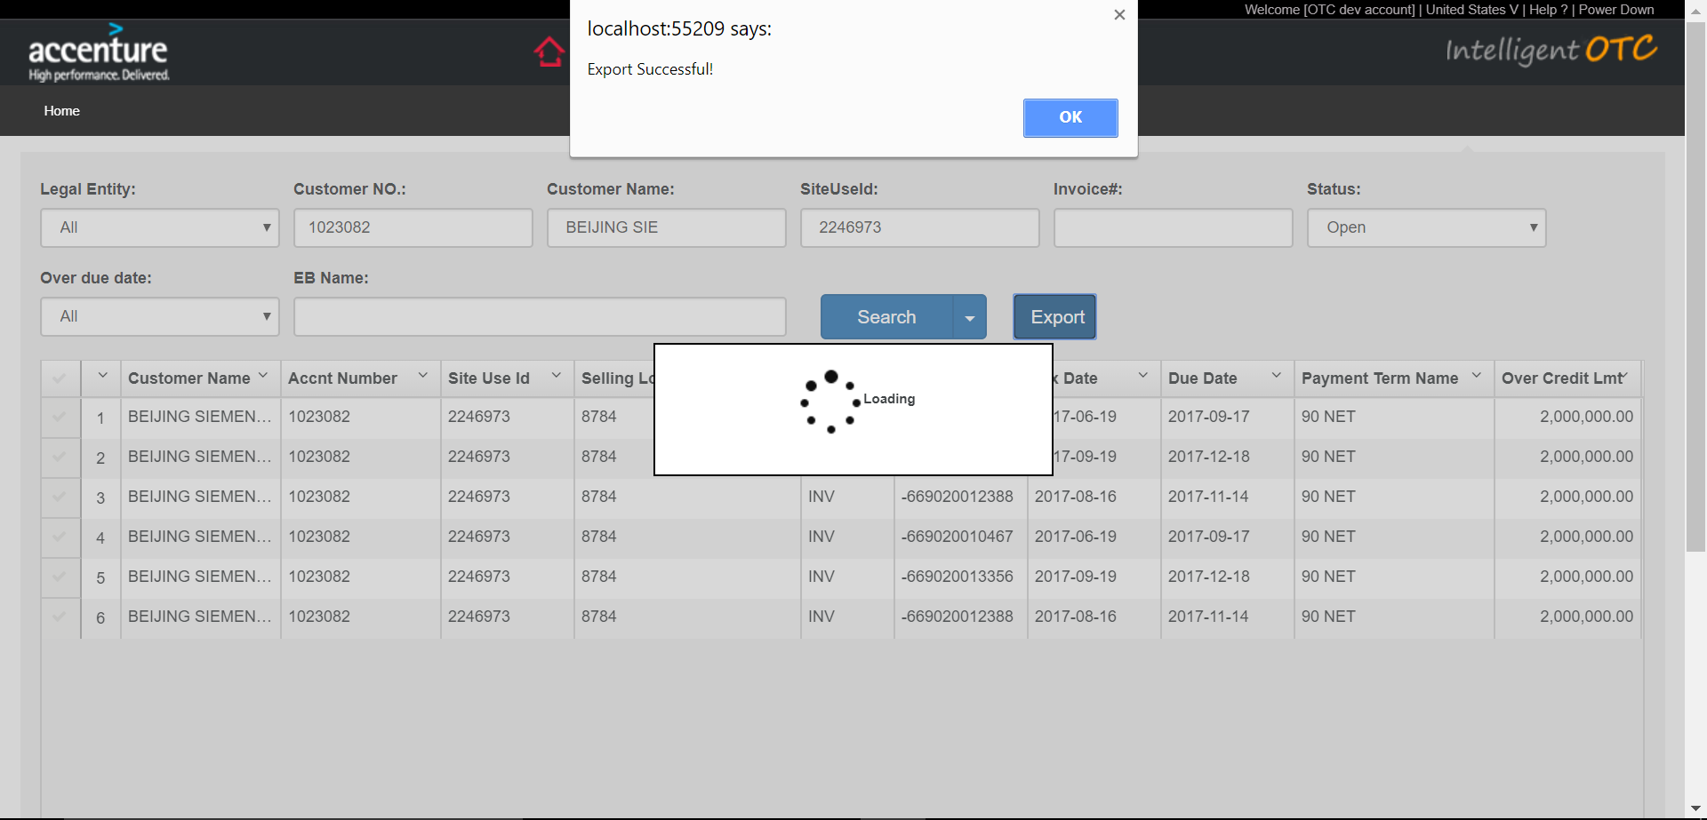

1. Click excel file in the red box.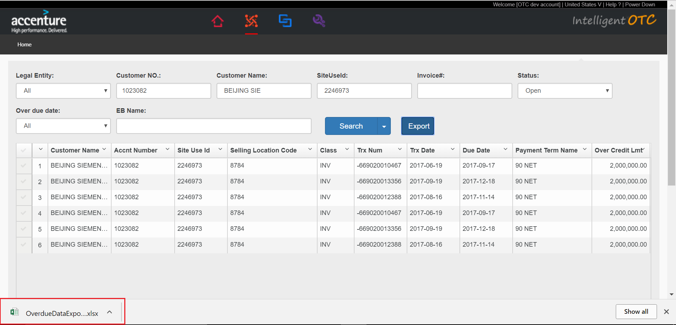
2. The corresponding data is shown in the excel file based on the input condition. 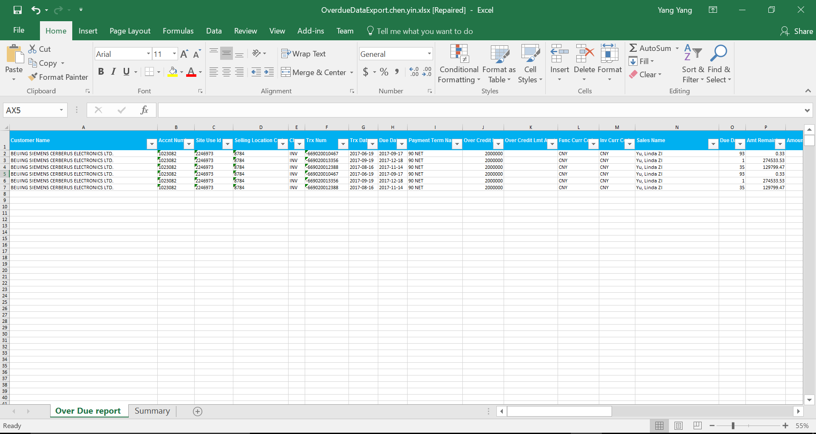

## Collection Period

Set Collection Period

### New Collection Period

1. Select “New Period Start Date” and “New Period End date”.The “New Period Start Date” must be greater than the maximum “Close Date” in the list.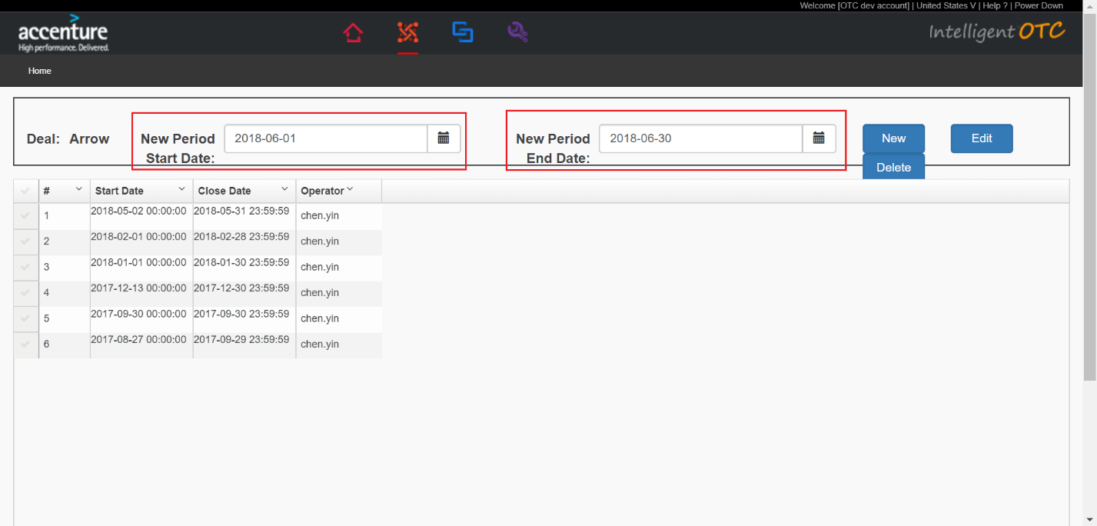
2. Click “New” botton.Pop-up success dialog box and click “OK”.

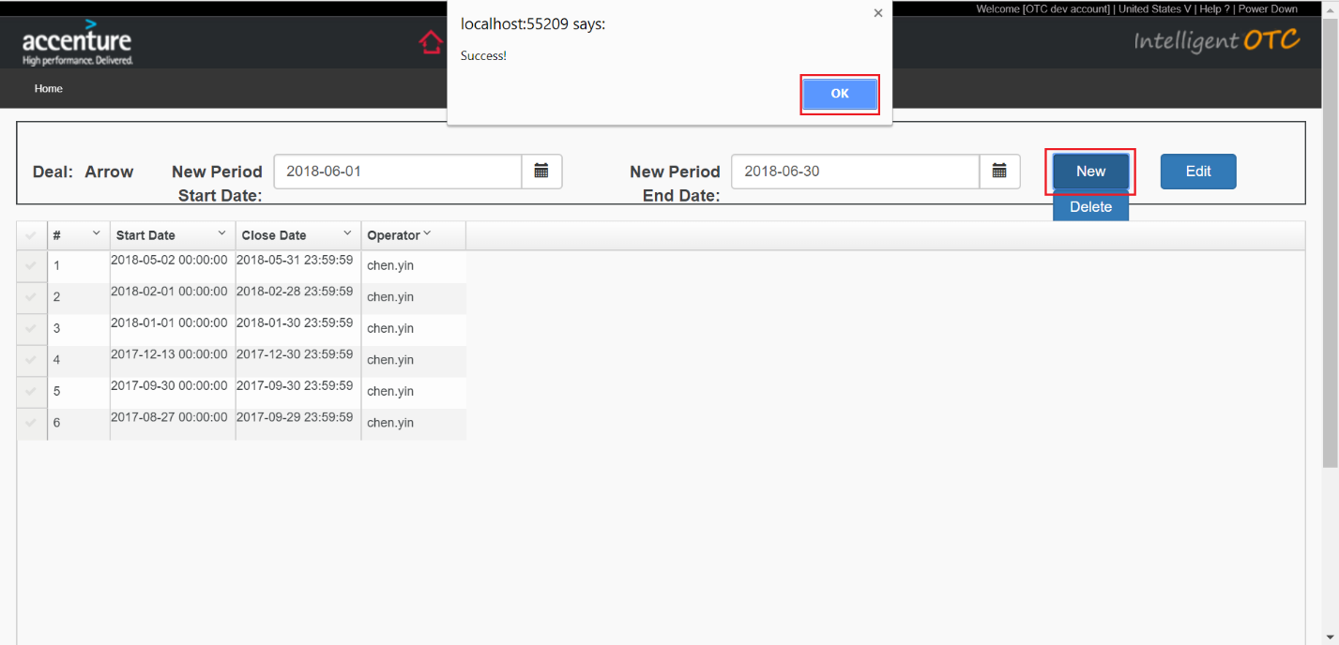

1. New data in the list.

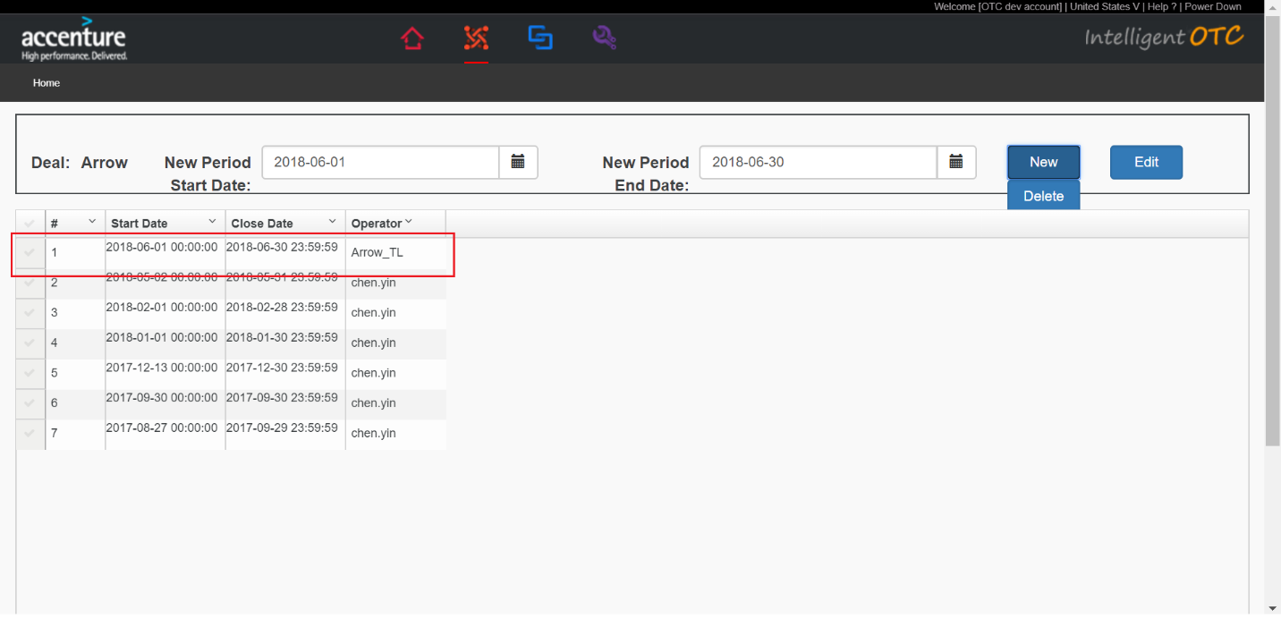

### Edit Collection Period

Edit Collection Period

1. Select any data in the list and click “Edit” button.

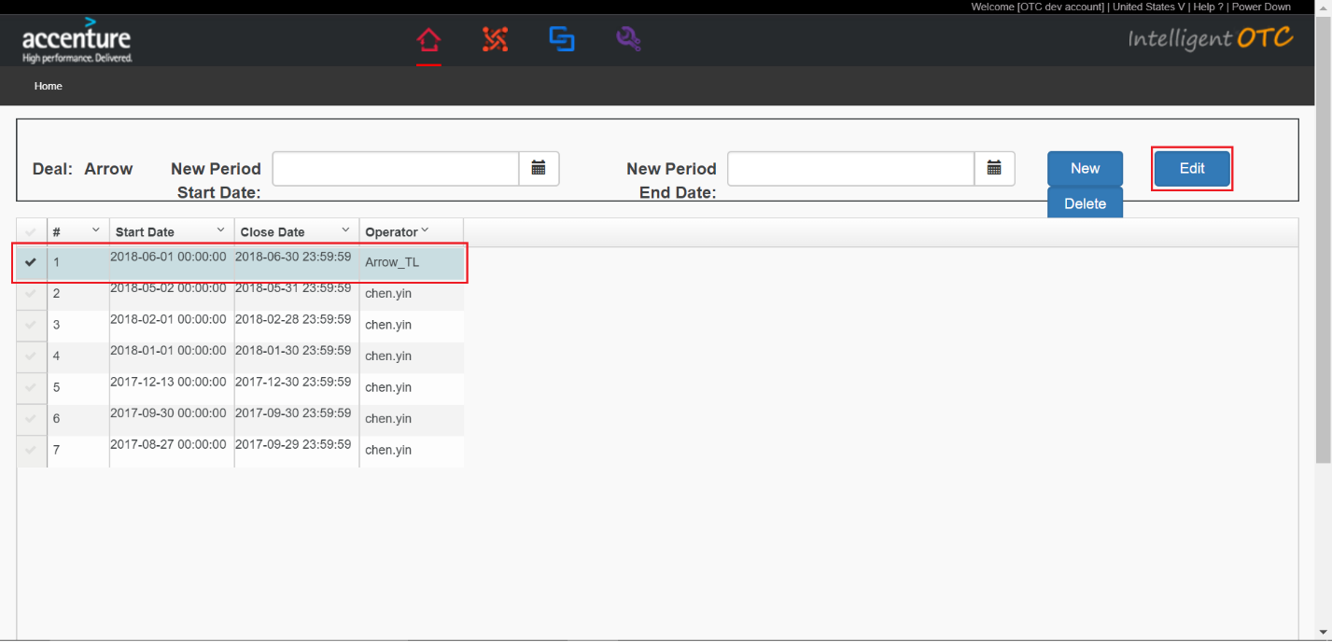

1. Set new “Start data” and “End data”.Click “Save” button.

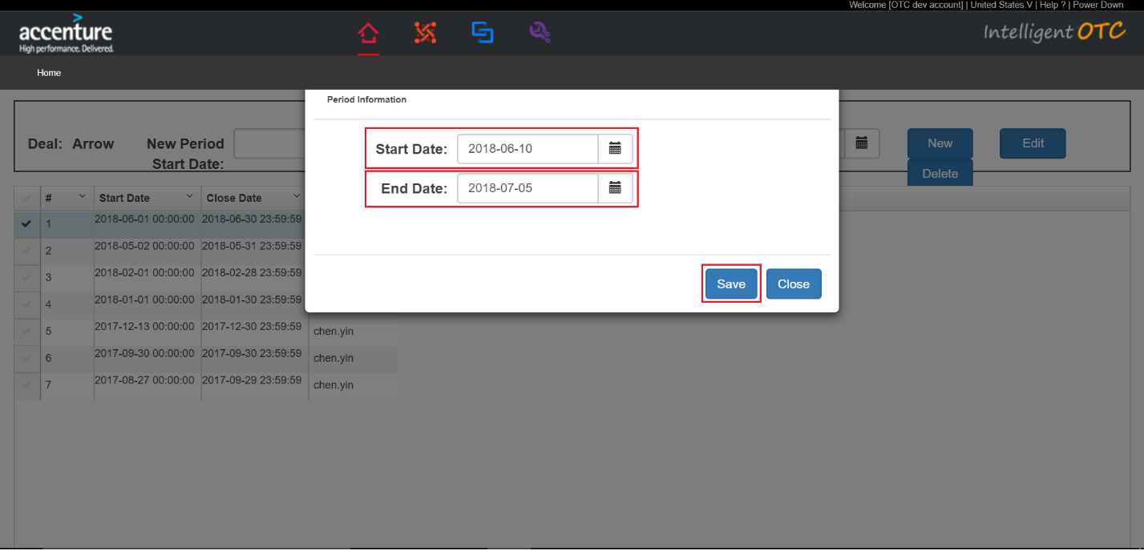

1. The modified data is displayed in the list.

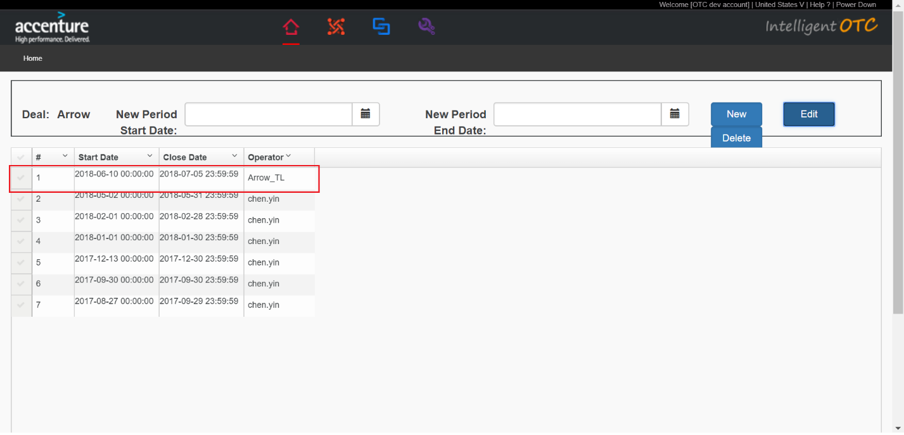

### Delete Collection Period

Delete Collection Period

1. Select any data in the list and click “Delete” button.

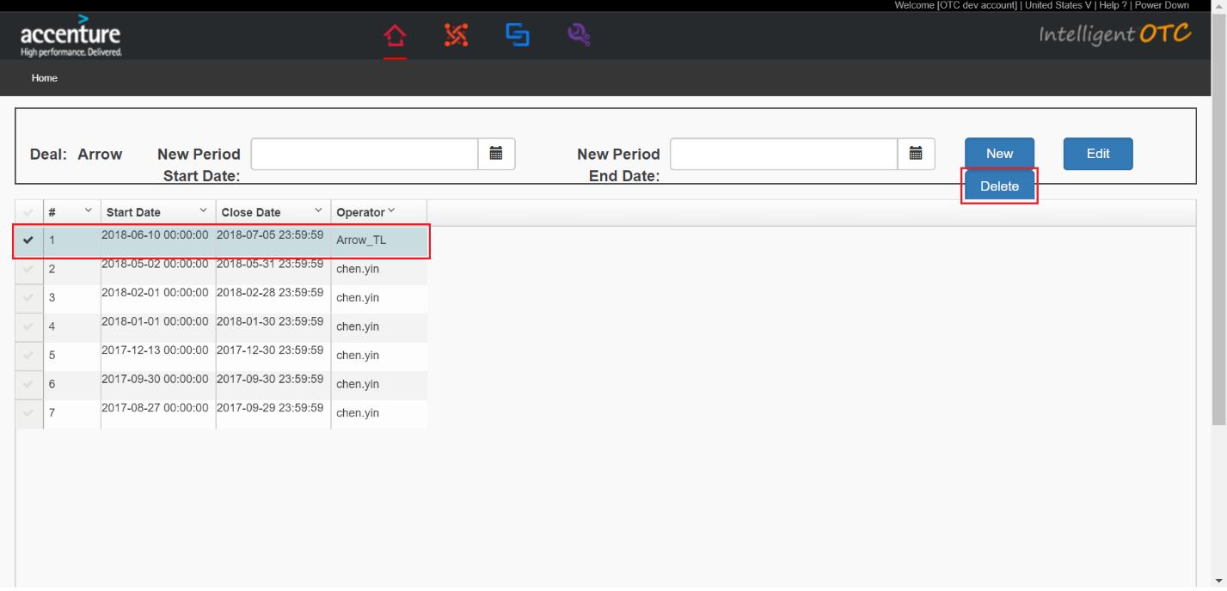

1. Click “OK” button.

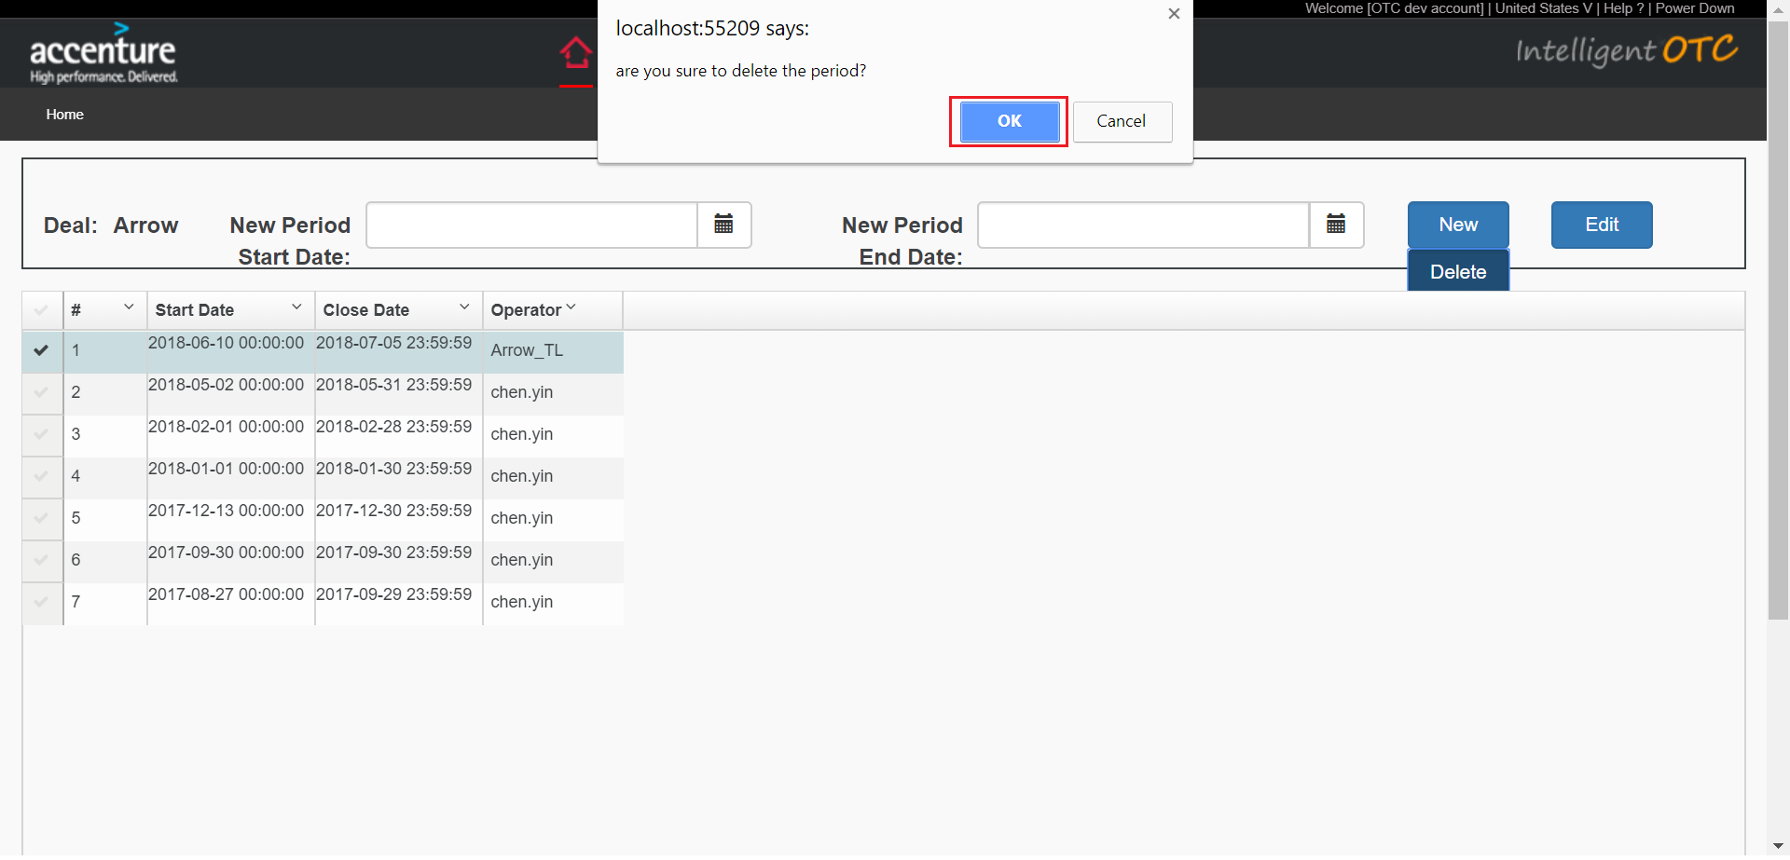

1. The selected data disappears in the list and is deleted successfully.

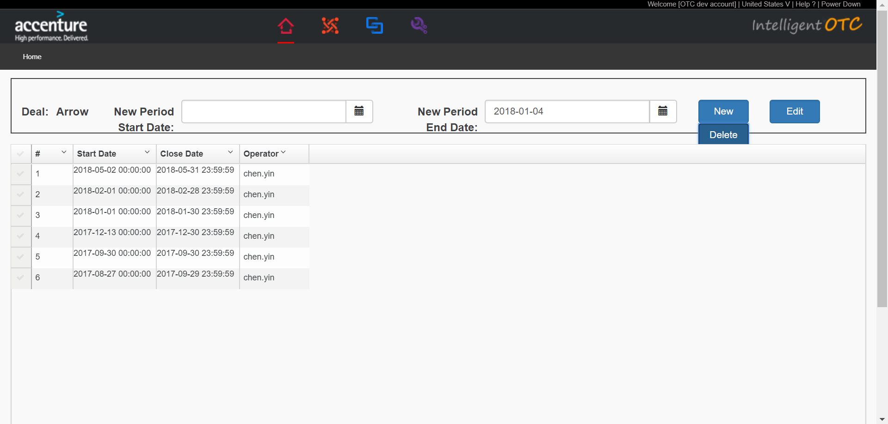

## AR Analysis

### Re-Analyse

1. Click “Re-Analyse”button.Pop-up confirmation dialog box,click “OK” button.

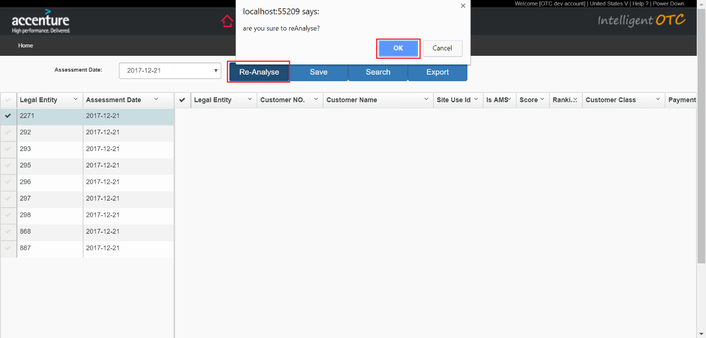

1. The analysis has been successful.the “Assessment Date” is the current date of the system,and the left list is the data of the current date of the current date of the system.

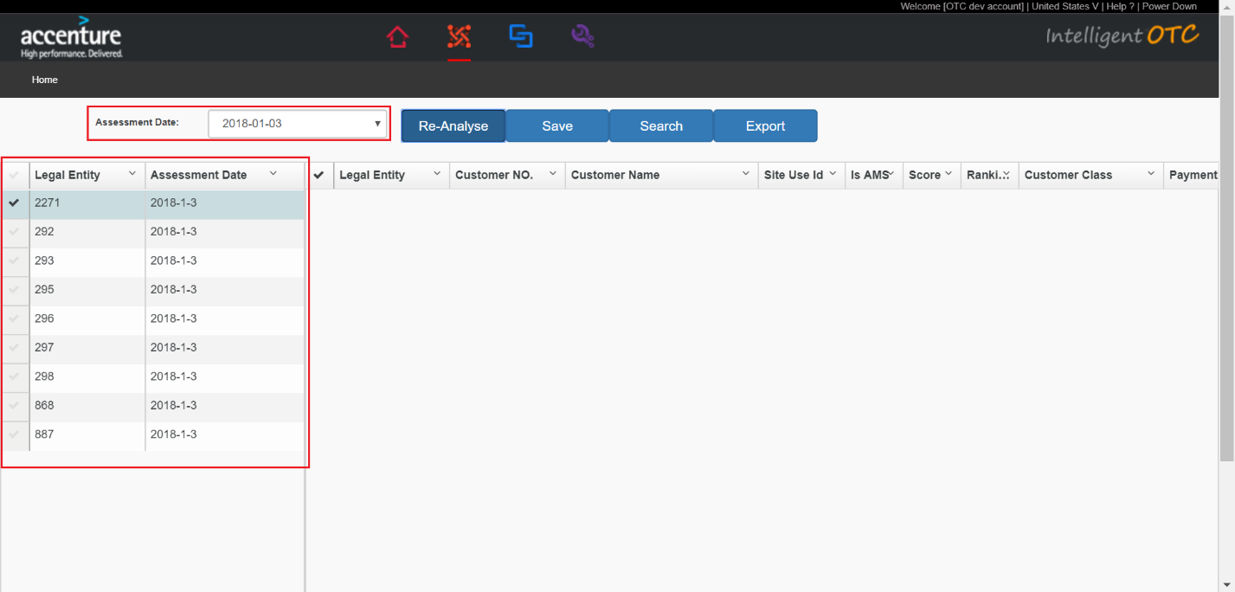

### Query the CustomerAssessment data according to “Legal Entity” and “Assessment Date”.

1. Select any data in the left list.

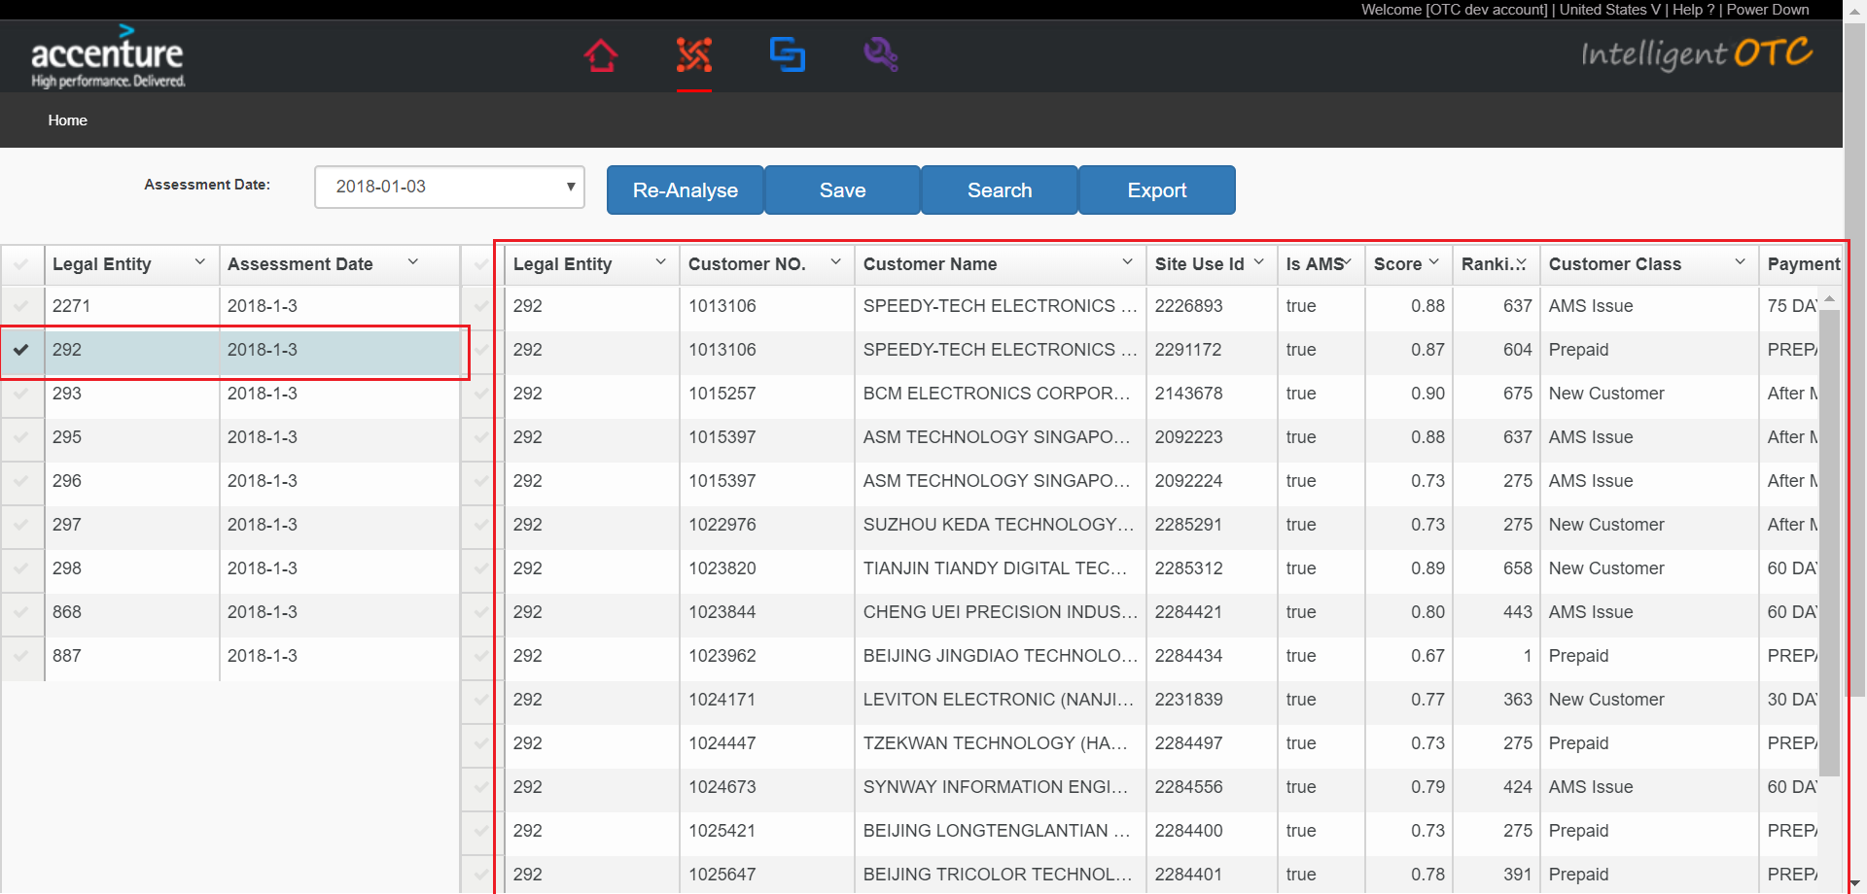

### Query the CustomerAssessment data according to “Legal Entity” and “Assessment Date” and conditions.

1. Select any data in the left list.

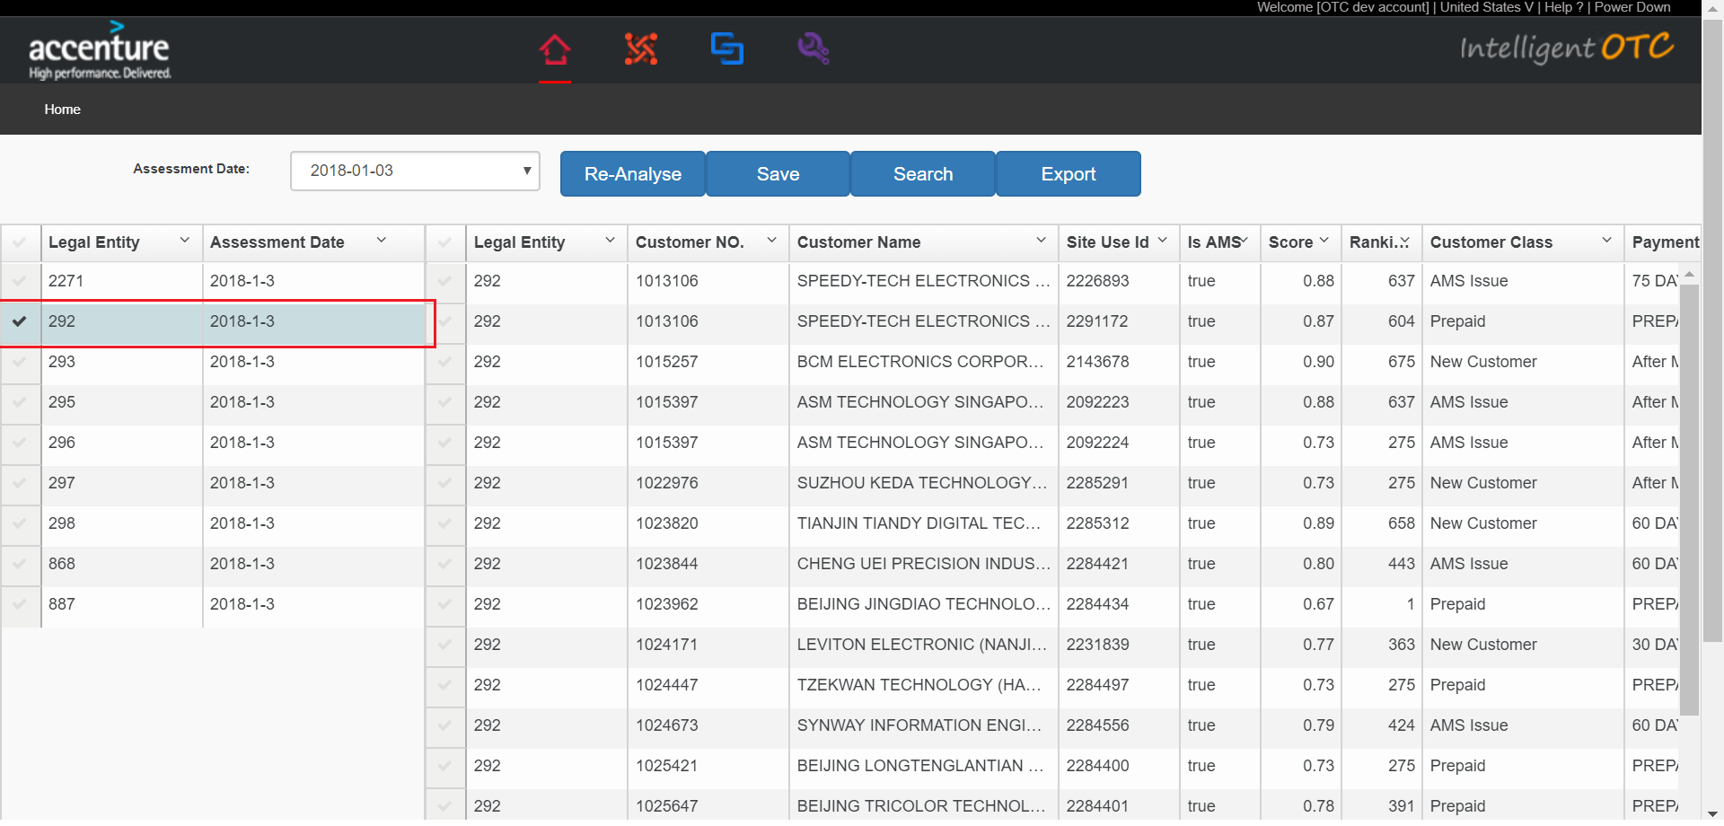

1. Click “Search” button.The query condition area is displayed.

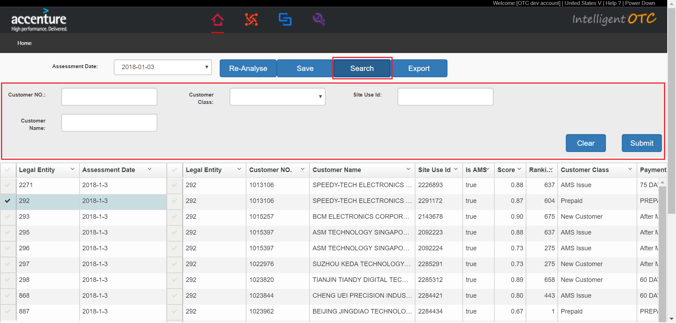

1. Input conditions.click “Submit” button.

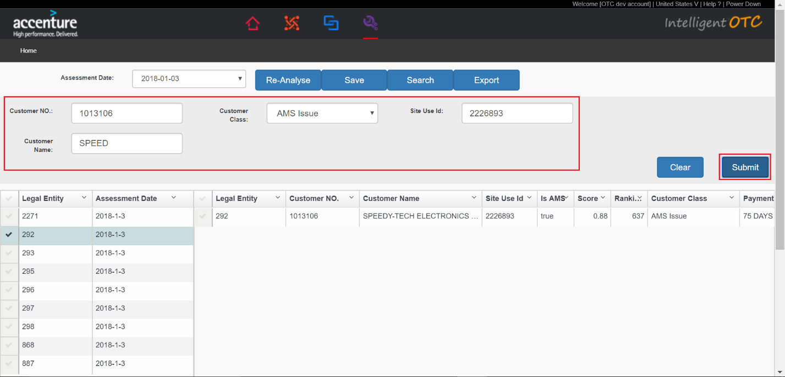

### Save “Customer Class”

1. Click the “Customer Class” column that you want to modify the data.

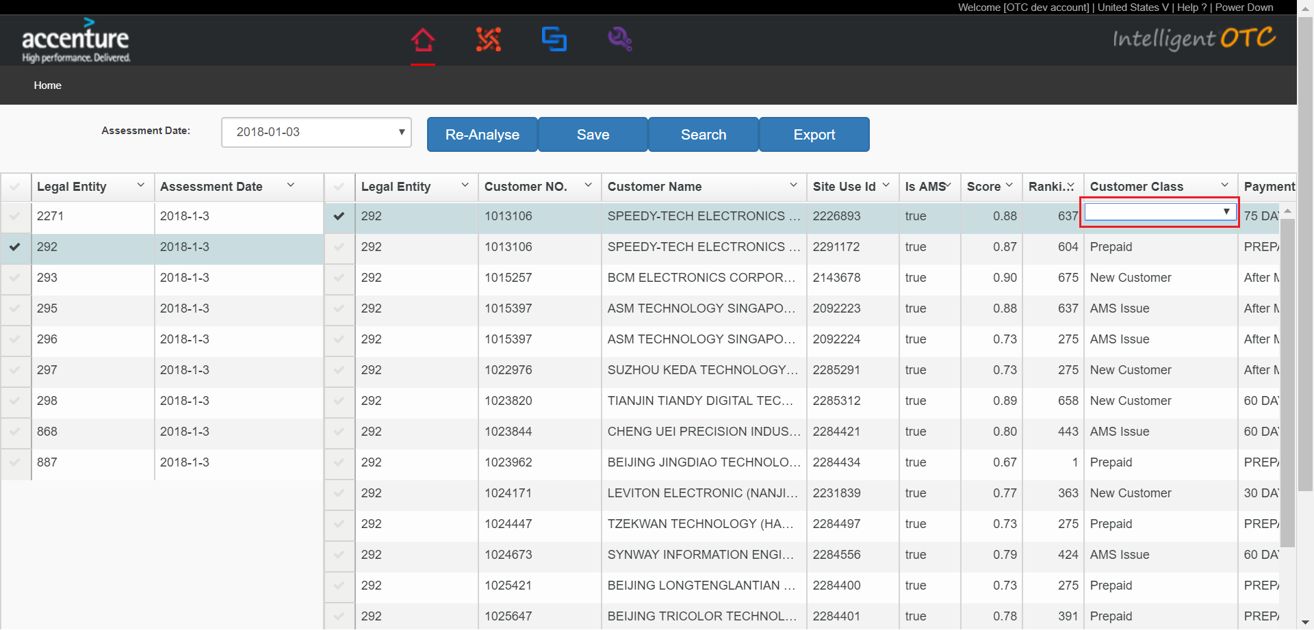

1. Click the value to be modified.

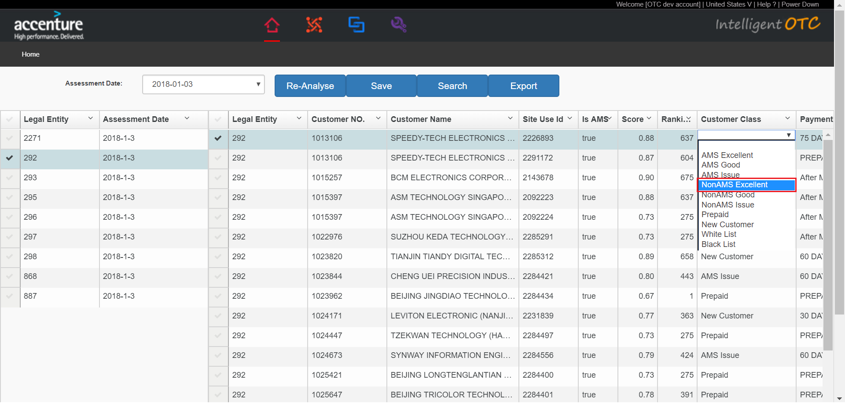

1. Click “Save” button.

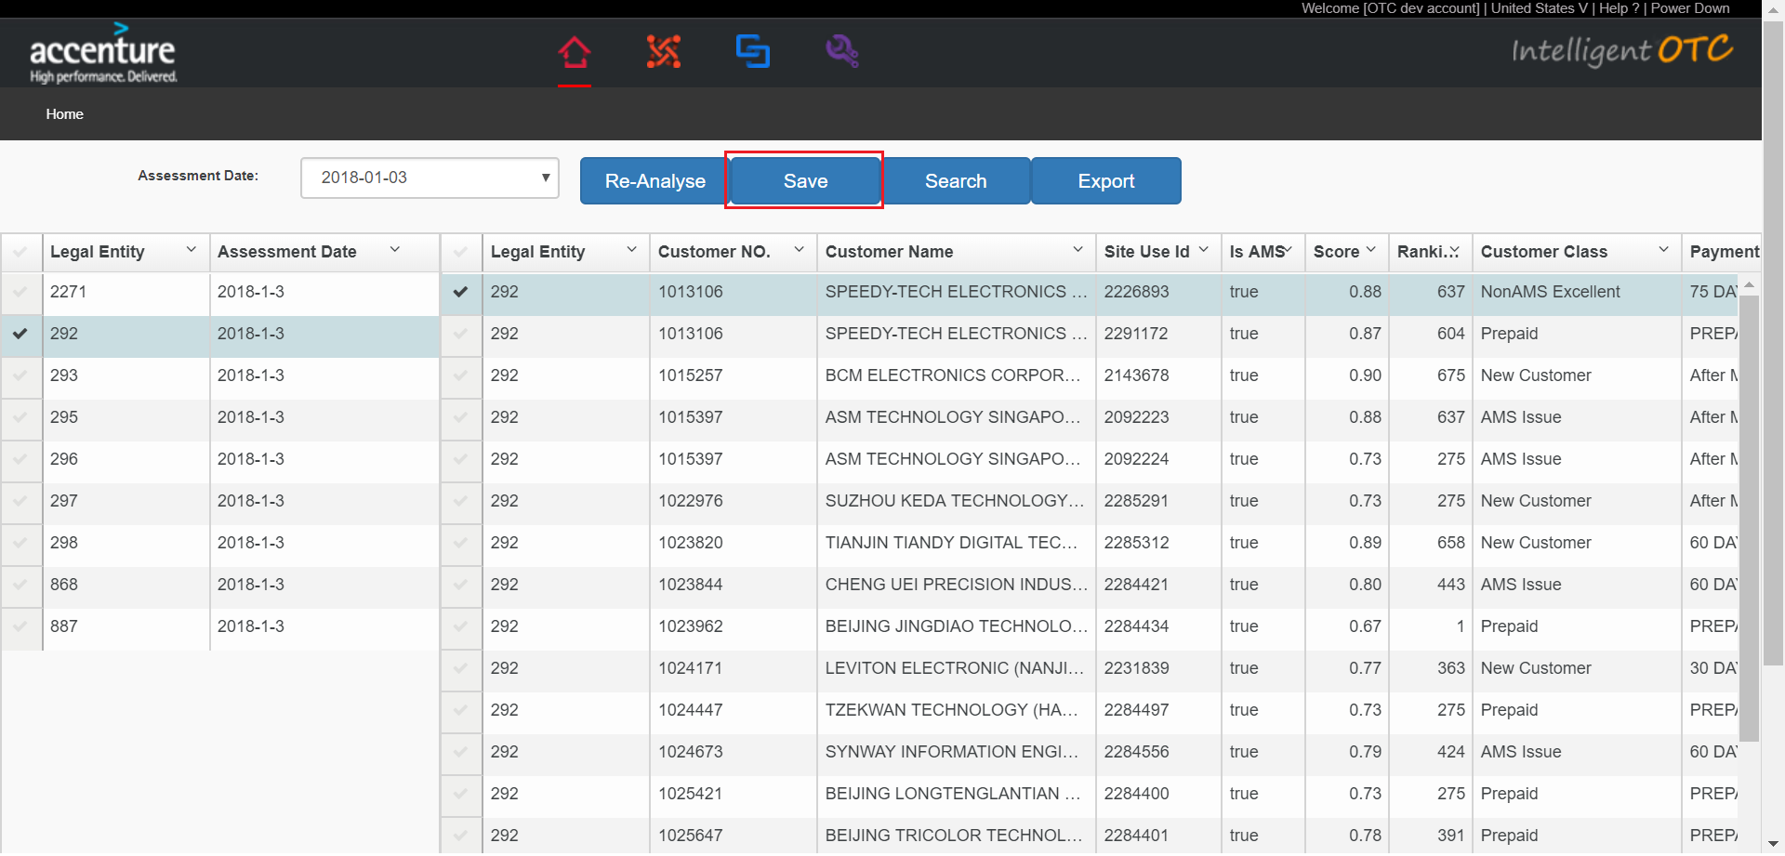

### Export CustomerAssessment Data

1. Click “Export” button.

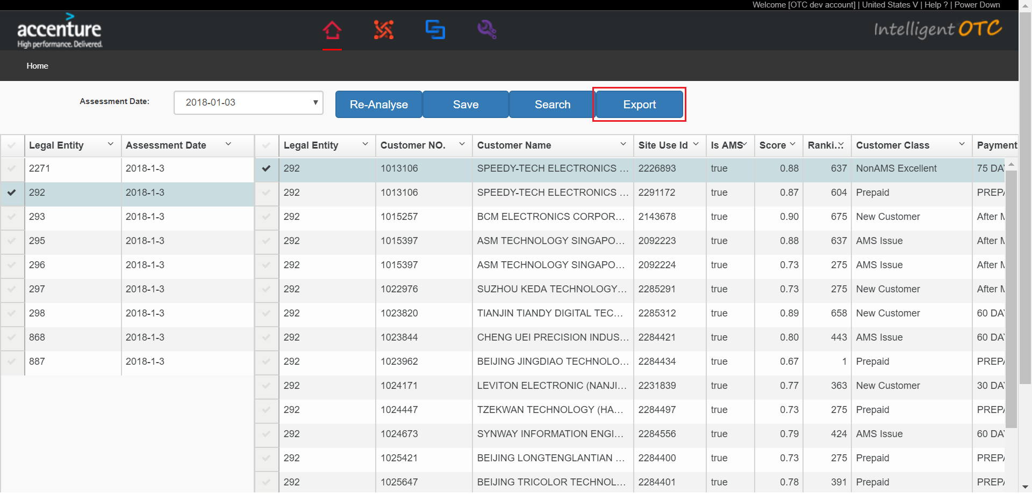

## Customer Master Data

### Query the customer master data according conditions.

1. Input conditions and click “Search” button.

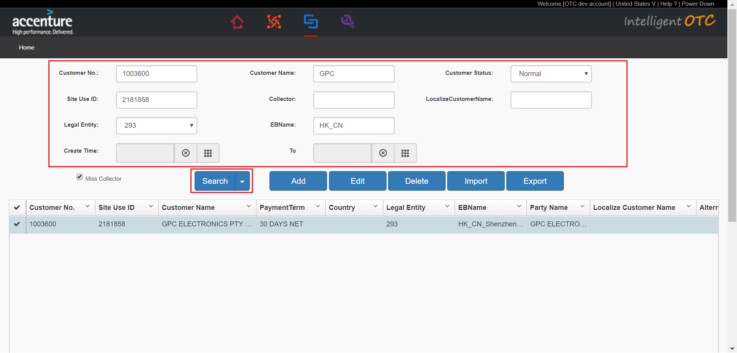

### Delete any customer master data.

1. Select the data you want to delete in the list.click “Delete” button.

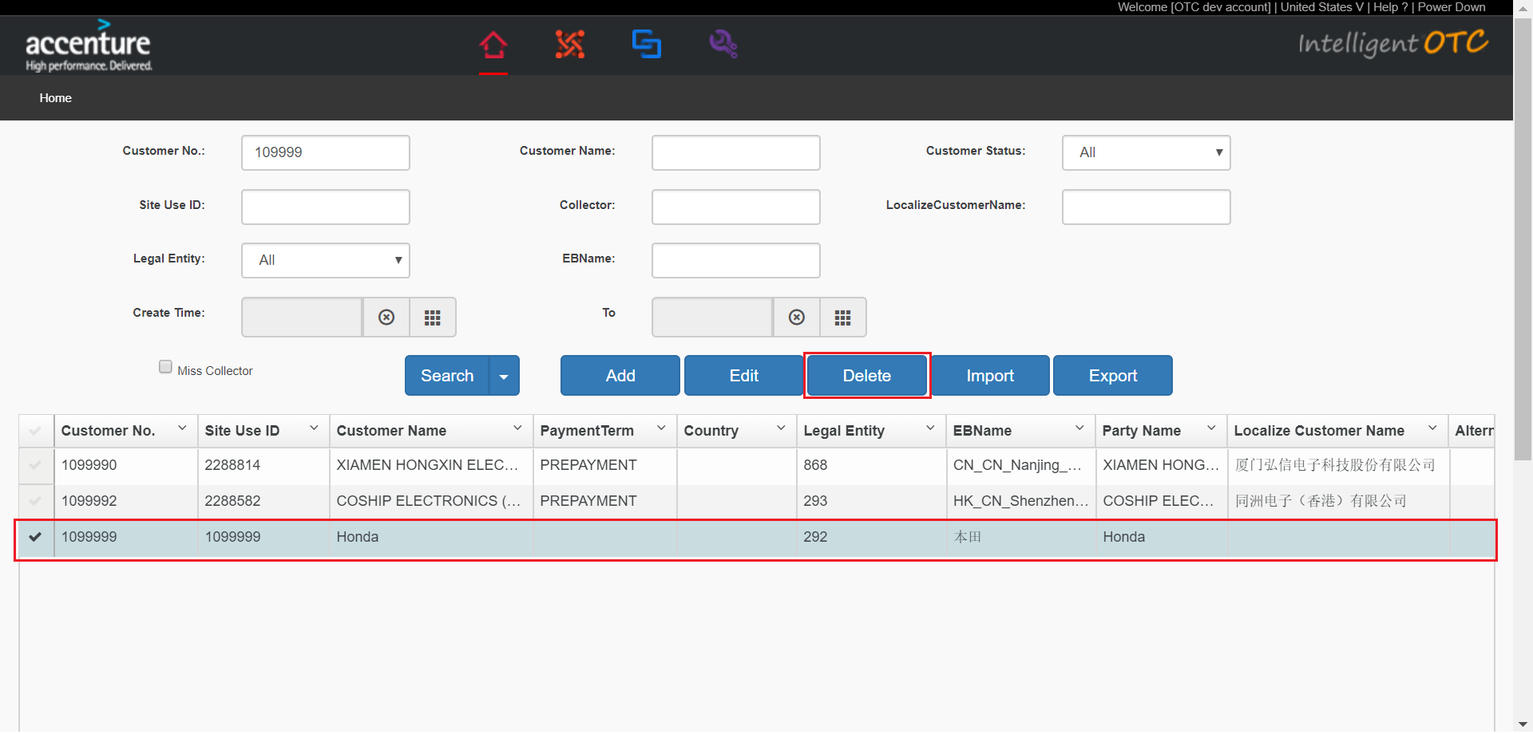

1. Click “Yes” button.

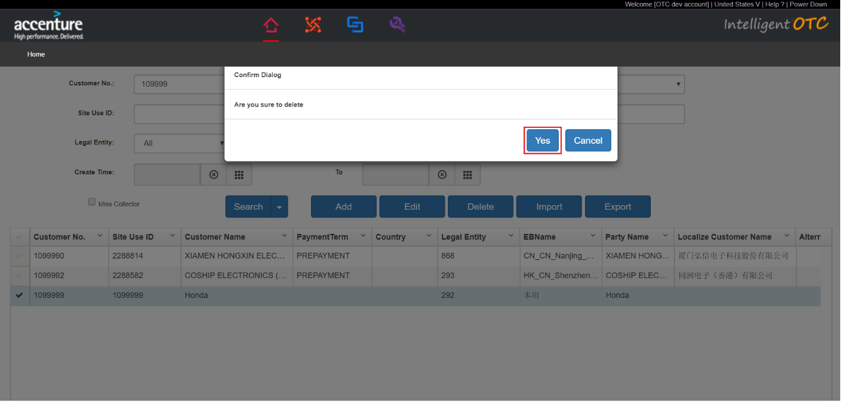

### Import Customer Master Data.

1. Open excel template,and input data.

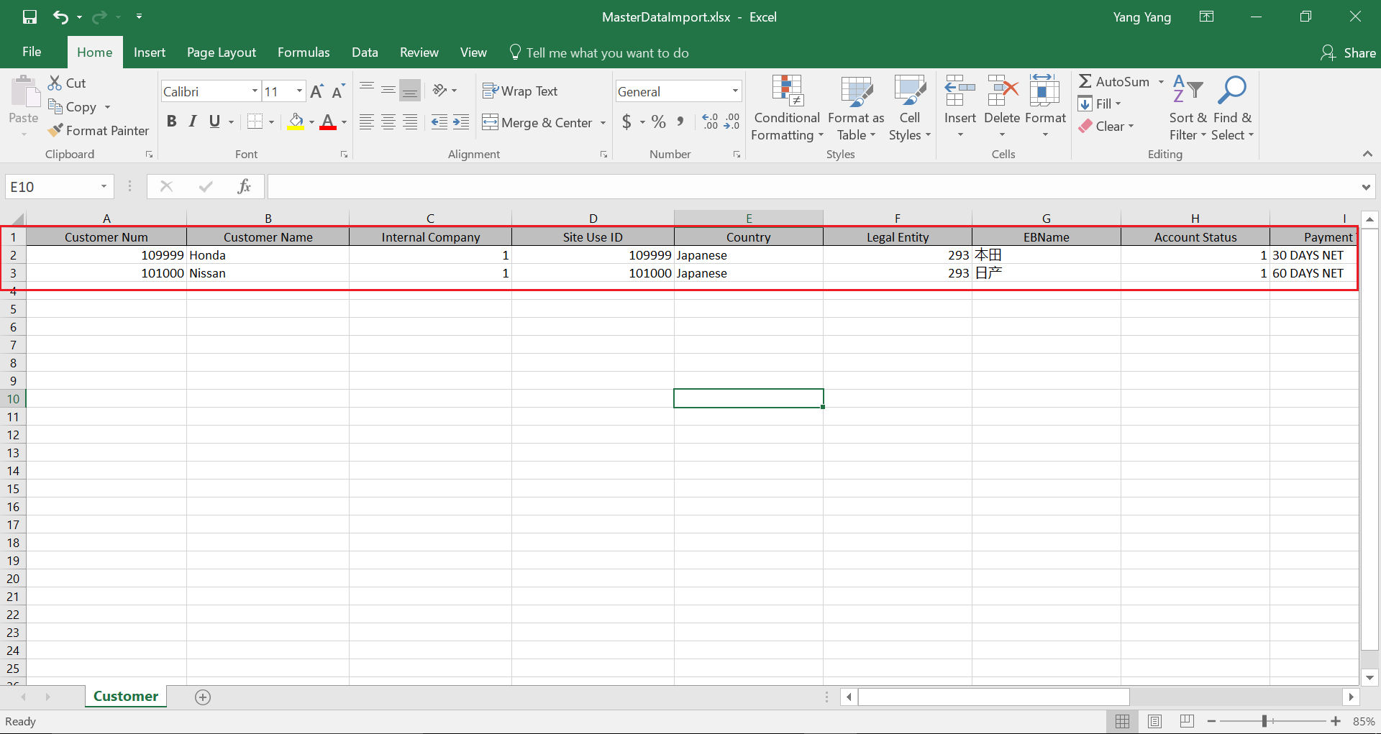

1. Click “Import” button.

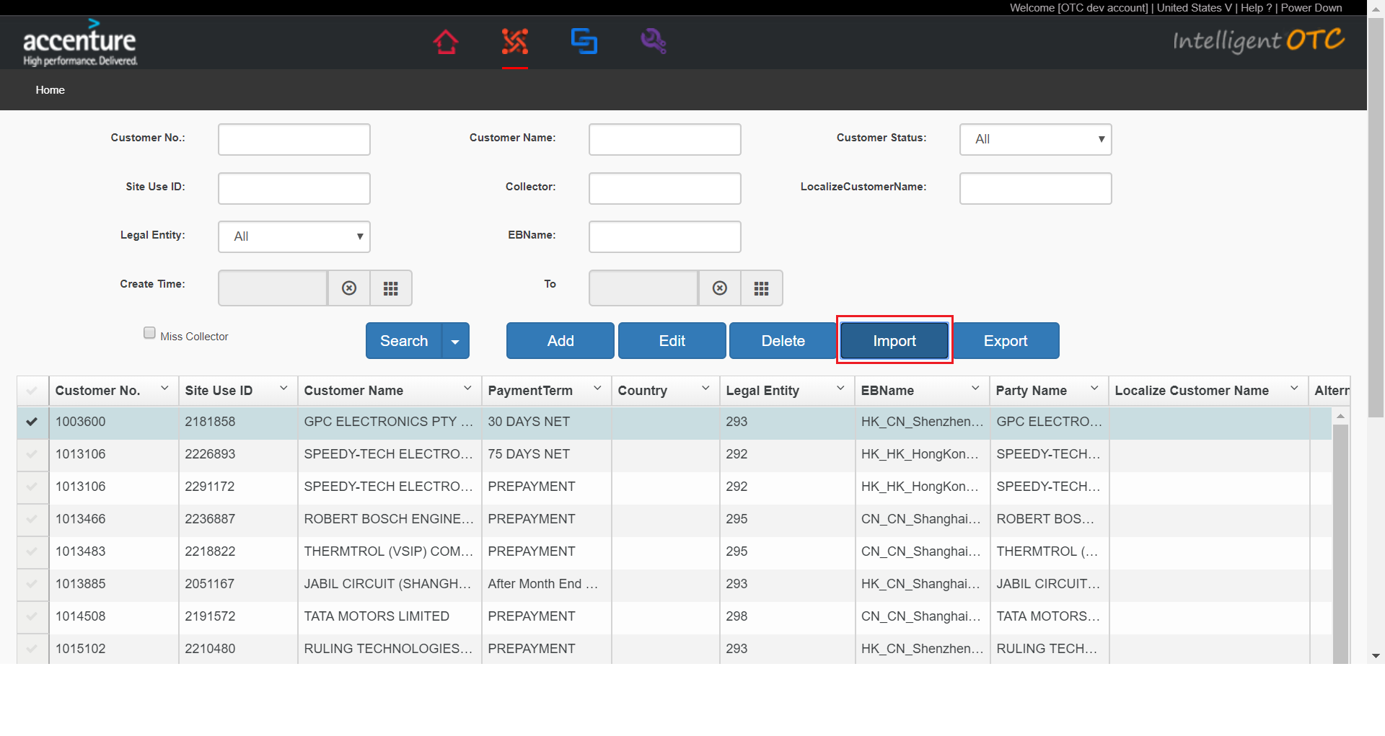

1. Click “Choose File” button.

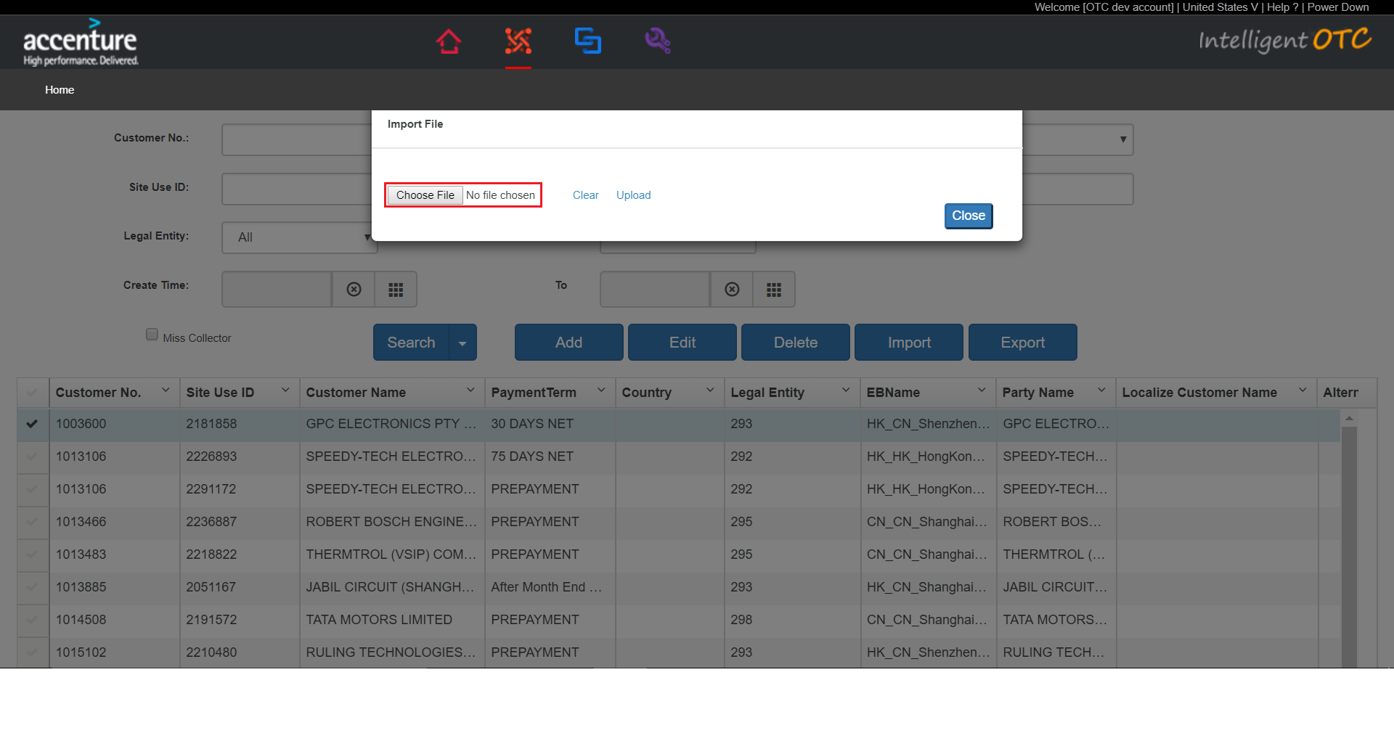

1. Select excel file that adds the data.

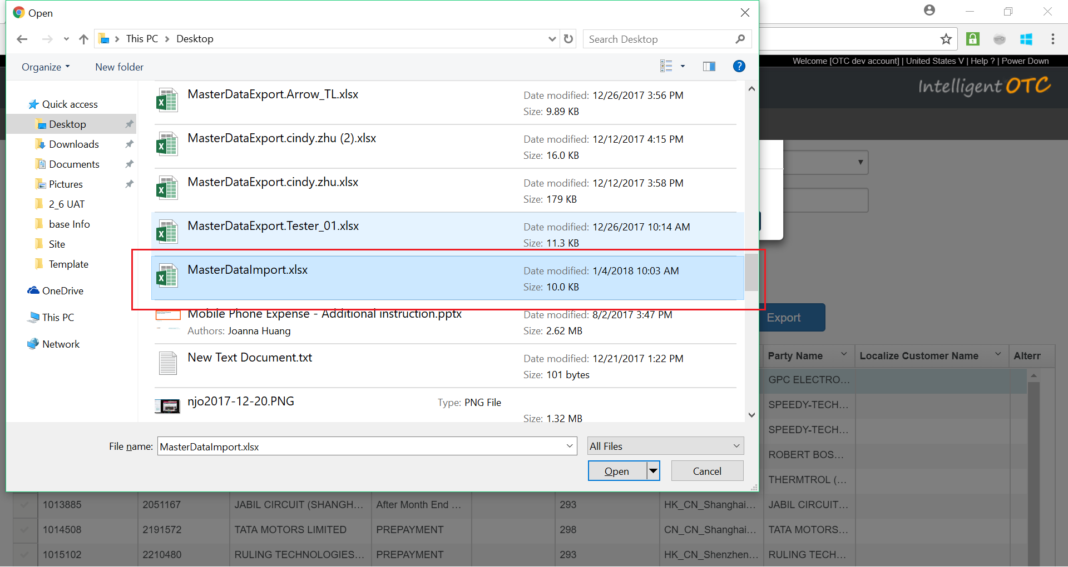

1. Click “Upload”.

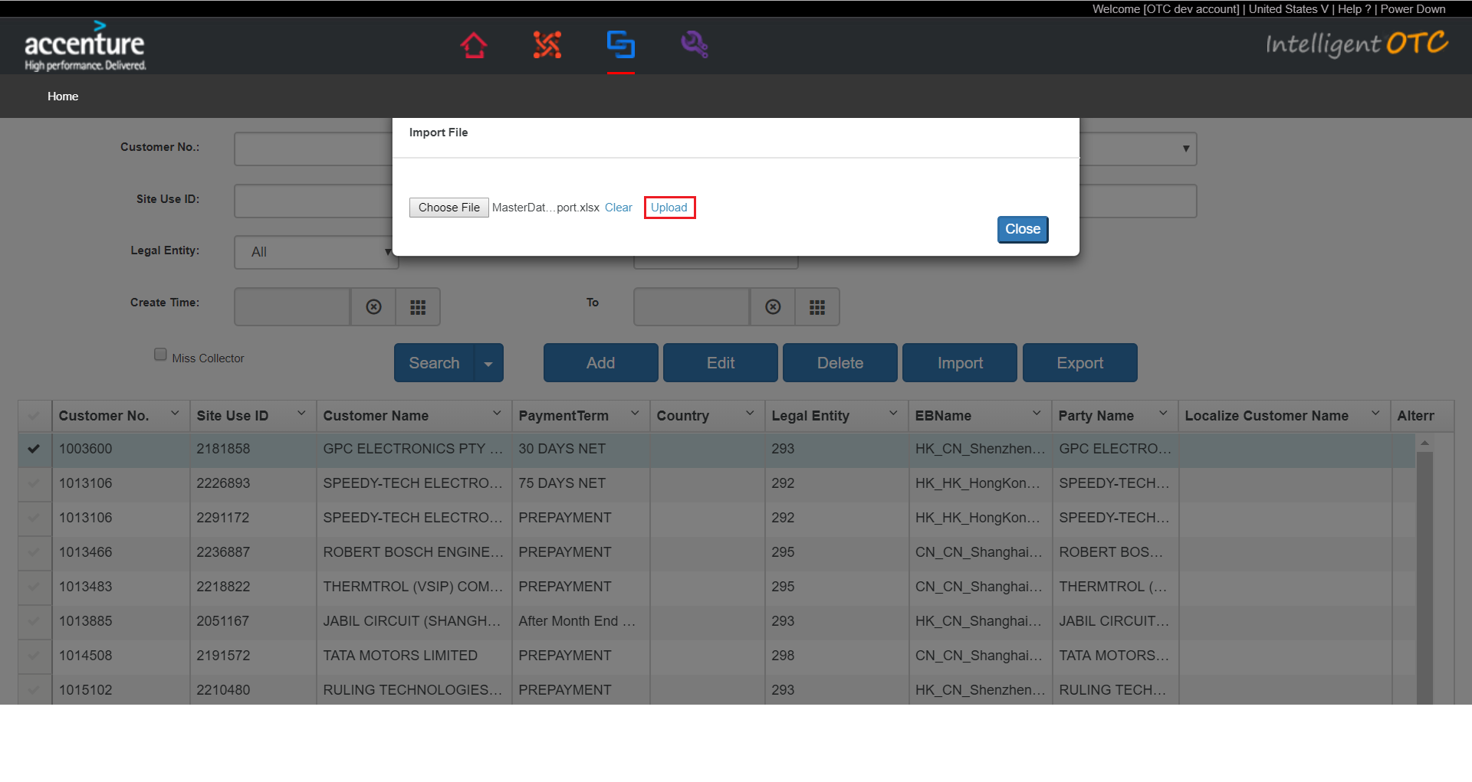

### Export Customer Master Data.

1. Input conditions.

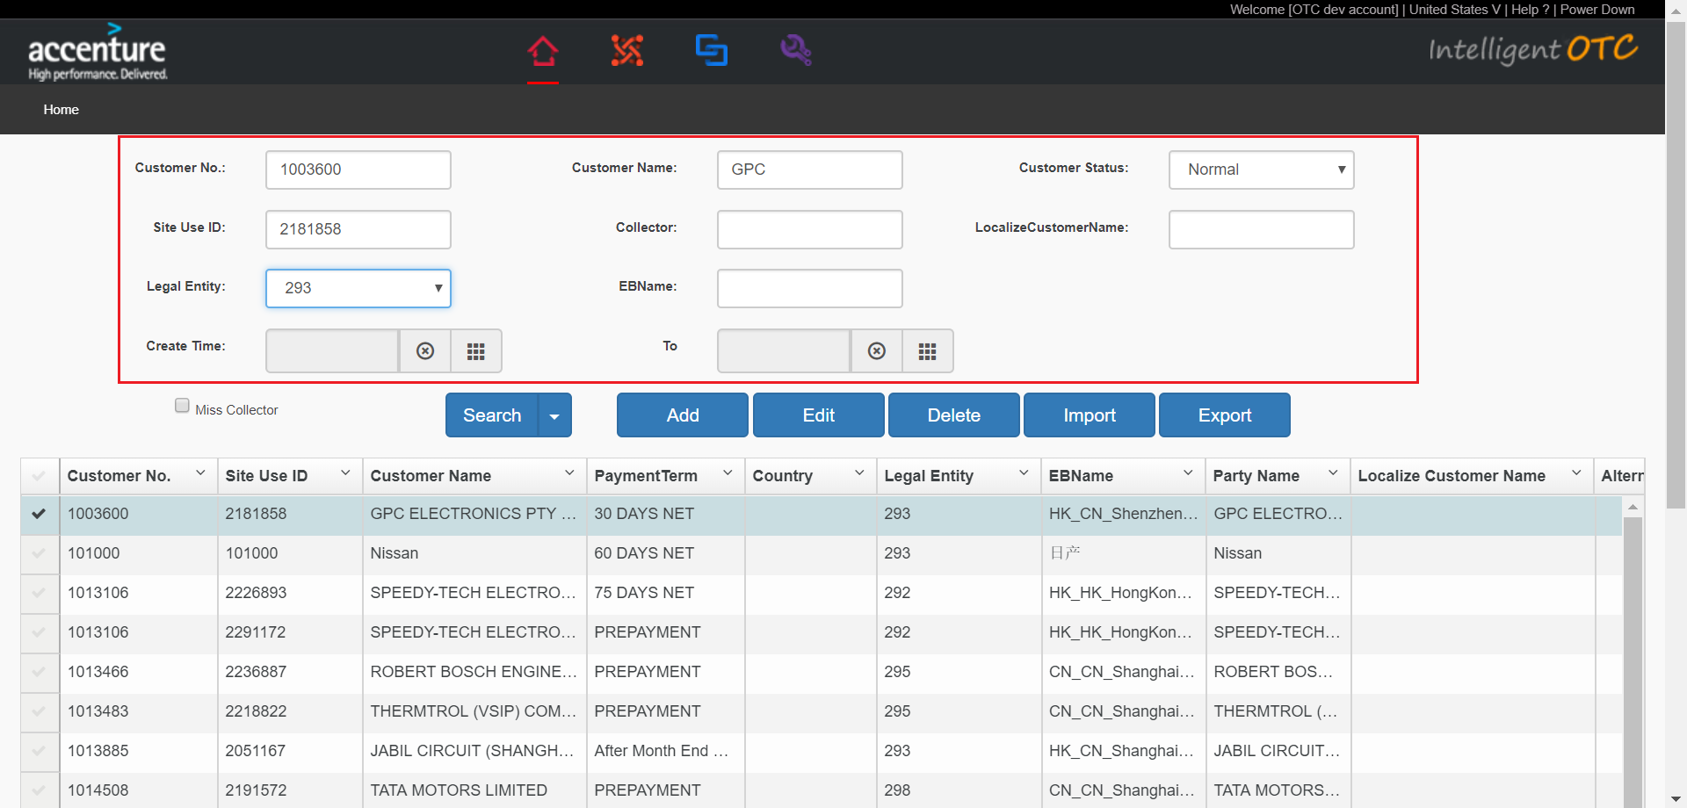

1. Click “Export” button.

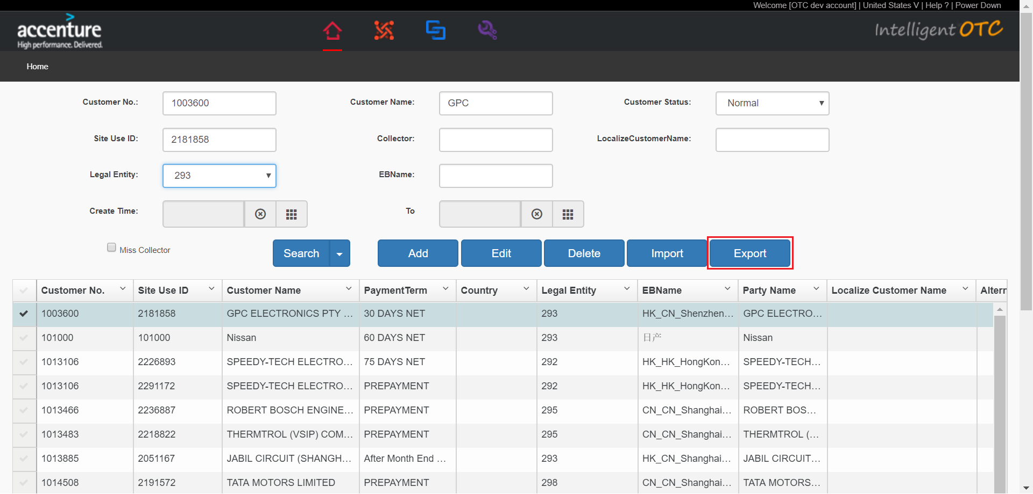

1. Click “OK” button.

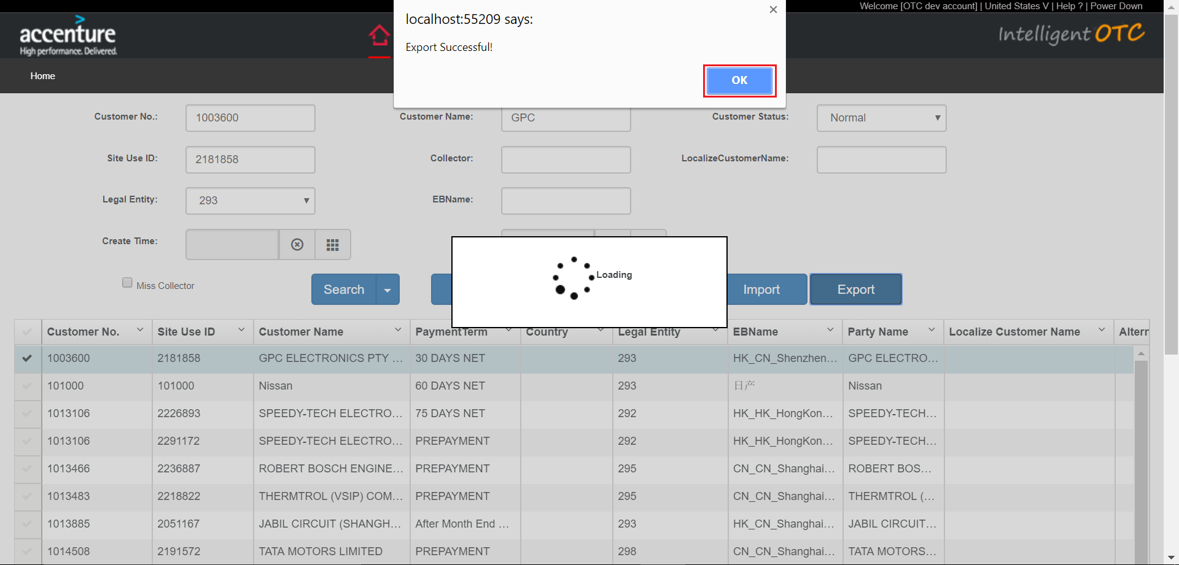

### Add Customer Master Data.

1. Click “Add” button.Add page open.

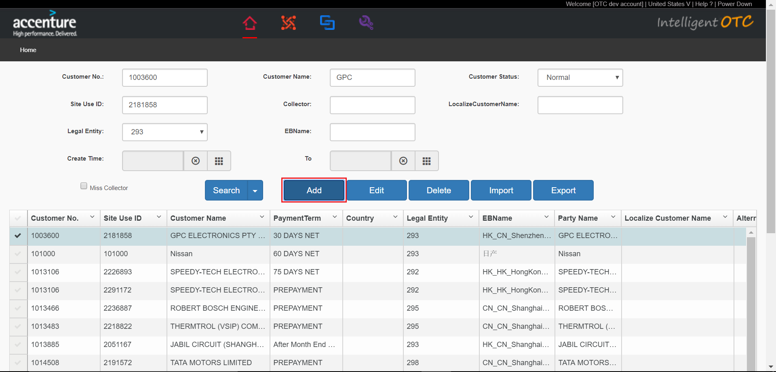

1. Add Master Data.

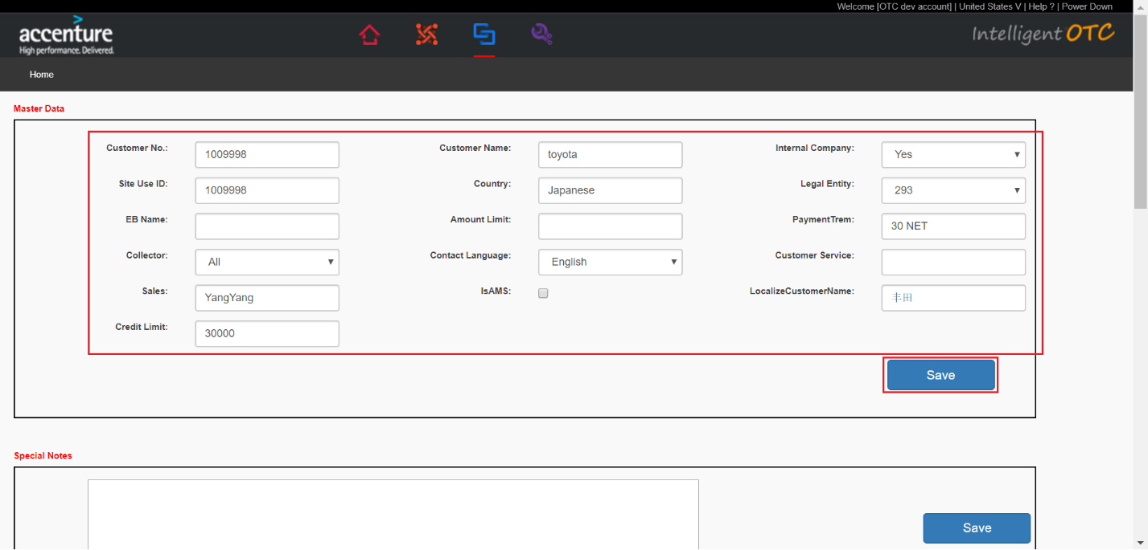

1. Add Special Notes

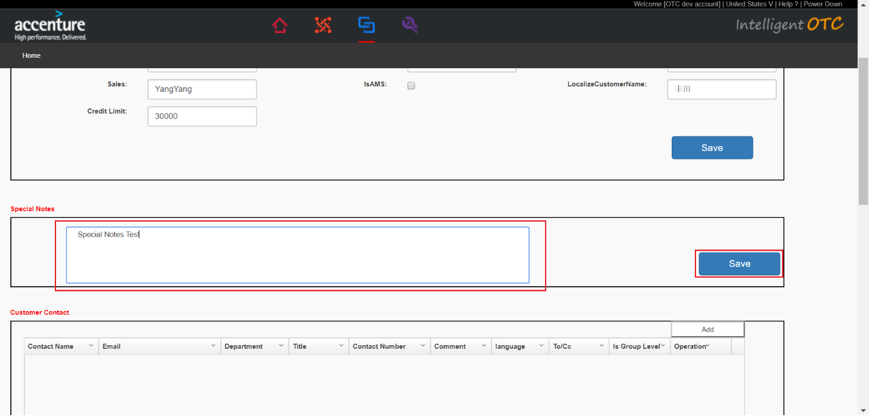

1. Customer Contacts.
   1. Add Customer Contacts.

Click “Add” button.

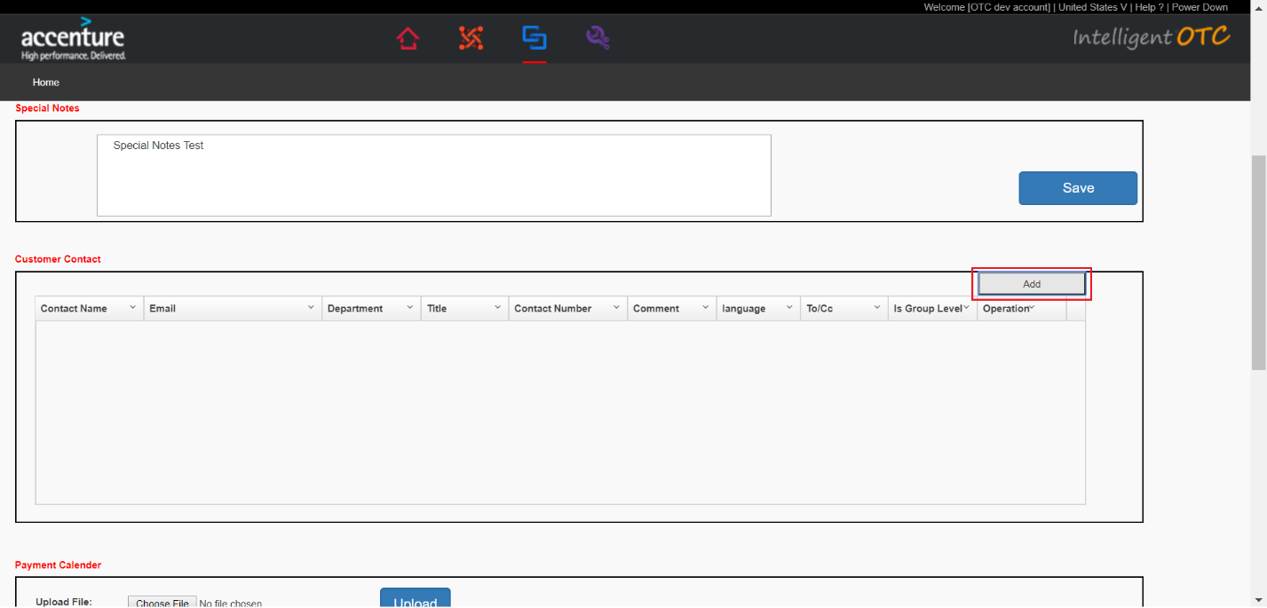

Input data and click “Save” button.

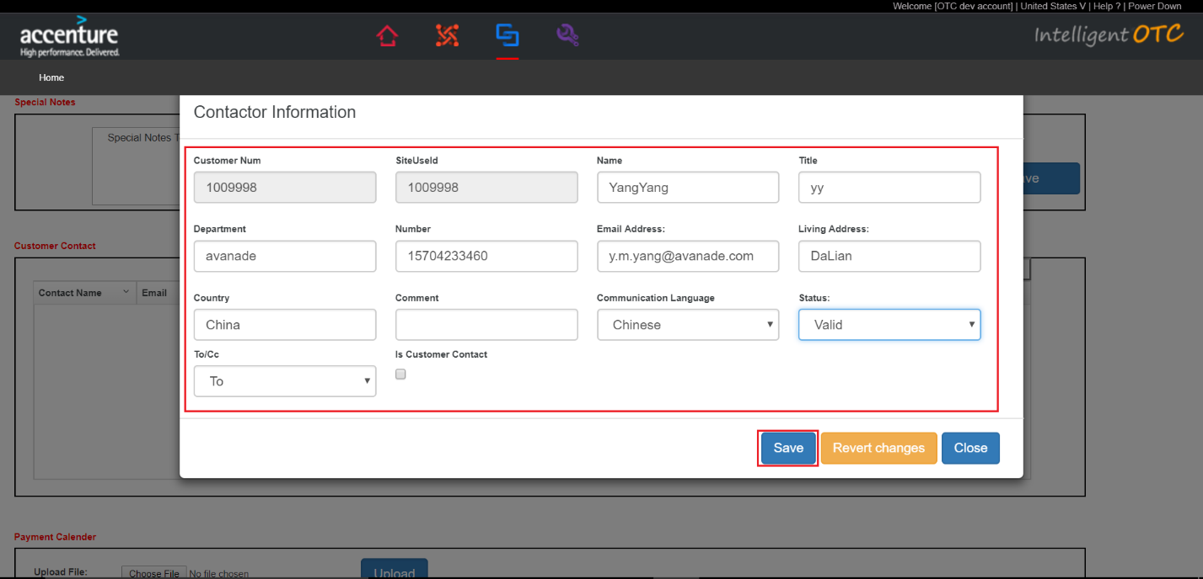

* 1. Modify Customer Contacts.

Click on the pencil icon that you want to modify the data.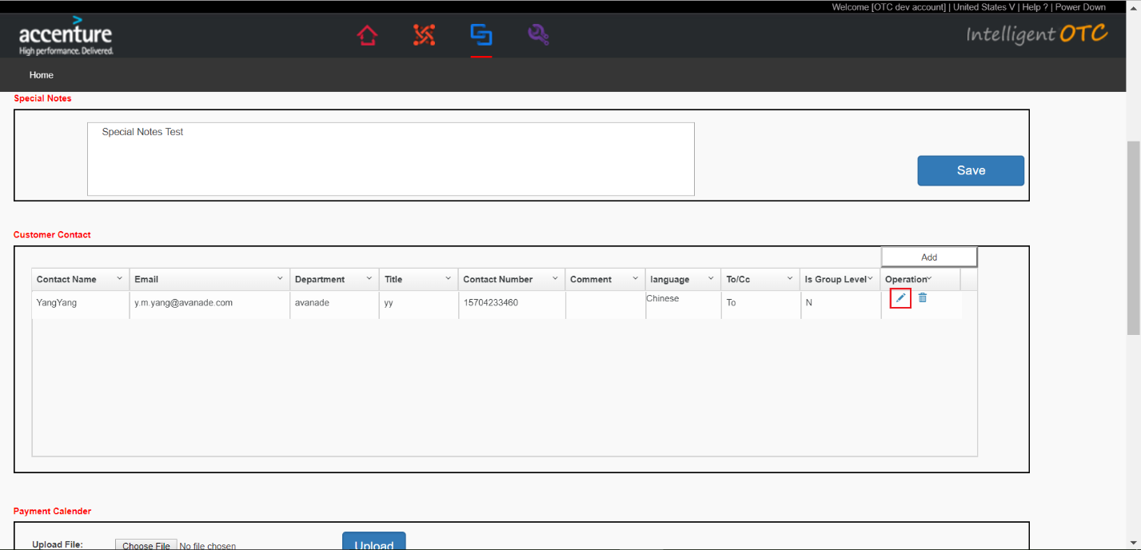Modify data and click “Save” button.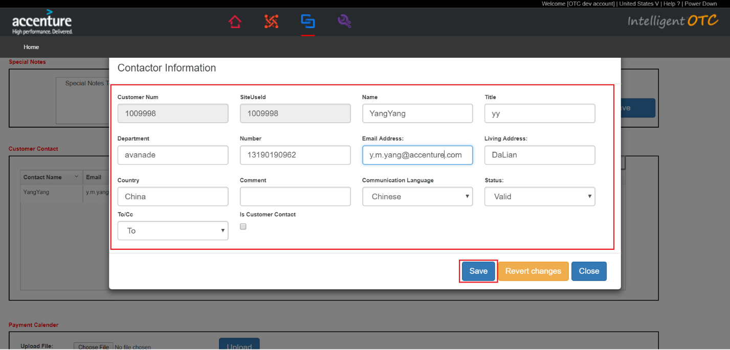

* 1. Delete Customer Contacts.

Click on the dustbin icon that you want to delete.

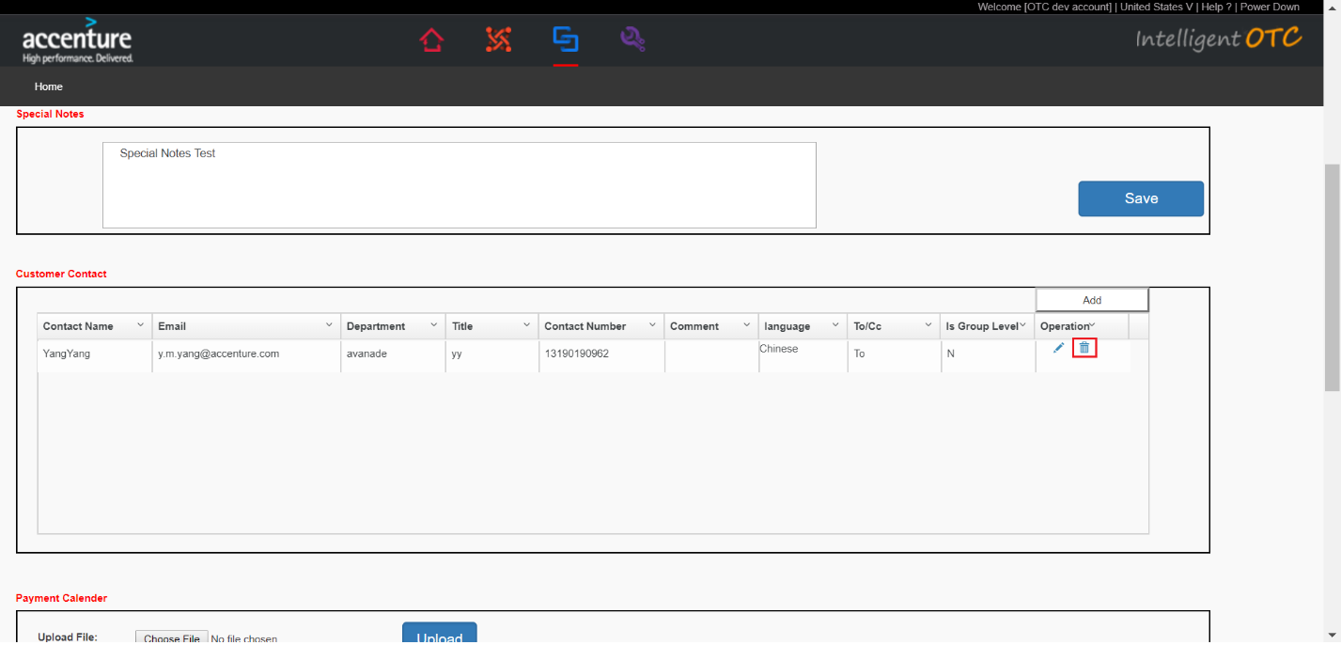

1. Payment Calender.
   1. Add Payment Calender.

Select “Reconciliation Day”.

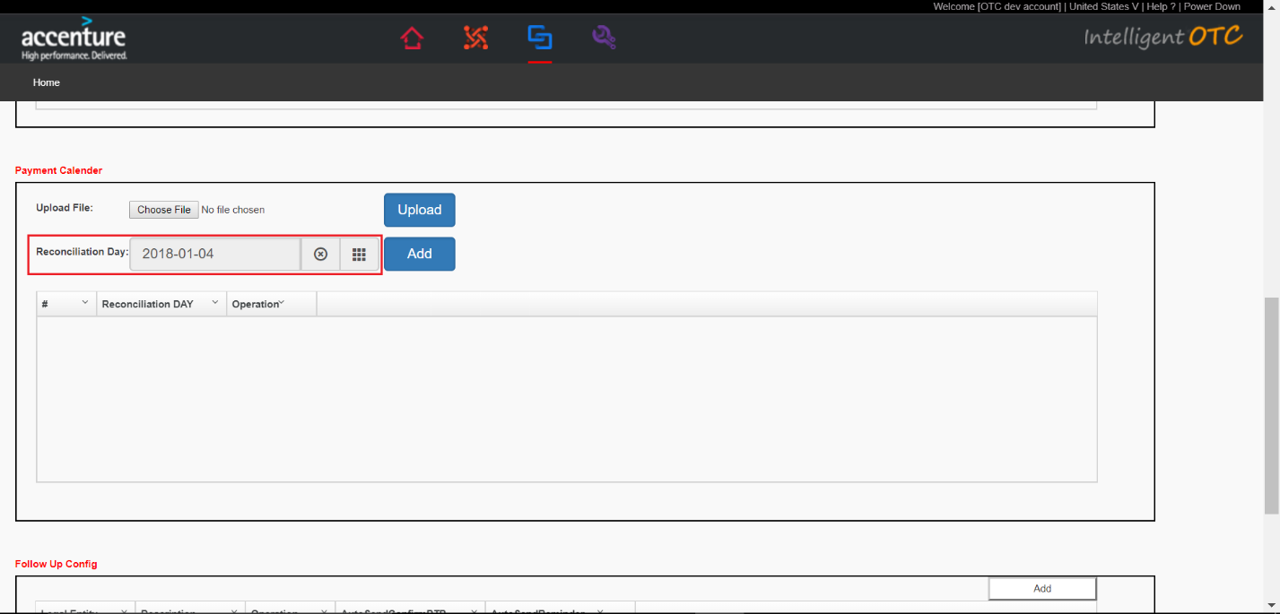

Click “Add” button.

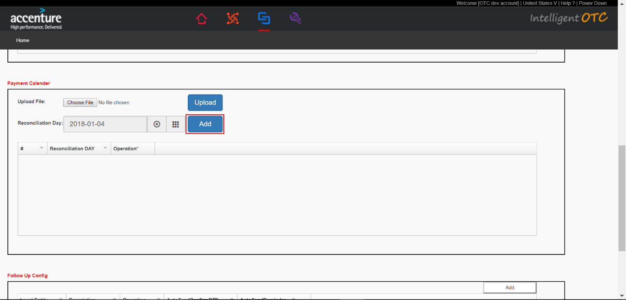

* 1. Upload Payment Calender.

Add data to the CSV file.If the current user does not need to fill in “CustomerNumber” and “SiteUseId”.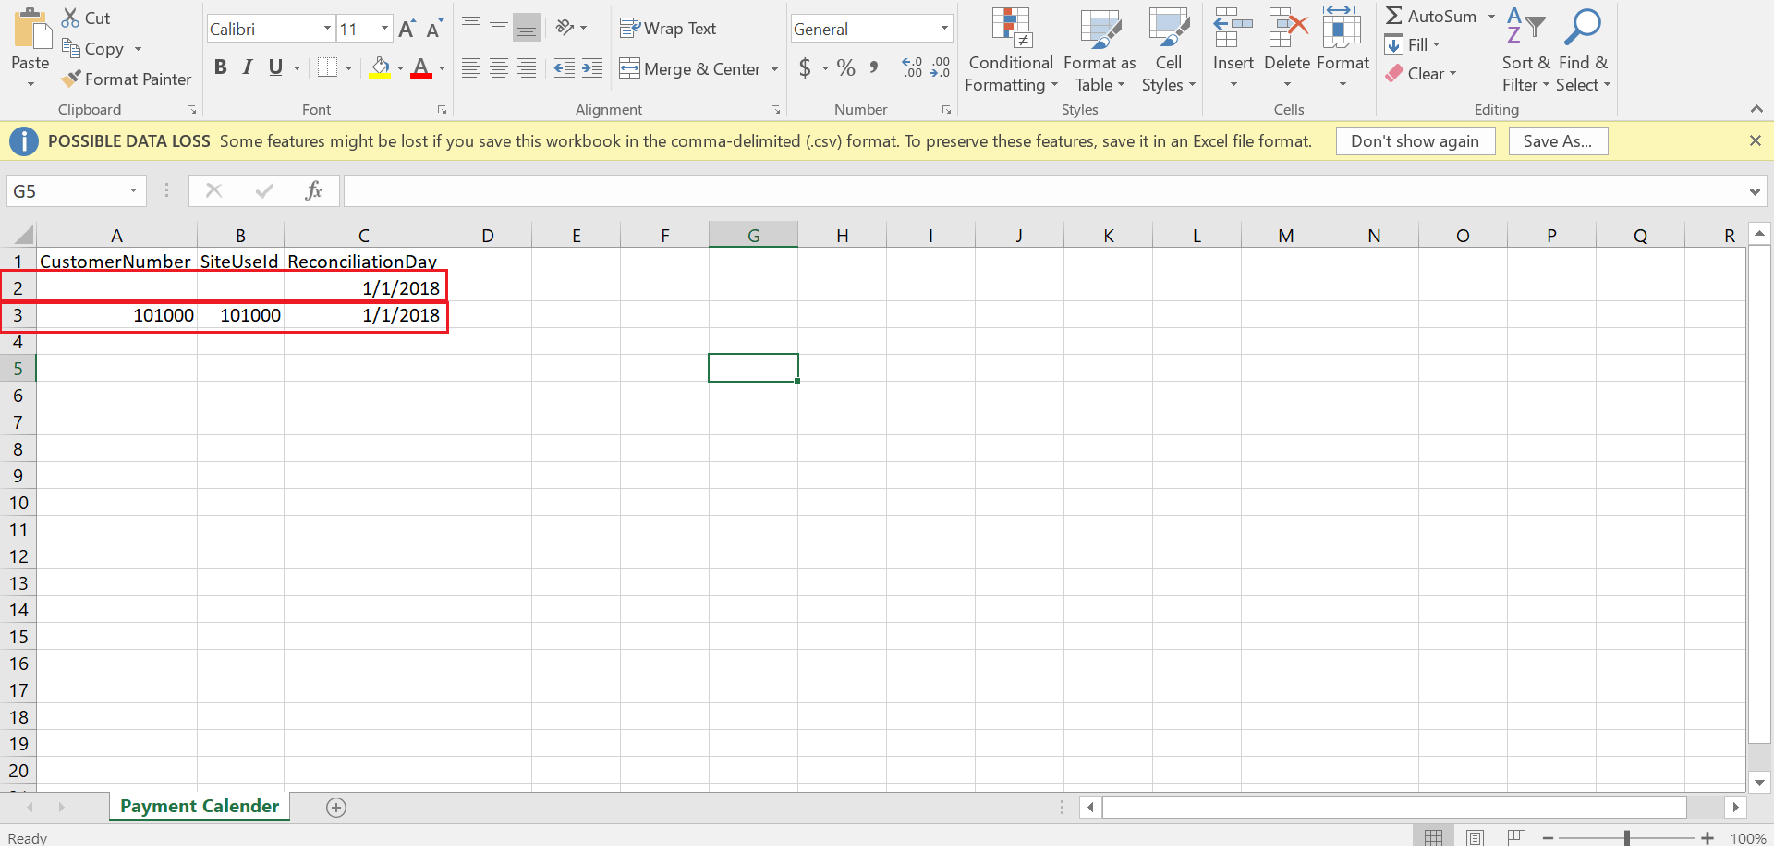

Click “Choose File” button. 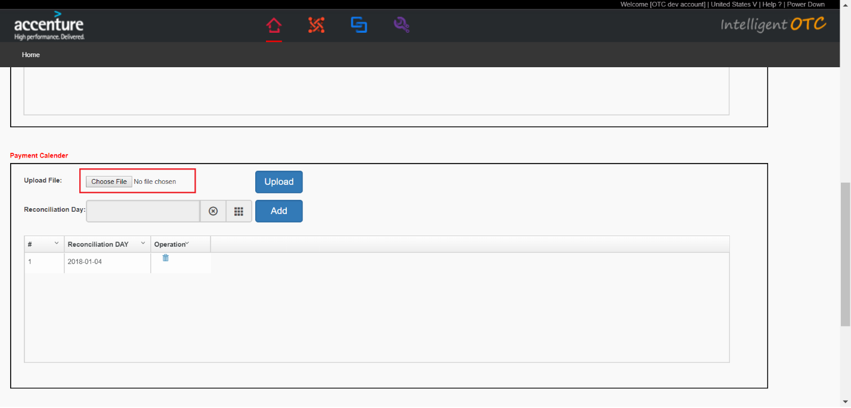

Select CSV file that adds data.

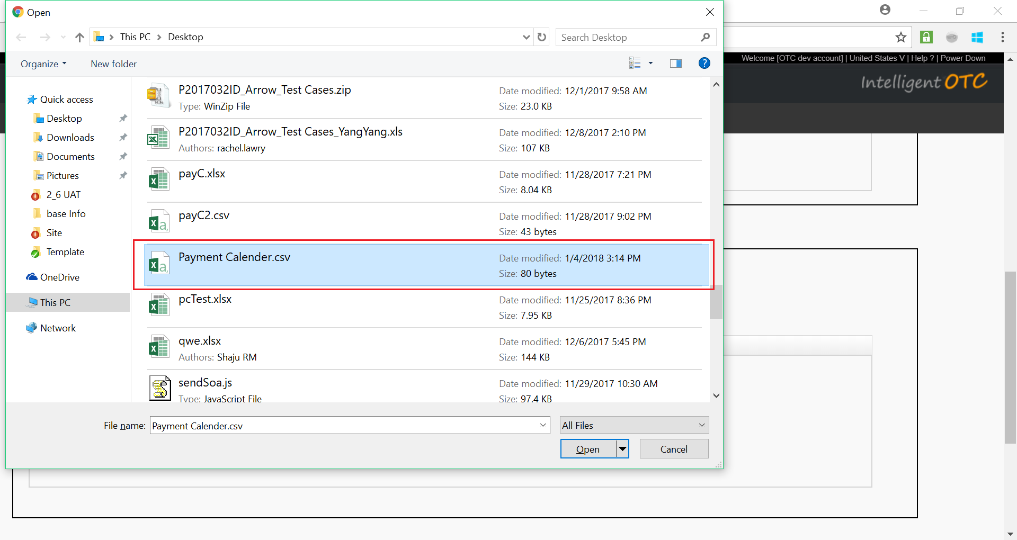

Click “Upload” button.

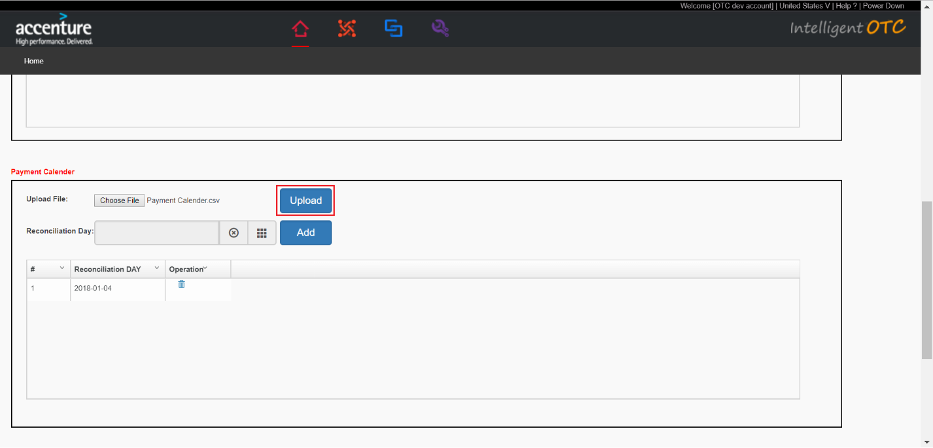

* 1. Delete Payment Calender.

Click on the dustbin icon that you want to delete.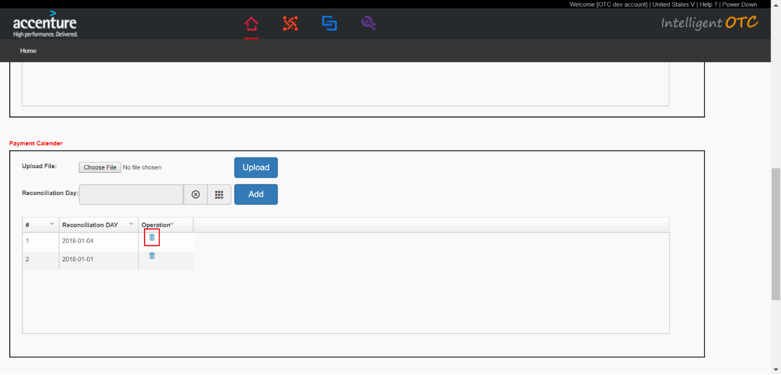

1. Follow up config
   1. Add Follow up config.

Click “Add” button.

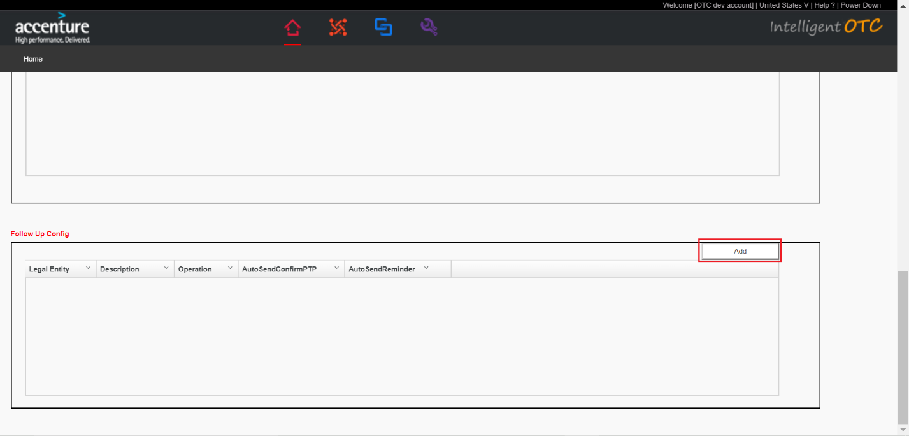

Input data and click “Save” button.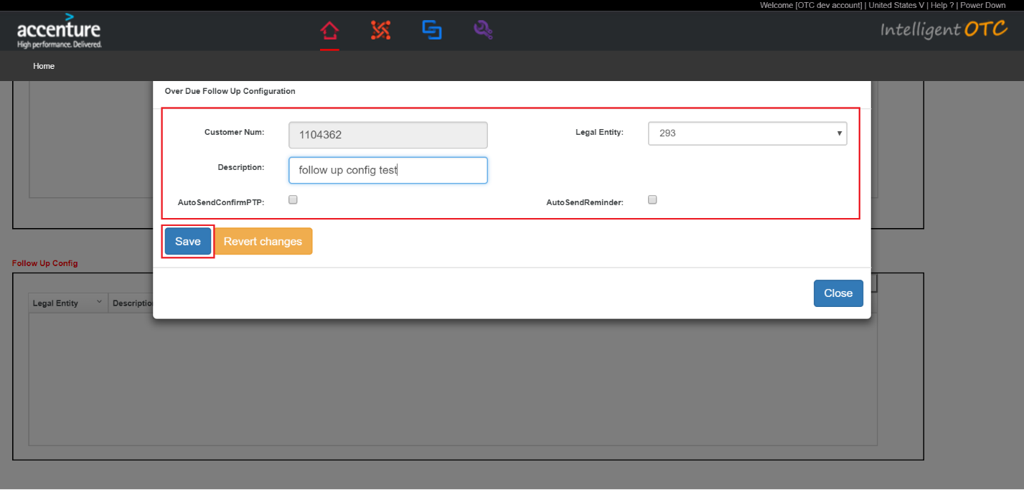

* 1. Modify Follow up config.

Click on the pencil icon than you want to modify.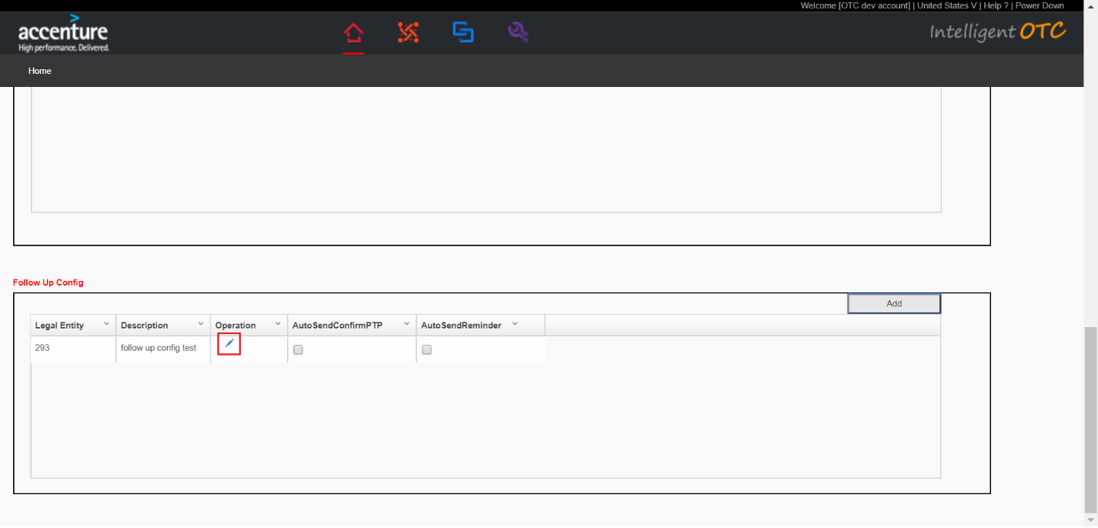

Modify data and click “Save” button.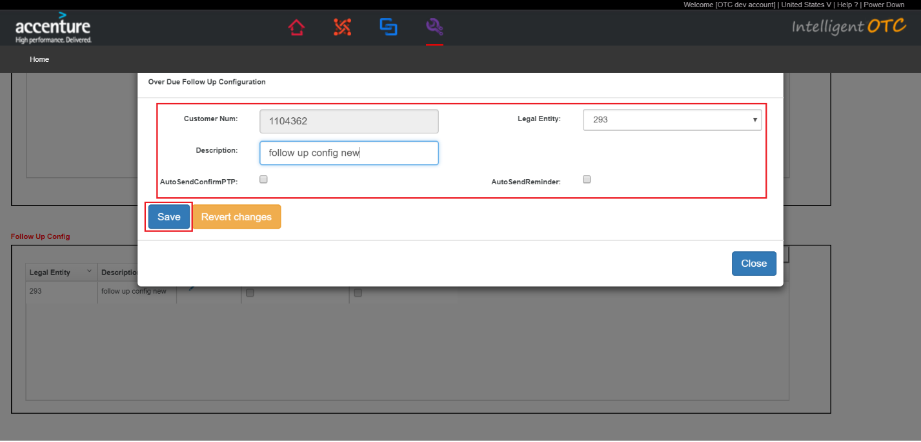

### Edit Customer Master Data.

The operation method is the same as “Add Customer Master Data”.

## User initialization

### Grant Mail Access

Input data and click “Submit” button.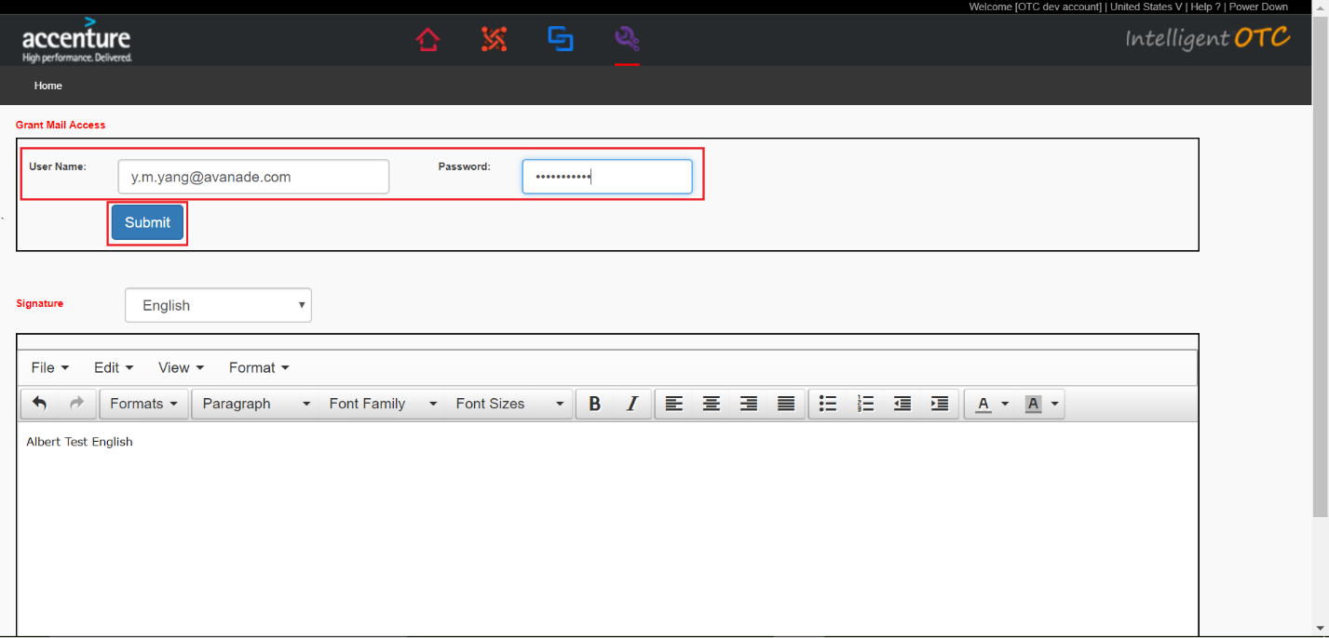

### Set signature.

Select “signature”.

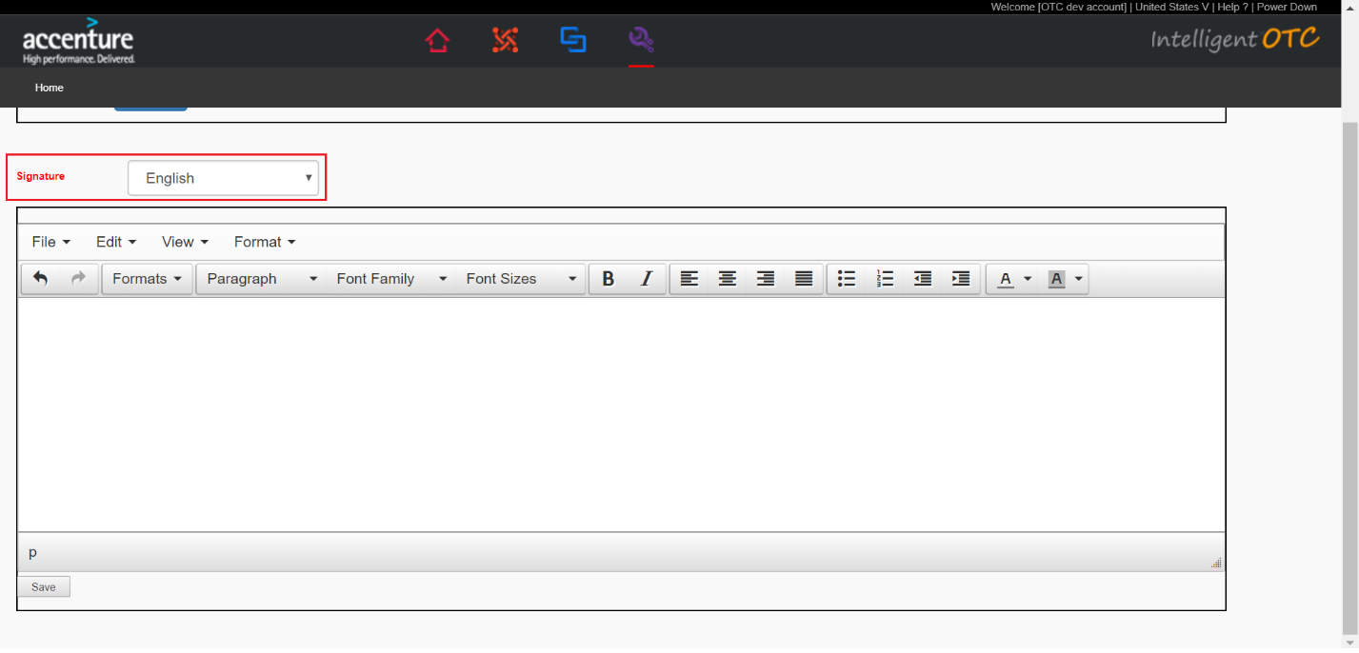

Input signature content and click “Save” button.

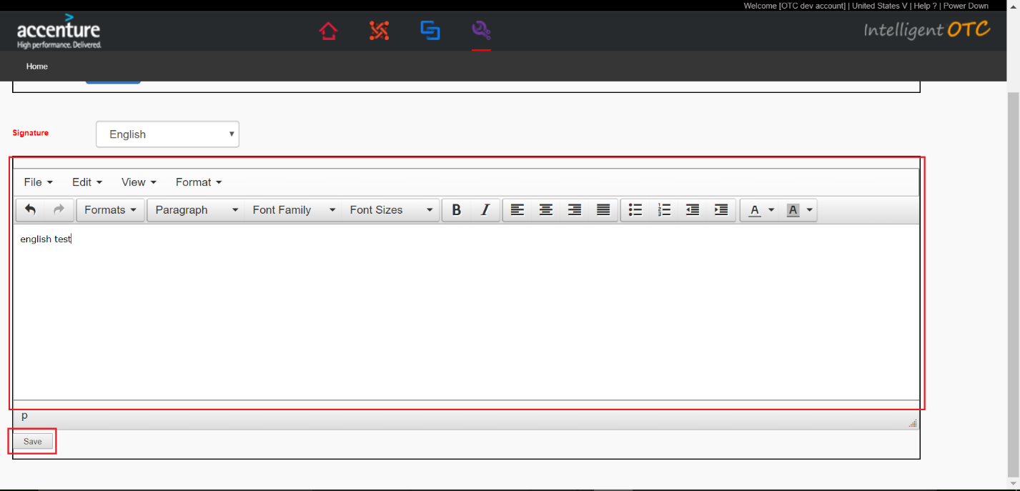

## Dashboard

### Confirm PTP

Wait For Send and Sent Email.

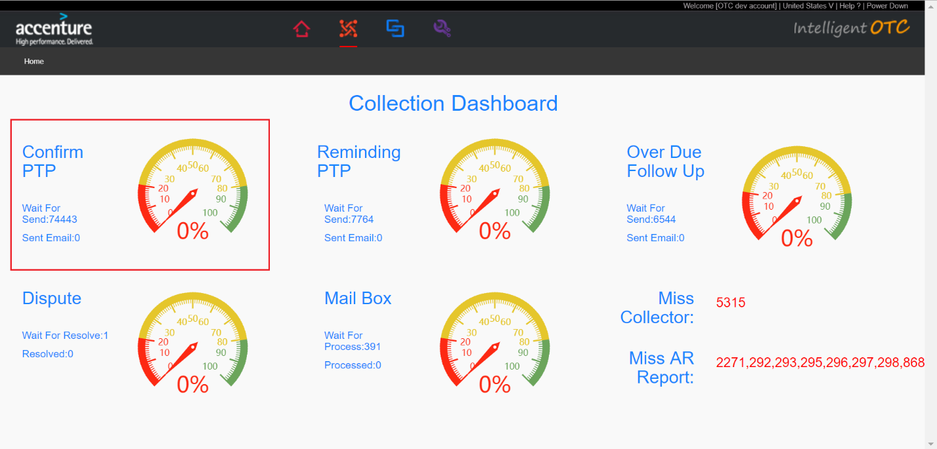

### Reminding PTP

Wail For Send and sent Email.

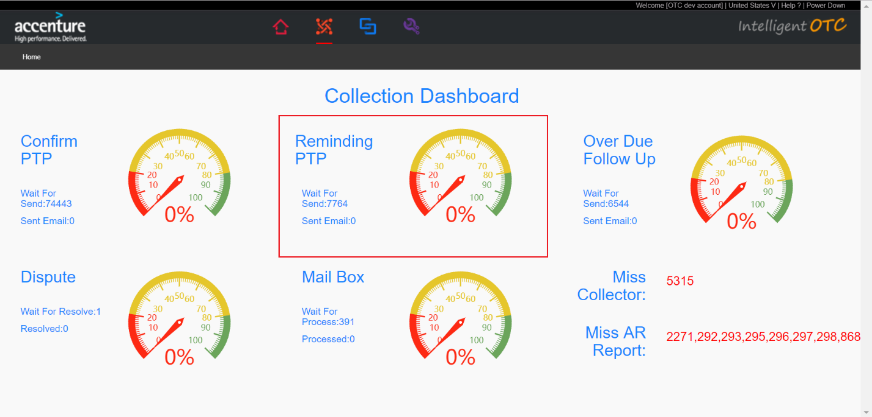

### Over Due Follow Up

Wait For Send and Sent Email

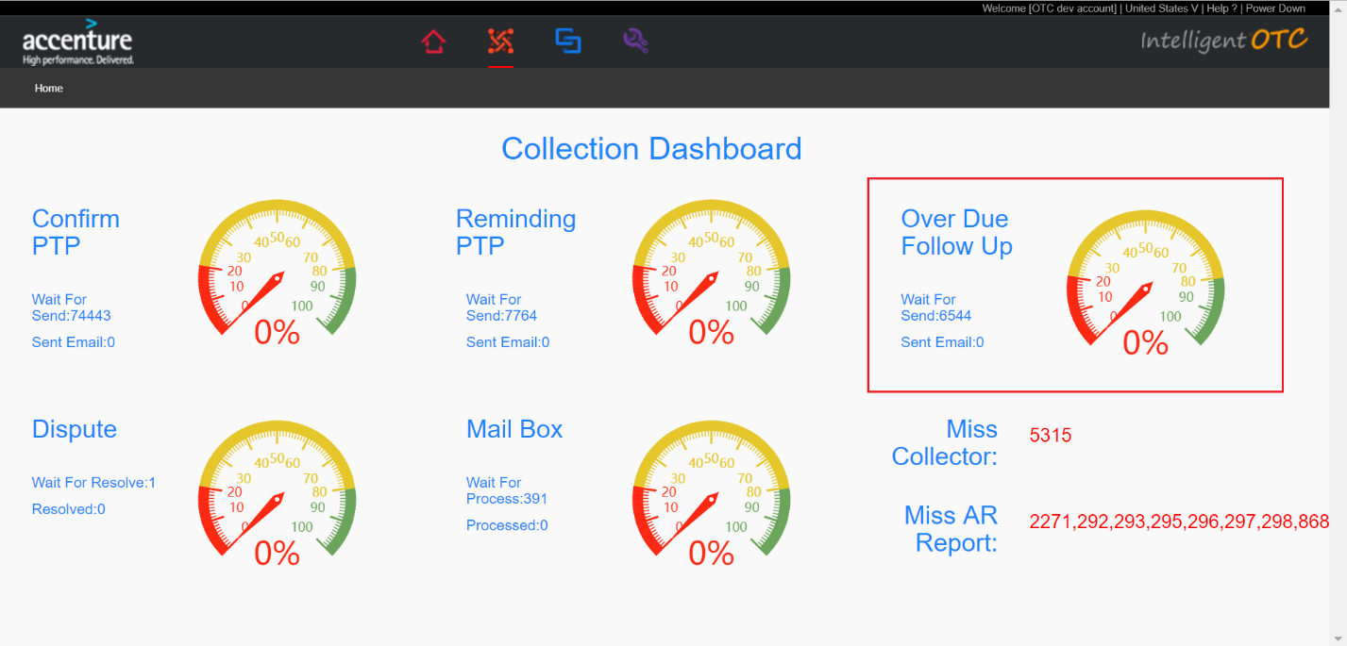

### Dispute

Wait For Resolve and Resolved.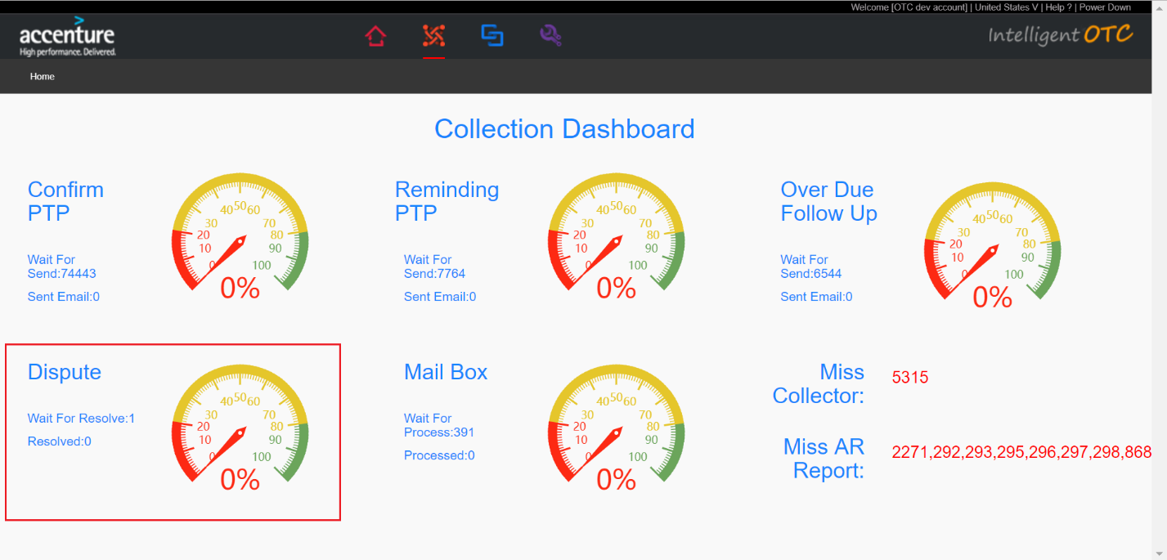

### Mail box

Wait For Process and Processed.

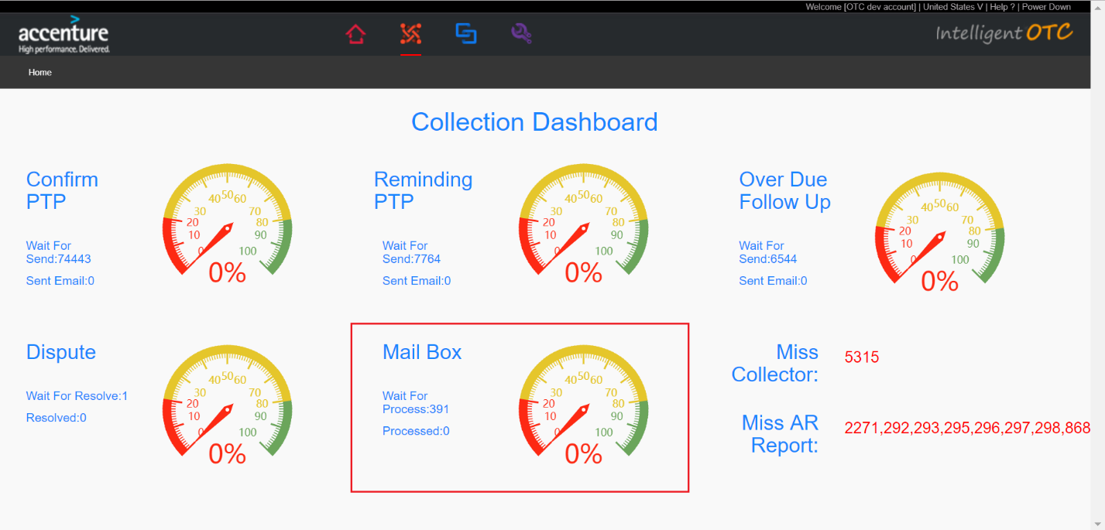

### Miss Collector

Customer master data is missing the collector.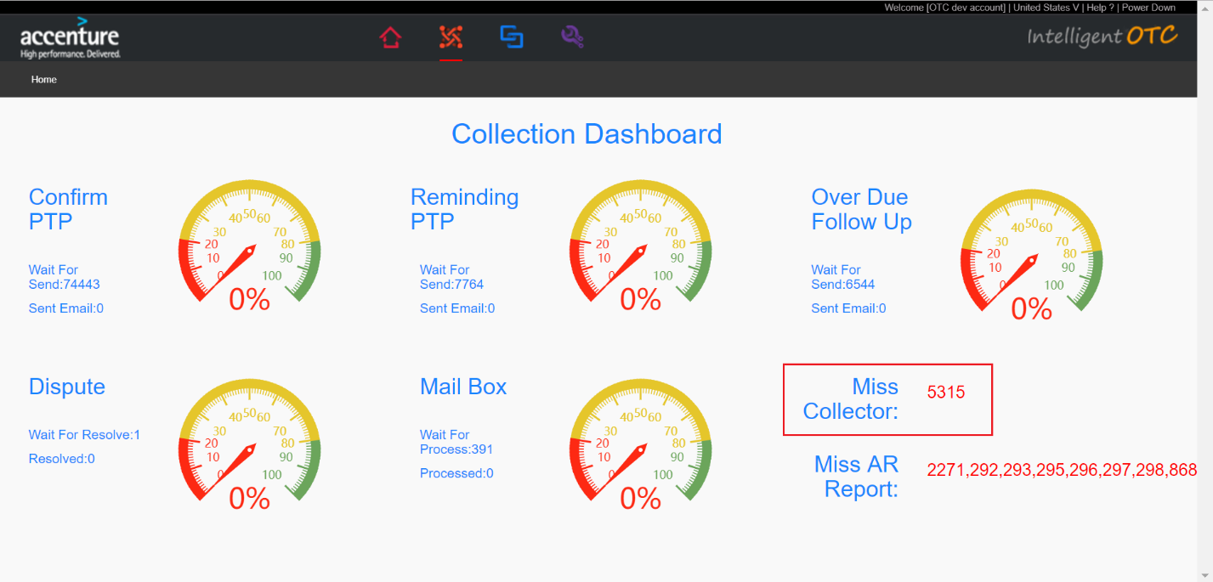

### Miss AR Report

Legal Entitys of Miss AR Report.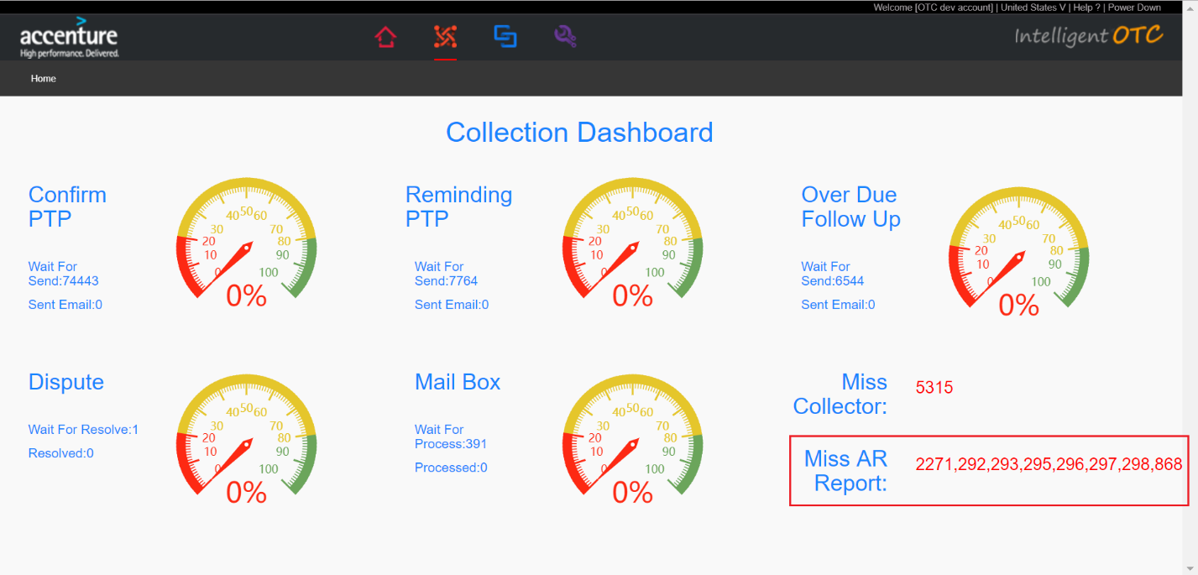

## Data preparation

### Account Level File and Invoice Level File Upload

1. These two CSV files need to match uploads.

Files name rule,

Account Level File:AR_Legal_summary-currentDate.csv,like ‘AR_296_summary-20180105.csv’.

Invoice Level File:AR_Legal_detail-currentDate.csv,like’AR_296_detail-20180105.csv’.

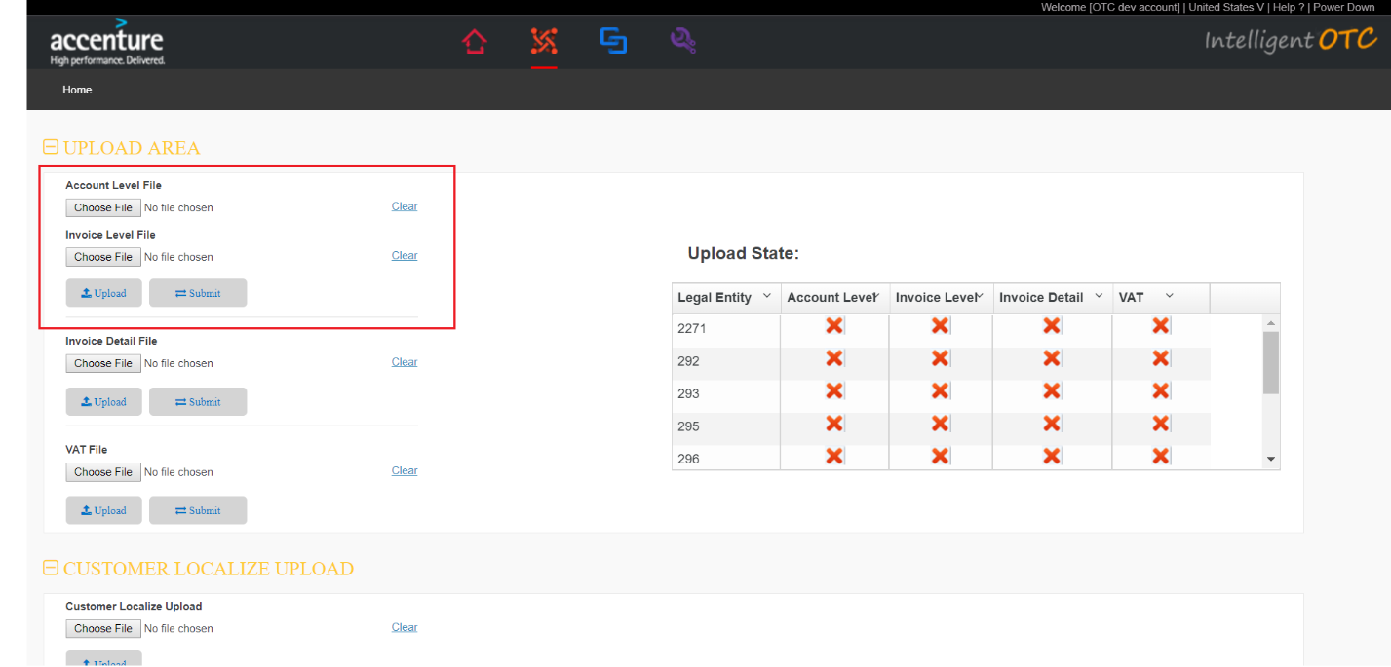

1. Select Account Level File.

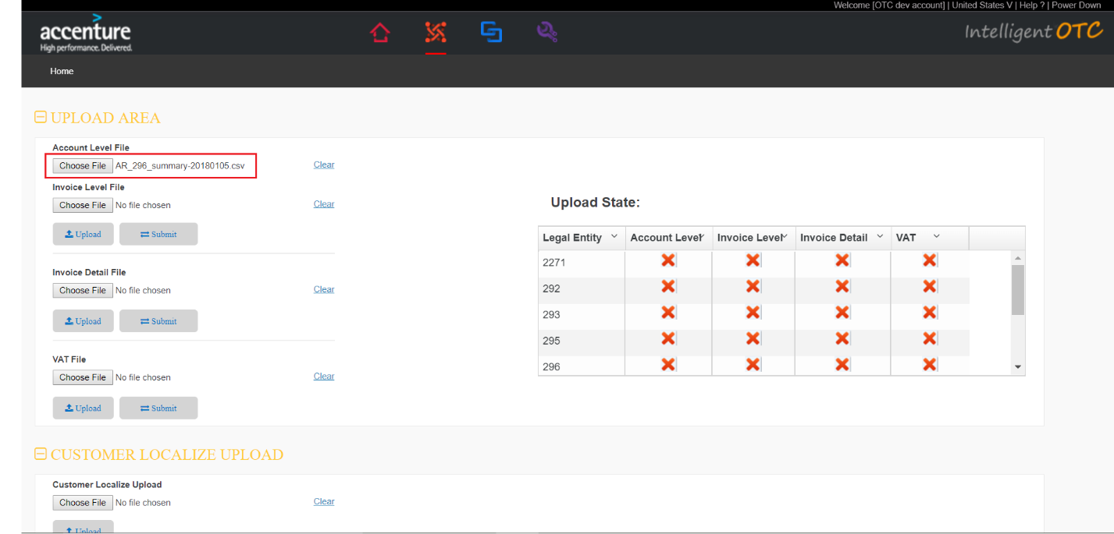

1. Select Invoice Level File.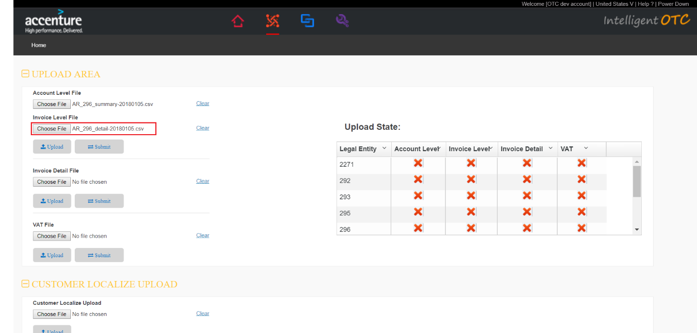
2. Click ”Upload” button.

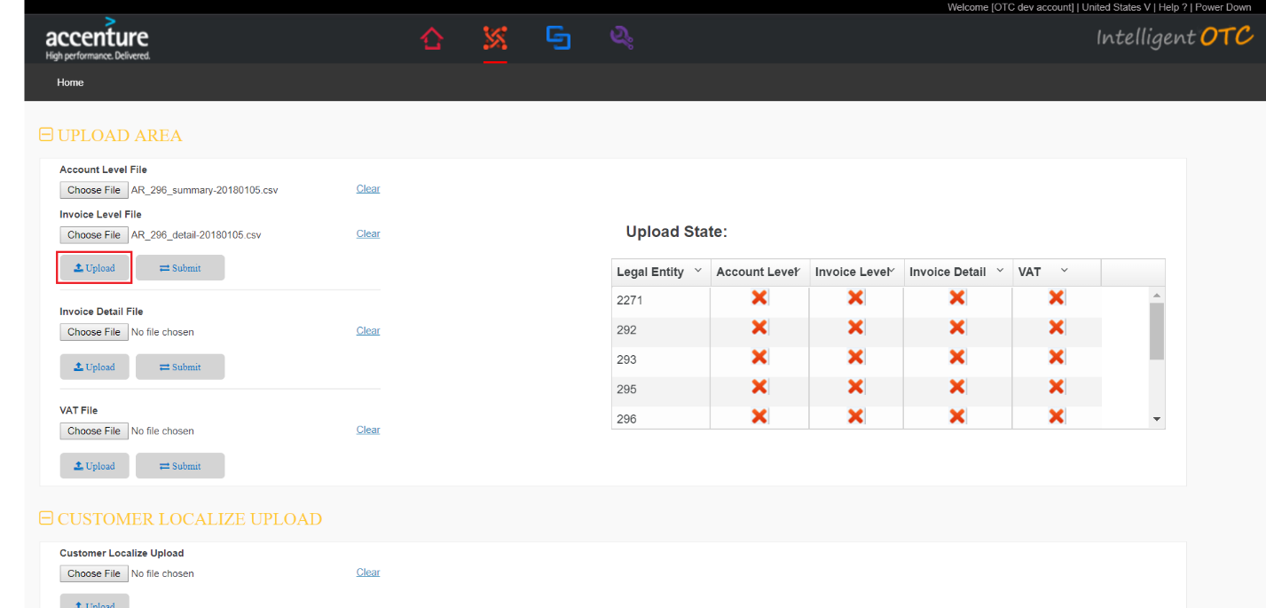

1. Select “Aging Report”.You can view the data to be uploaded.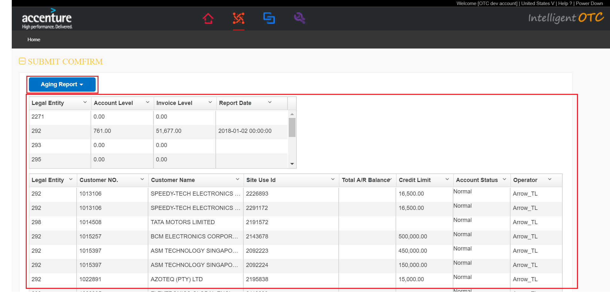
2. Click “Submit” button.The values of the Account Level and Invoice Level columns of the list of Upload State are cuntermark.indicationg that the corresponding Legal Entity has been uploaded successfully.

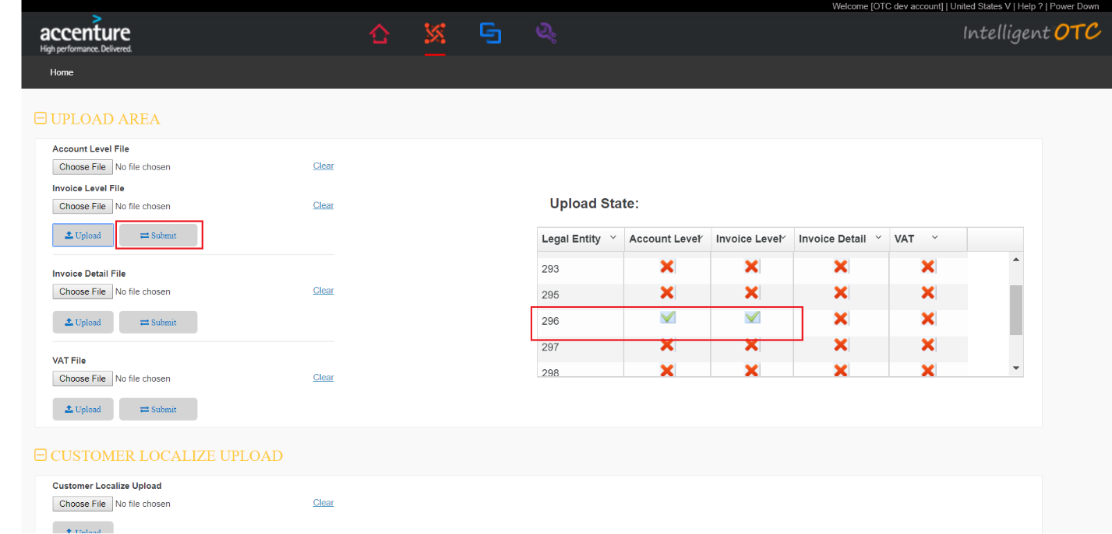

### Invoice Detail File Upload

1. Select Invoice Detail File.file name rule,accenture_invoice.csv.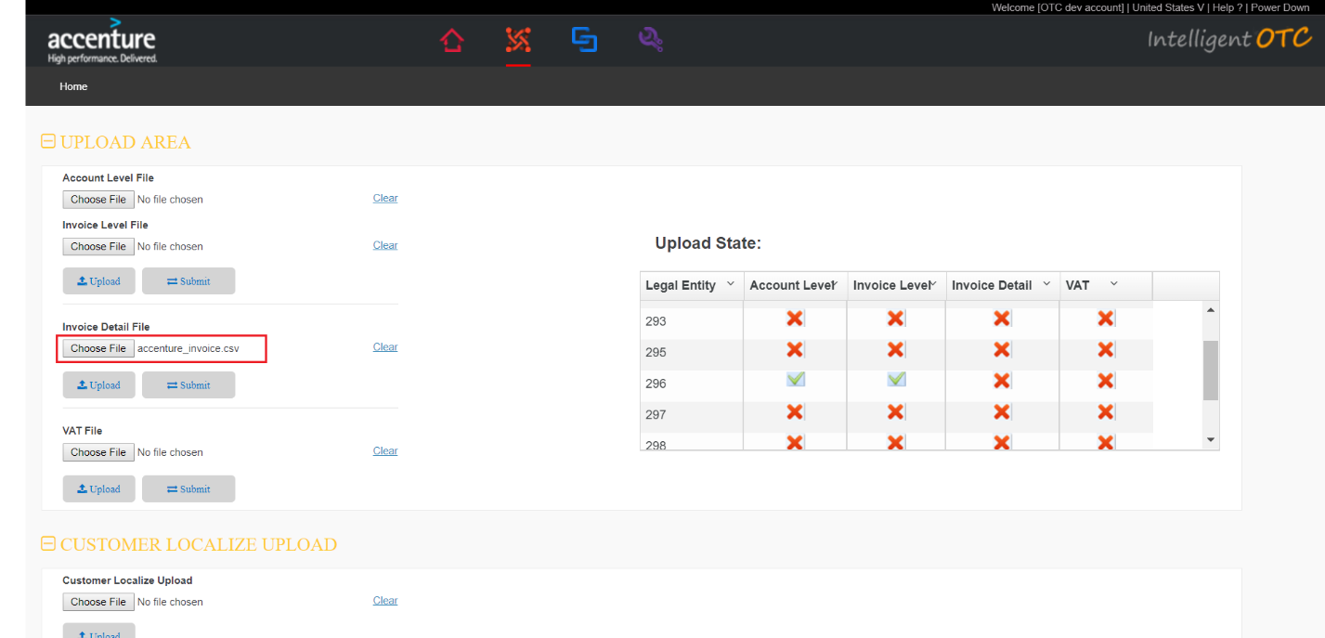
2. Click “Upload” button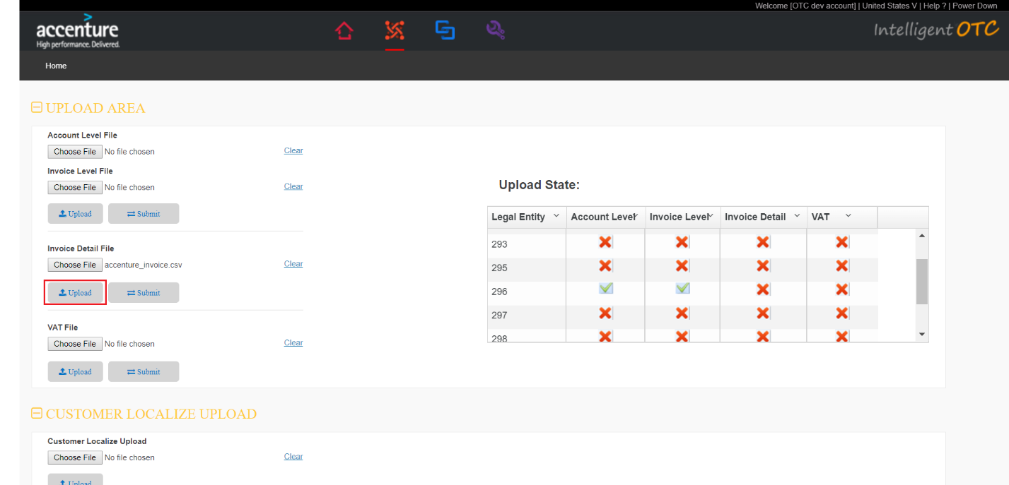
3. Select “Invoice Detail File”.You can view the data to be uploaded 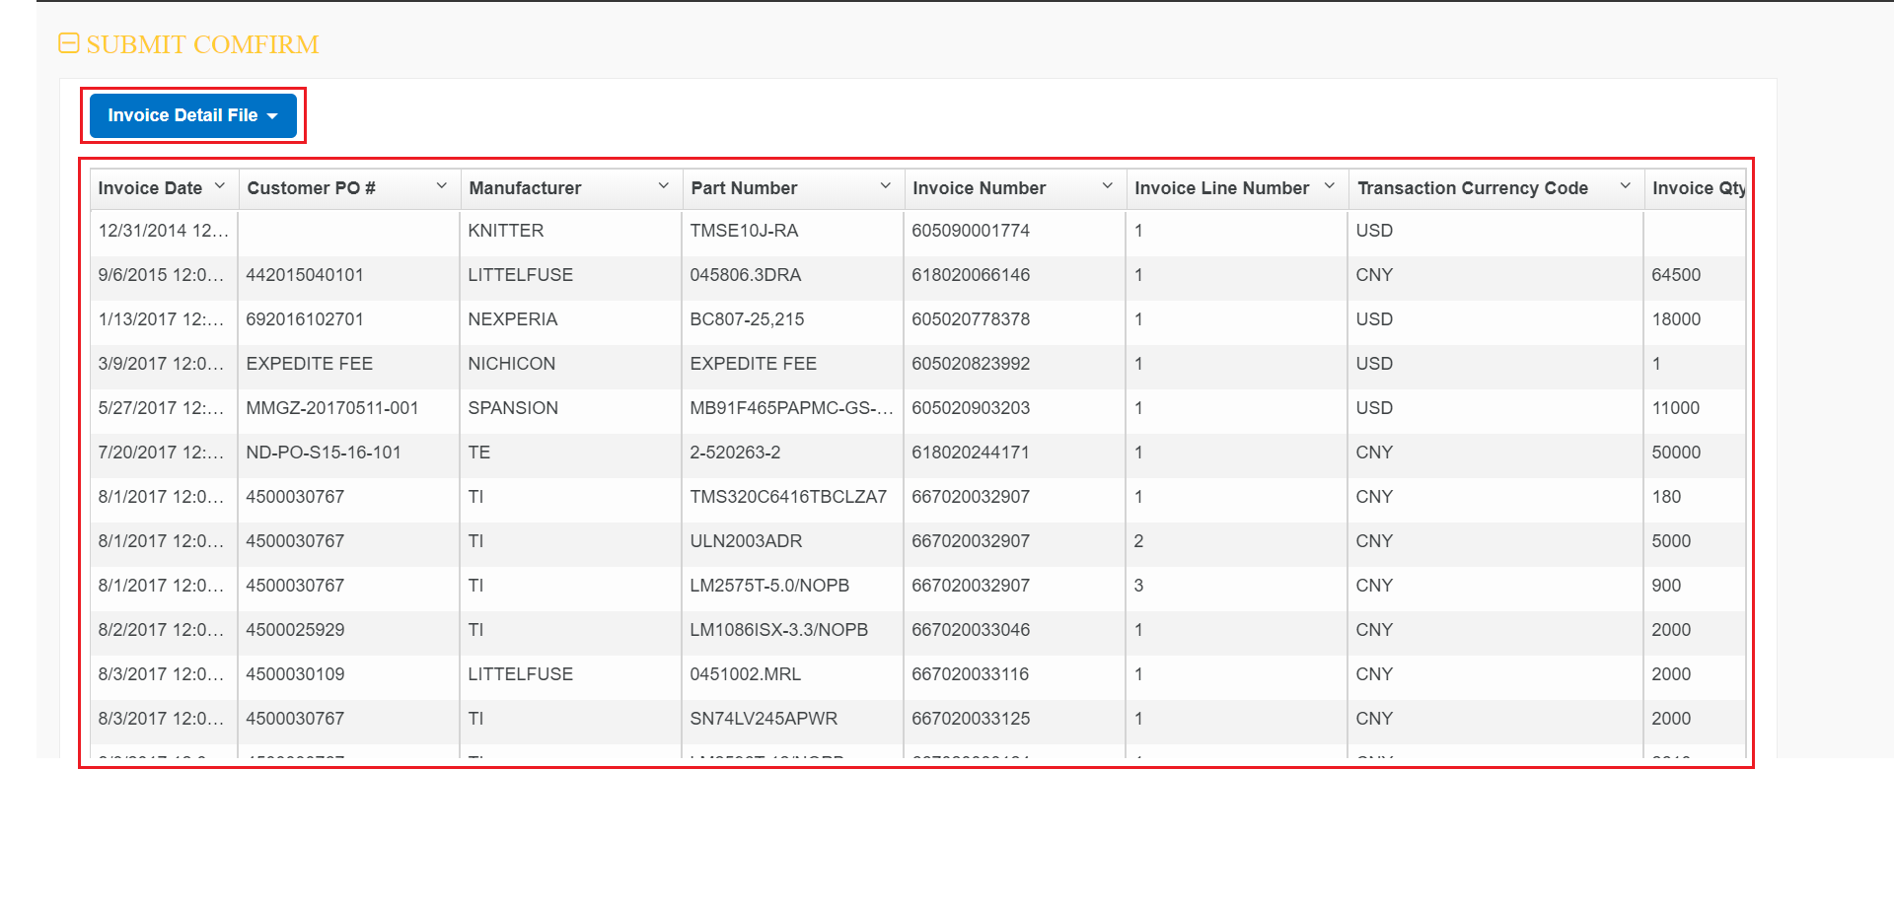
4. Click “Submit” button.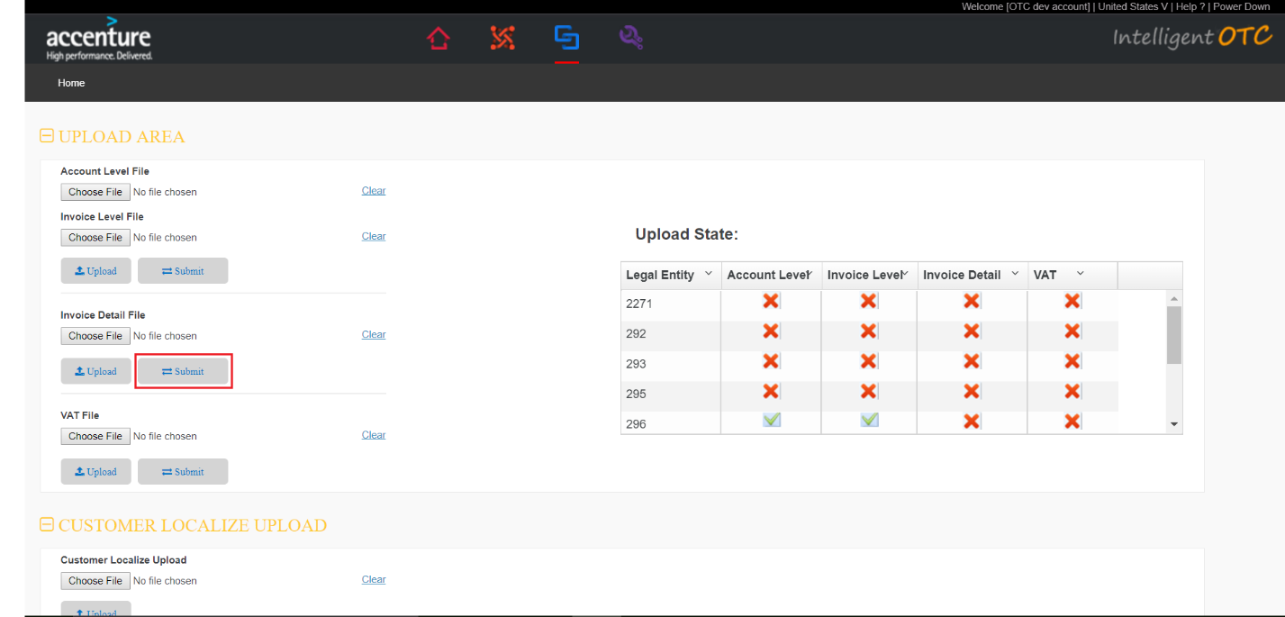

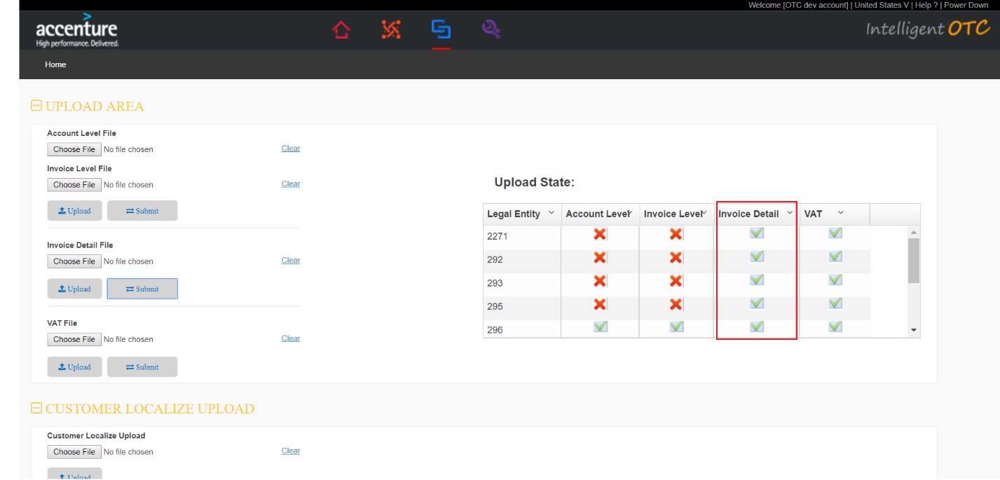

### VAT File upload

1. Select VAT File.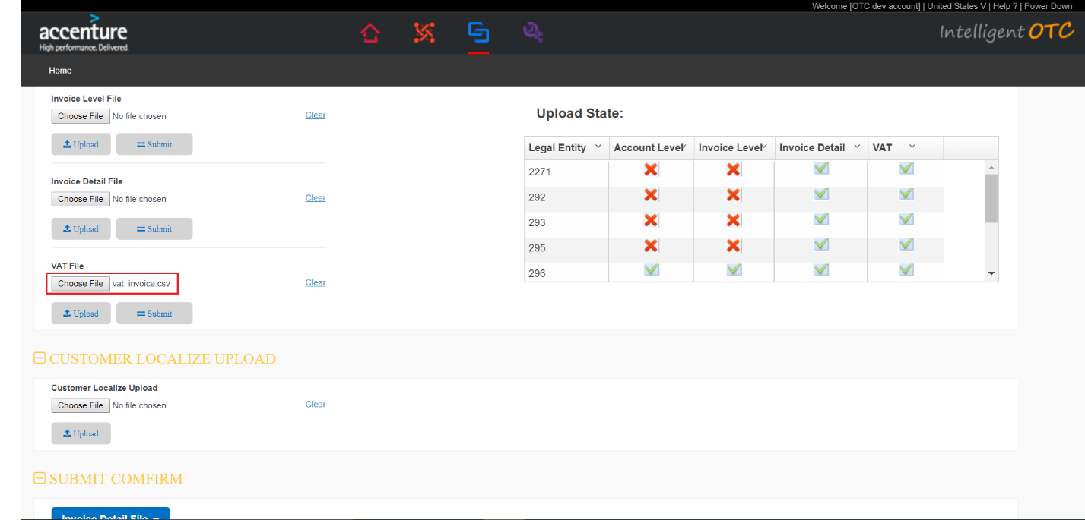
2. Click “Upload” button.

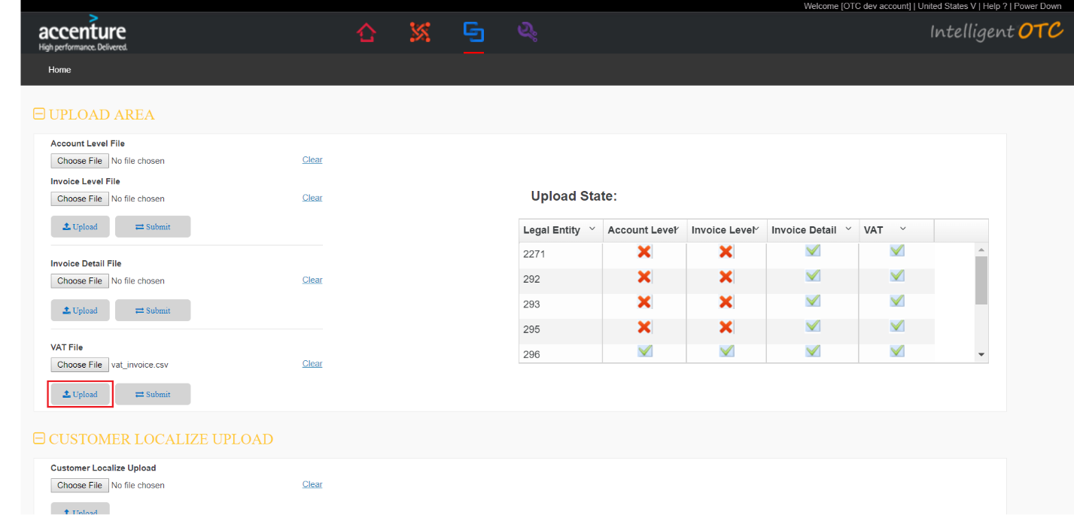

1. Select “Vat File”.You can view the data to be uploaded.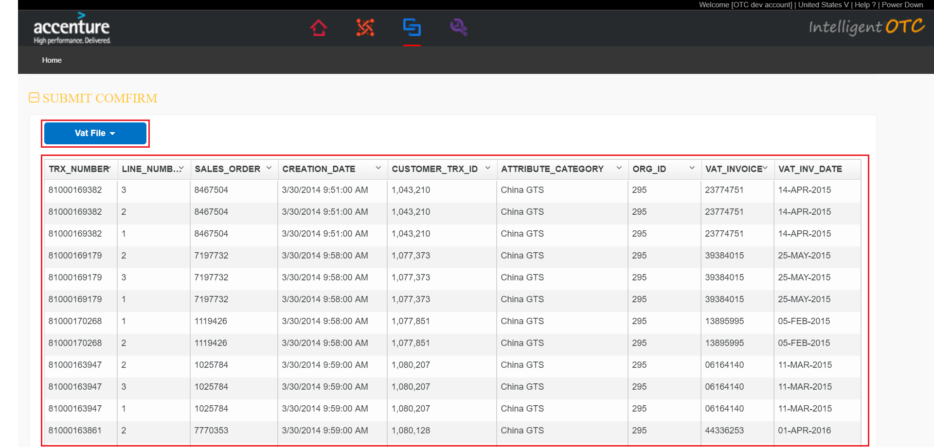
2. Click “Submit” button.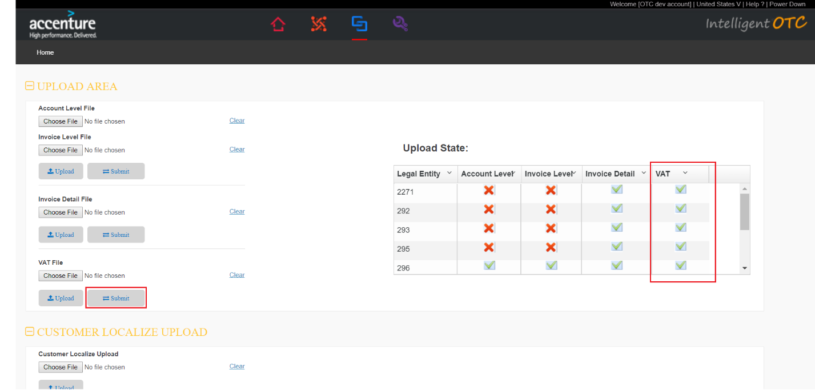

### Customer Locailize Upload

1. Select Customer Locailize file.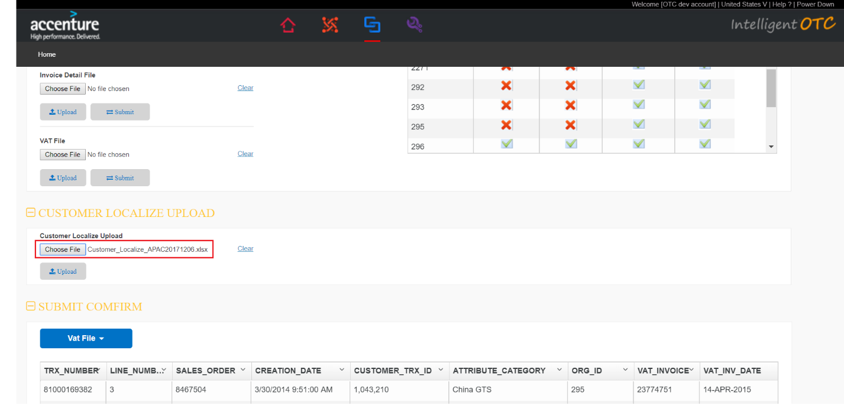
2. Click “Upload” button.

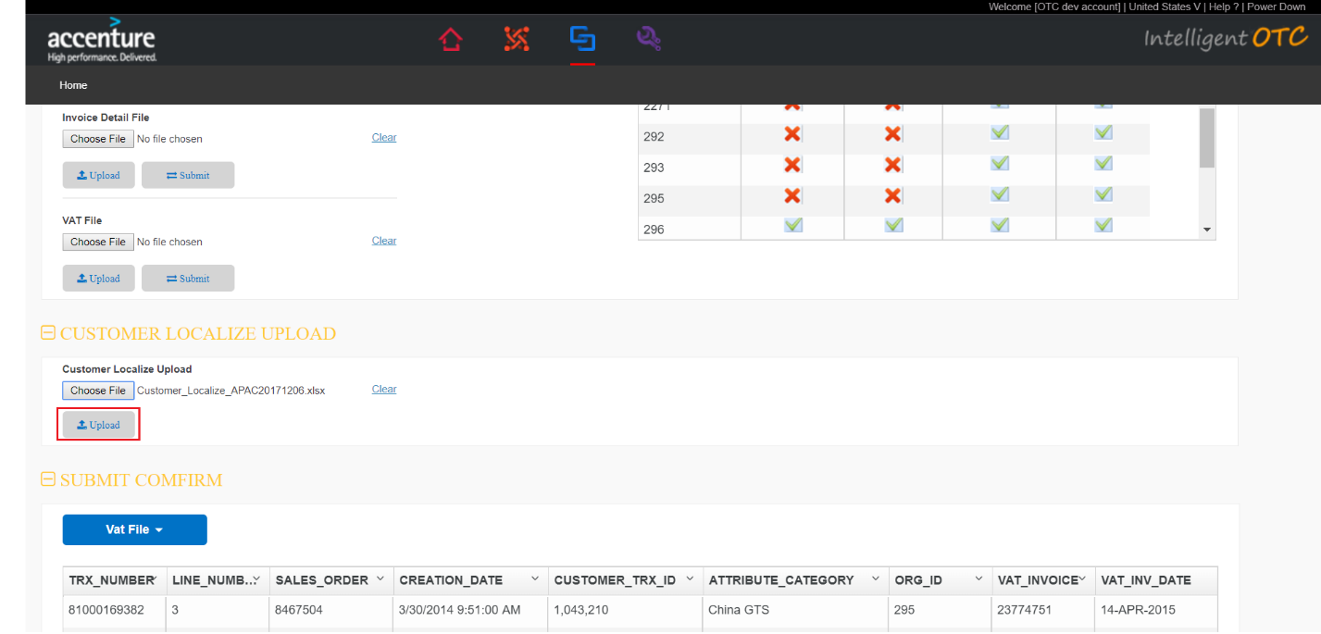

### Upload History

1. Query Upload History.

Select Upload Date and click “Search” button.

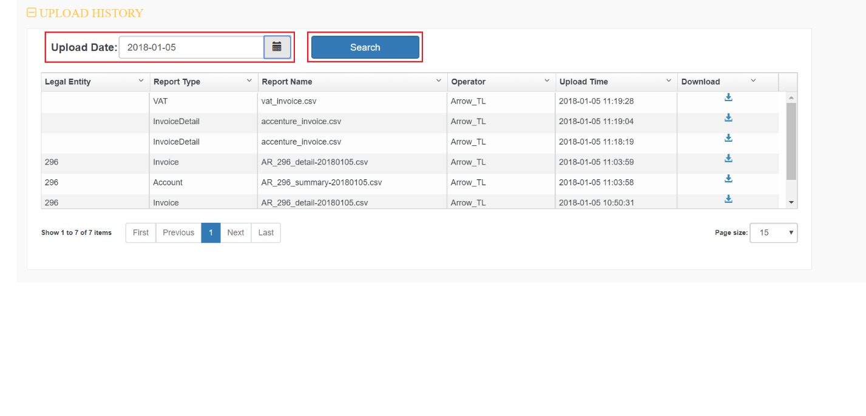

1. Download Upload History.

Click on the download icon that you want to download data.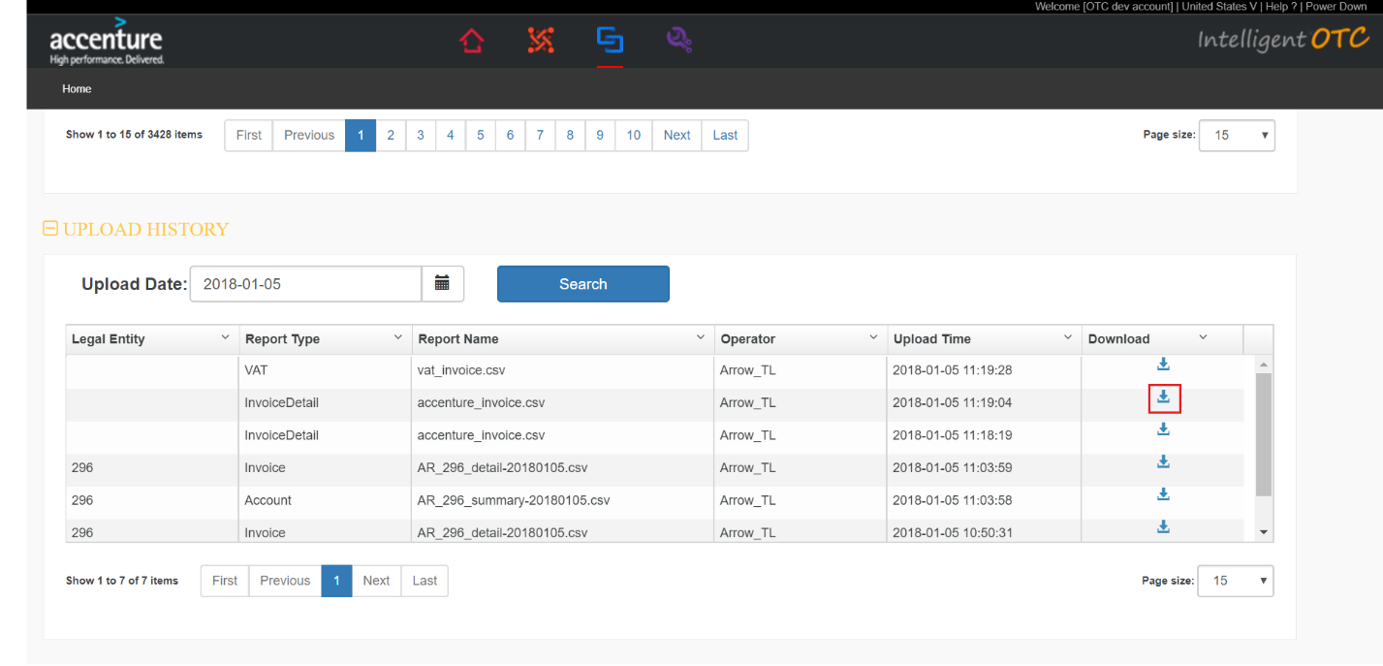

## Collection

### Mail Box

1. Mouse over the red box section of the head menu,Click on “Collection” in the drop-down.Click “Mail Box” Icon in the left menu.

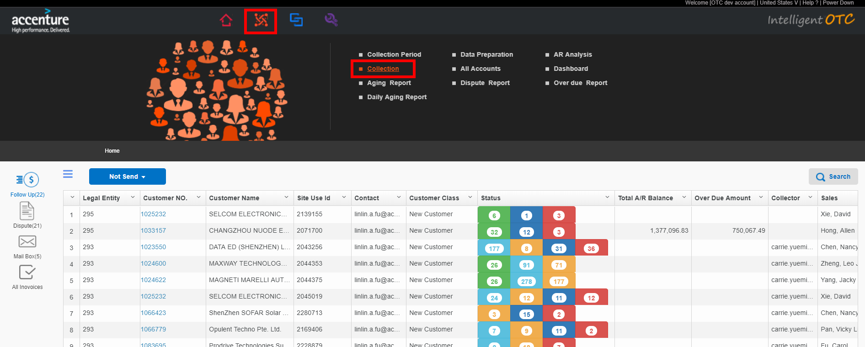

1. Click the item in the left red box to change different category
   1. Customer New Mail : Mail from customer or mail relates to any customers
   2. Unknow: Mail from other contractor and not relates any customers
   3. Draft: Saved but not sent mail
   4. Sent Items: Sent mail
   5. Processed : Finished mail (after clicking finish button)
   6. Pending: Pending mail (after clicking Pending button)

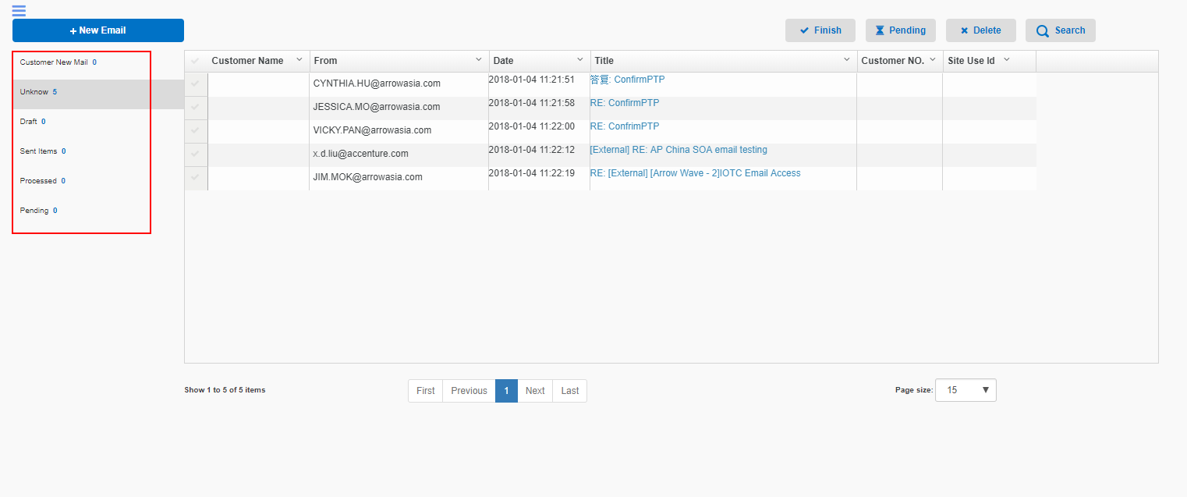

1. Click “Search” button to show the filter detail as below
   1. Click “Search” button below to filter mails
   2. Click “Clear” to clear the filter in red box

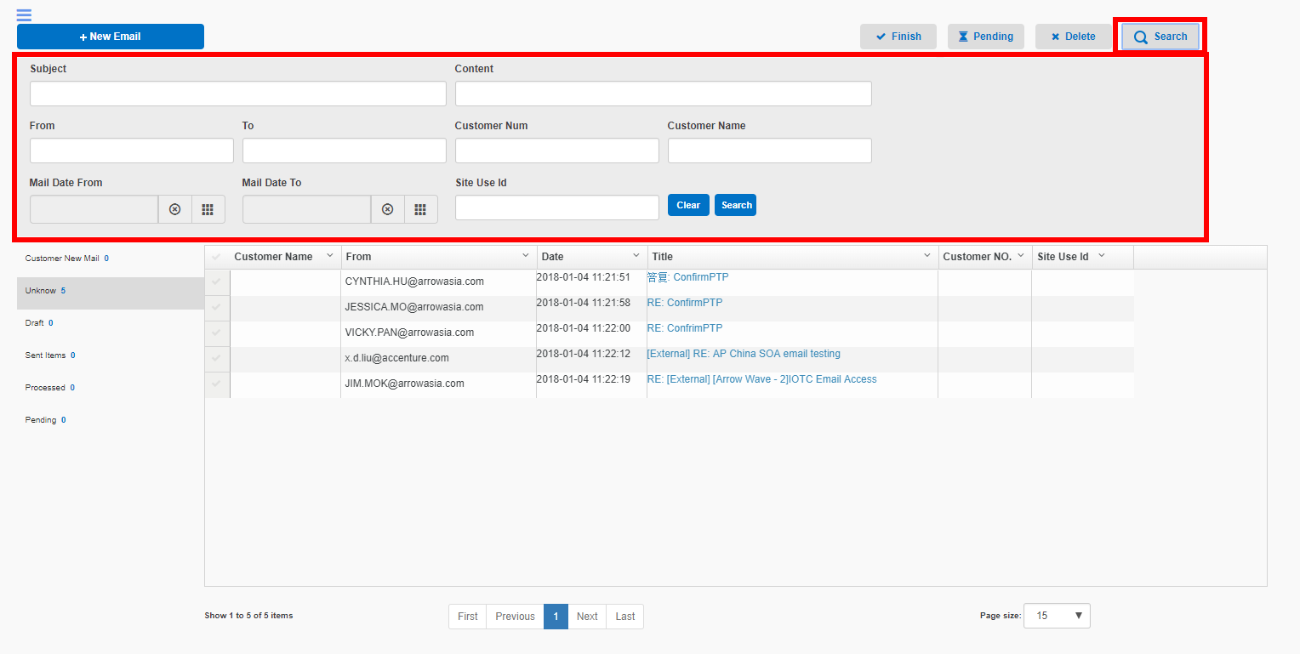

1. Click “Finish” button to classify the selected mail into “Processed” category
2. Click “Pending” button to classify the selected mail into “Pending” category
3. Click “Delete” button to delete the selected mail
4. Click “New Mail” to create new mail
   1. Click the icon in the 1st red box to select the contractor
   2. Click the icon in the 2nd red box to select the template language
   3. Click the icon in the 3rd red box to upload attachments

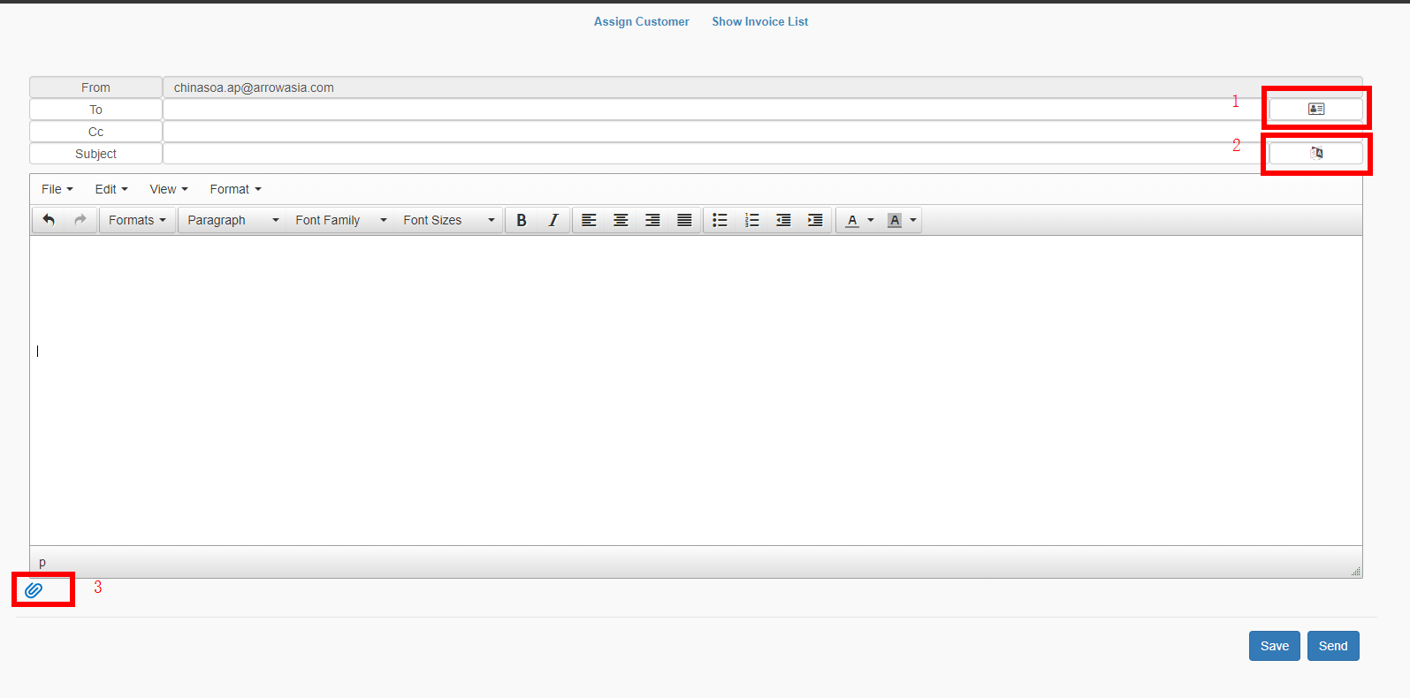

* 1. Click “Assign Customer” link to set the related customer
     1. Click “Search” to filter customers
     2. Click “Clear” to clear the filter
     3. Click “Submit” to bind current mail and selected customer
     4. Click “Close” to close current window
     5. After assigning customer, the mail will be classified to “Customer New Mail” category

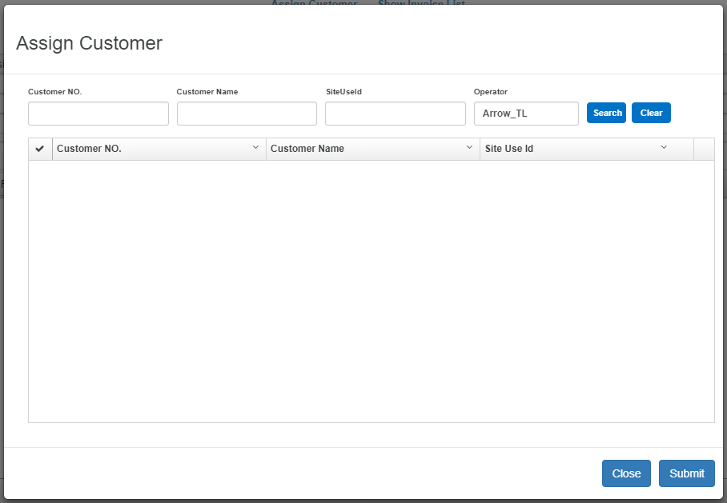

1. Click the link in “Title” column to navigate to the mail detail page
   1. Click the items in 1st red box to download the attachment
   2. Click “Assign Customer” link to set the related customer , after assigning customer the mail would be classified to “Customer New Mail” category
   3. Click “Reply” button to replay current mail
   4. Click “Forward” button to forward current mail
   5. Click “Finished” button to classify current mail to “Processed” category
   6. Click “Pending” button to classify current mail to “Pending” category

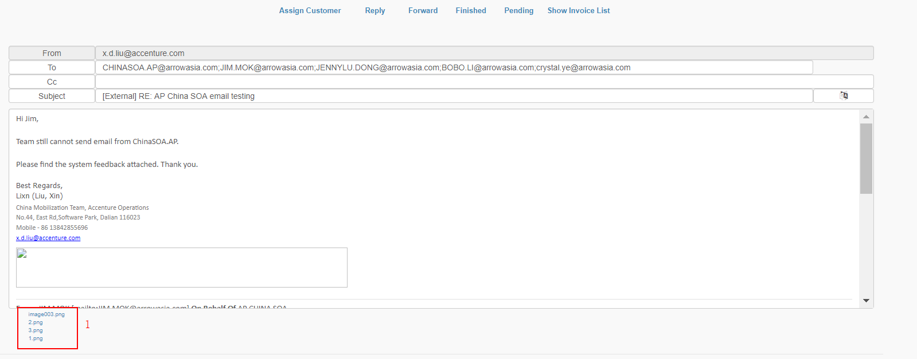

* 1. Click “Show Invoice List” to show the invoice of related customer
     1. Click “Invoice Memo” to record invoice memo of selected invoice, for further operation refer to12.1.7
     2. Click “Dispute” to mark dispute for selected invoices, for further operation refer to12.1.8
     3. Click “PTP” button to mark PTP for selected invoices, for further operation rely to 12.1.9
     4. Click “Payment” button to mark payment for selected invoices, for further operation rely to 12.1.10
     5. Click “Clear PTP” button to clear the PTP records of selected invoices

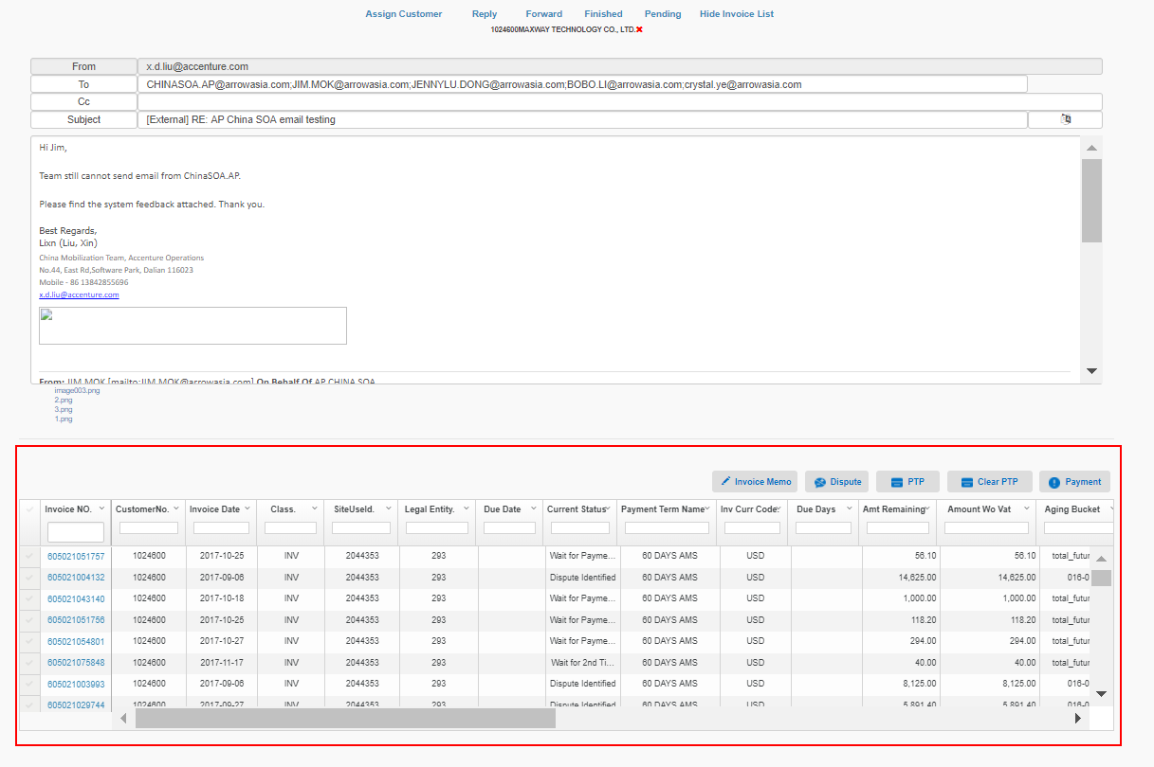

### Follow Up

1. Mouse over the red box section of the head menu,Click on “Collection” in the drop-down.Click “Follow Up” Icon in the left menu.
2. Select the item in red box drop down list. After selecting “Not Send” item,it will show all the accounts. The other option “Work Completed” will show the completed follow up cases.

The “Status” column shows the invoice count in each status;

The digit in circle is instead of invoice counts.

Green color is instead of “First Confirm PTP”.

Orange color is instead of “Reminding”.

Blue color is instead of “First Over Due Follow Up”.

Red color is instead of “Second Over Due Follow Up”.

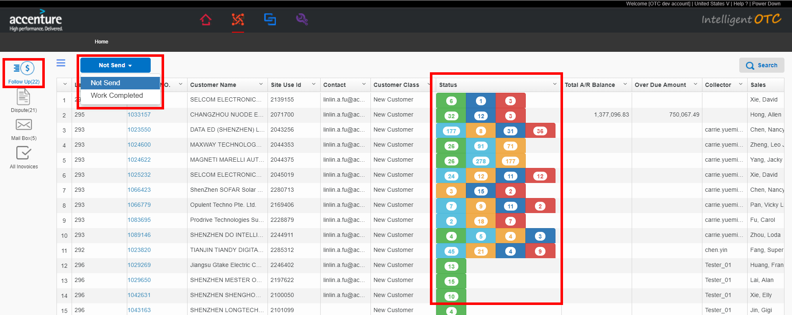

1. Click link in “Search” button to show the filter detail as below. After inputing the condition in the red box, click “search” button to filter cases.

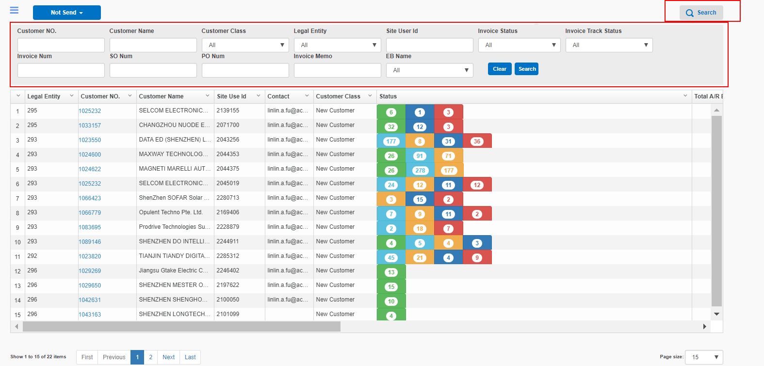

1. Click link in “Customer No.” column to navigate to the detail page as below:

The data grid will show all the open (not closed) invoices in current account. And will automatically selected the invoices in below condition

* 1. Ptp date <= Reconciliation Day invoices
  2. If no Ptp date then select Over due date <= Reconciliation Day invoices
  3. If there is no customer contact of current account, then select all the invoices

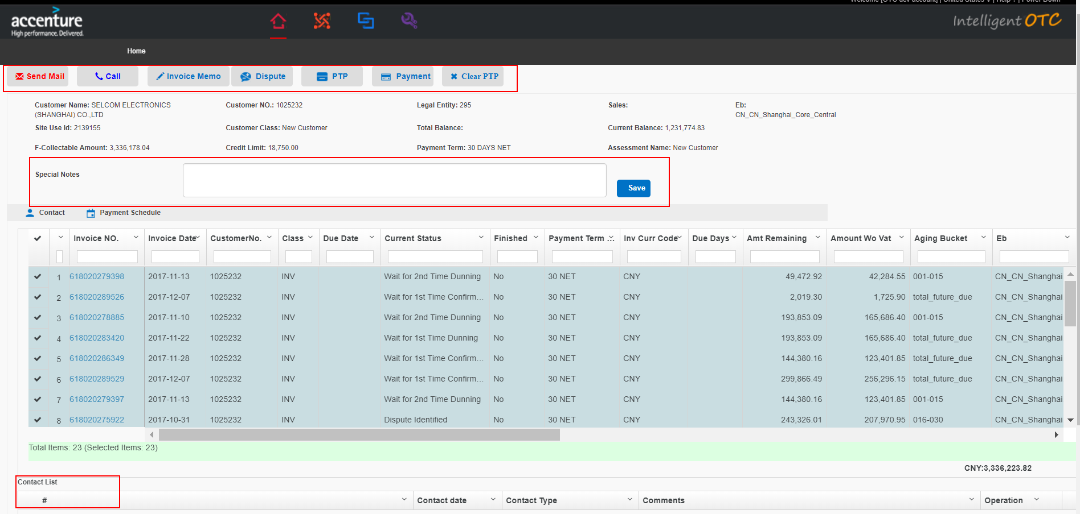

1. Click “Send Mail” button,generate new soa mail.
   1. In the 3rd red box , list the soa attachment,click the link to download the attachment.
   2. Click the left icon in the 3rd red box to upload new attachment
   3. Click the right icon in the 3e red box to delete the attachment
   4. Click the button in 1st red box to select contactor
   5. Click the button in 2nd red box to select the template language
   6. Click “Save” button to save the mail into “Draft” mailbox
   7. Click “Send” button to send the mail , the sended mail will save into “Sent Items” mailbox
   8. After sending mail, the “Send Mail” button will change to blue.

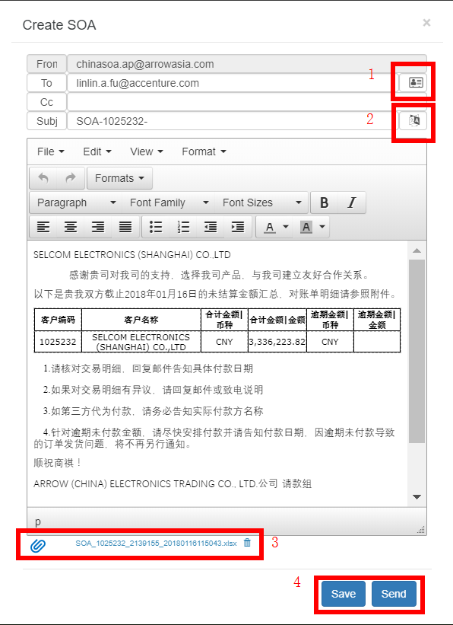

1. Click “Call” button to create call info
   1. Click “Submit” to save the call info
   2. Click “Close” to close current window

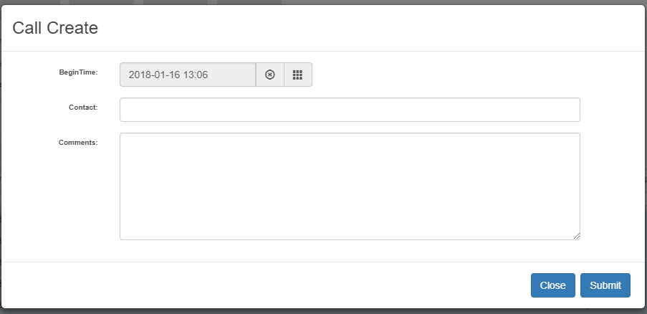

* 1. After clicking “Submit” button, the record will list in contact list.

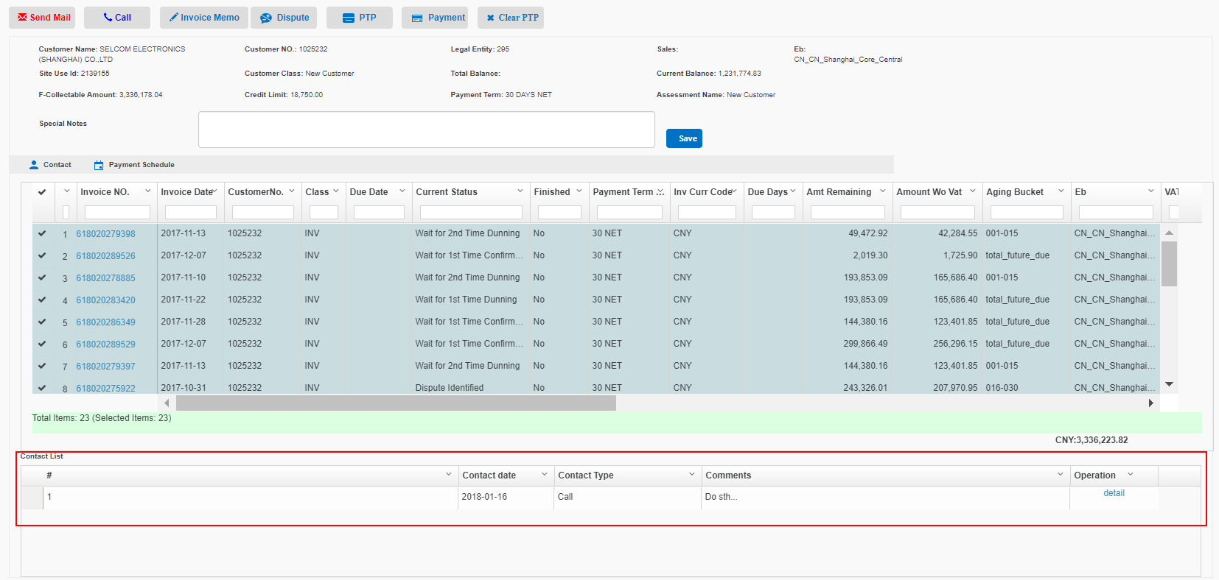

1. Click “Invoice Memo” button to save any comments in selected invoices
   1. Click “Save” to save memo
   2. Click “Close” to close current window

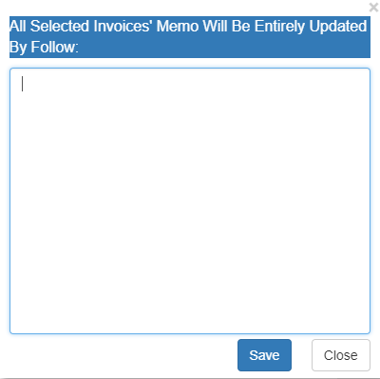

* 1. After clicking “Save” button, the record will be shown in the “Invoice Memo” in data grid.

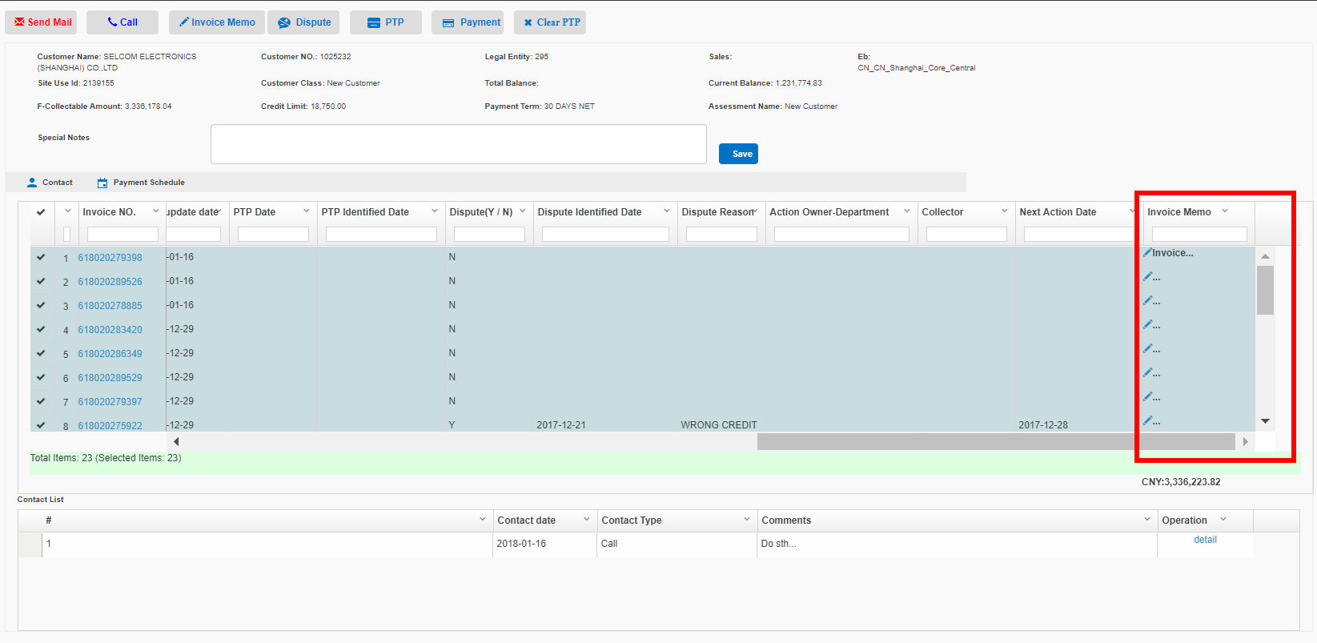

1. Click “Dispute” button to mark the selected invoices dispute status
   1. Select the dispute reason in “Dispute Reason” drop down list
   2. Record the contact record if input data in “Call Contact”
   3. Click “Submit” to save dispute
   4. Click close to close current window
   5. After submiting dispute, the selected invoices will change to “Dispute Identified” status

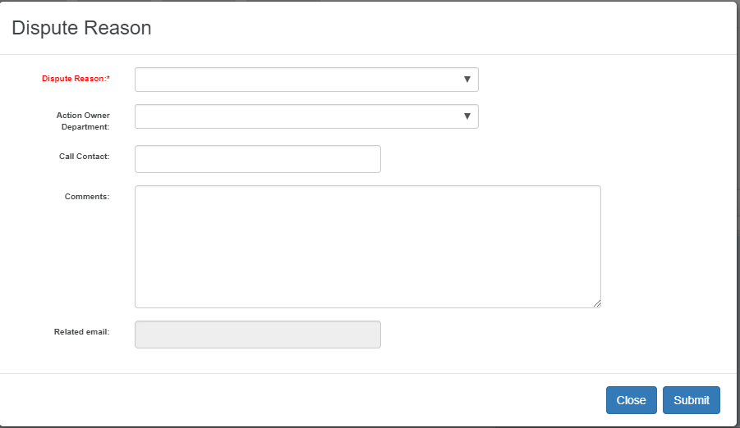

1. Click “PTP” button to record PTP info of selected invoices
   1. “Promise Amount” shows total amount of all the selected invoices
   2. Select “YES” in “Partial Pay”, the “Promise Amount” will be editable.
   3. Click “Submit” to save PTP
   4. Click “Close” to close current window
   5. After submiting PTP, the selected invoices will change to “PTP Confirmed” status

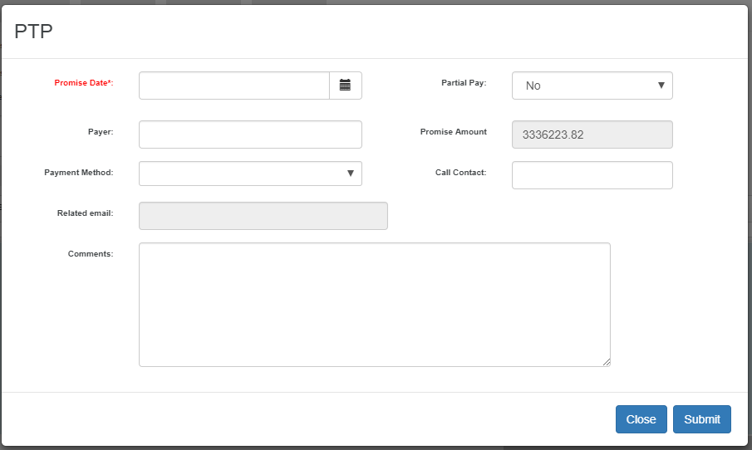

1. Click “Payment” button to record the payment info of selected invoices
   1. “Promise Amount” shows total amount of all the selected invoices
   2. Select “YES” in “Partial Pay”, the “Promise Amount” will be editable.
   3. Click “Submit” to save Payment
   4. Click “Close” to close current window
   5. After submiting Payment, the selected invoices will change to “Payment Notice Received” status

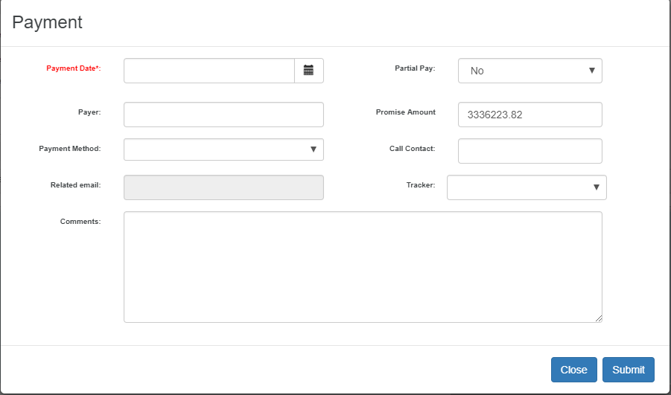

1. Click “Clear PTP” button to clear the PTP record of selected invoices.
2. Click “Contact” button to maintain the contact of current account
   1. Click the icon in 1st red box to add new contactor
   2. Click the icon in 2nd red box to edit the contactor
   3. Click the icon in 3rd red box to delete the contactor

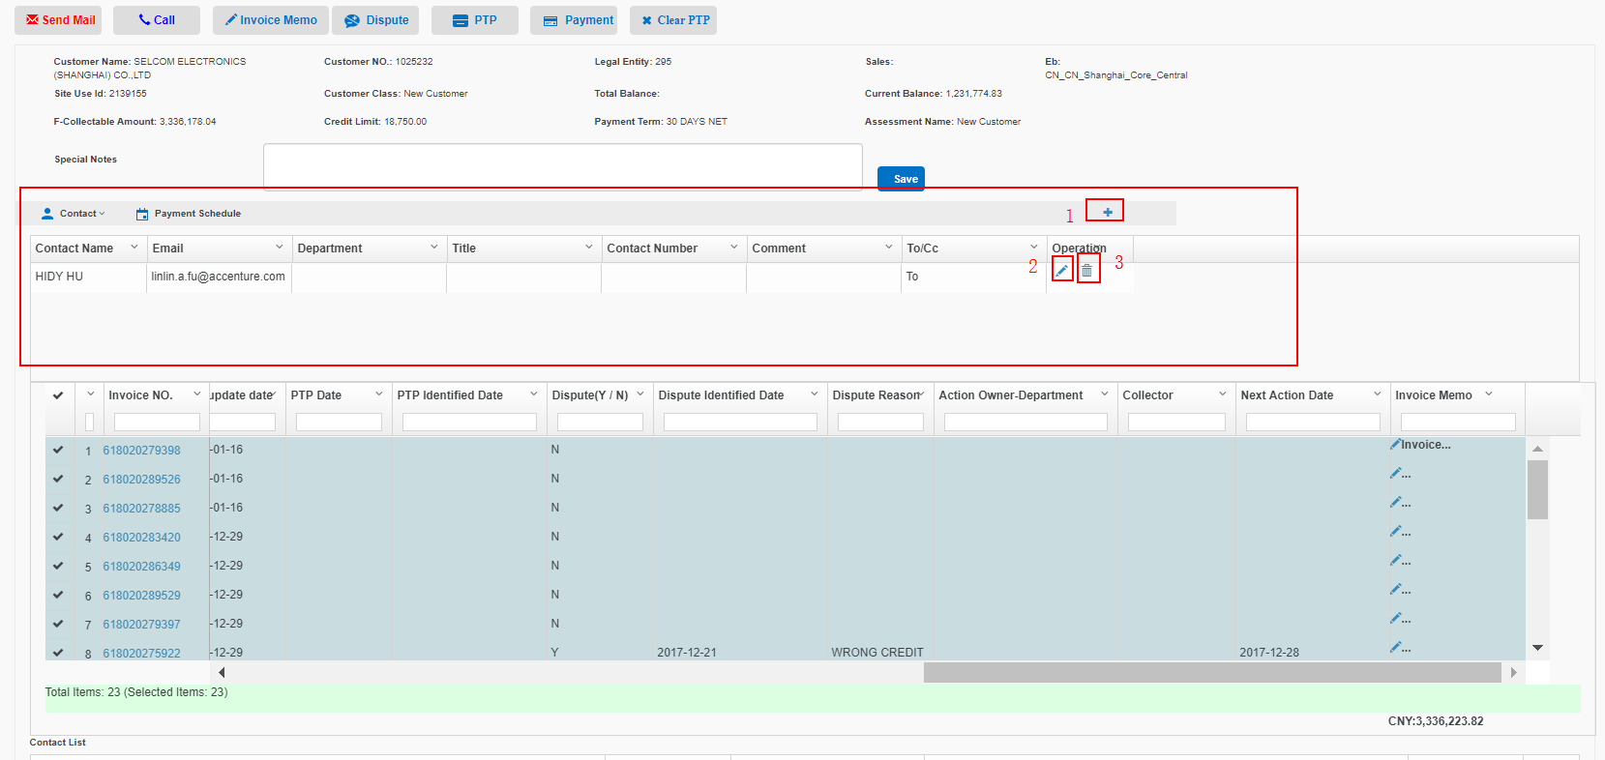

1. Click “Payment Schedule” to maintain Reconciliation day of current account
   1. Select Reconciliation day and click “Add” button to add new Reconciliation day.
   2. Click the icon in 1st red box to delete the Reconciliation day

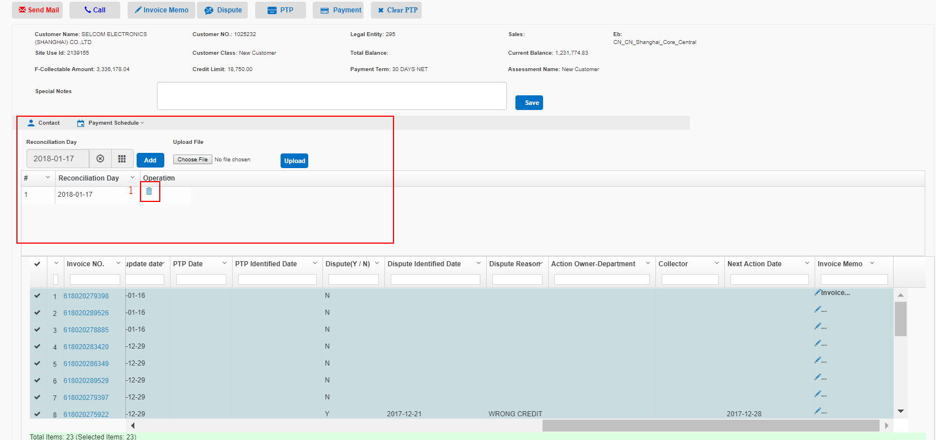

1. Input “Special Notes” and click “Save” button to save Special notes to current account.

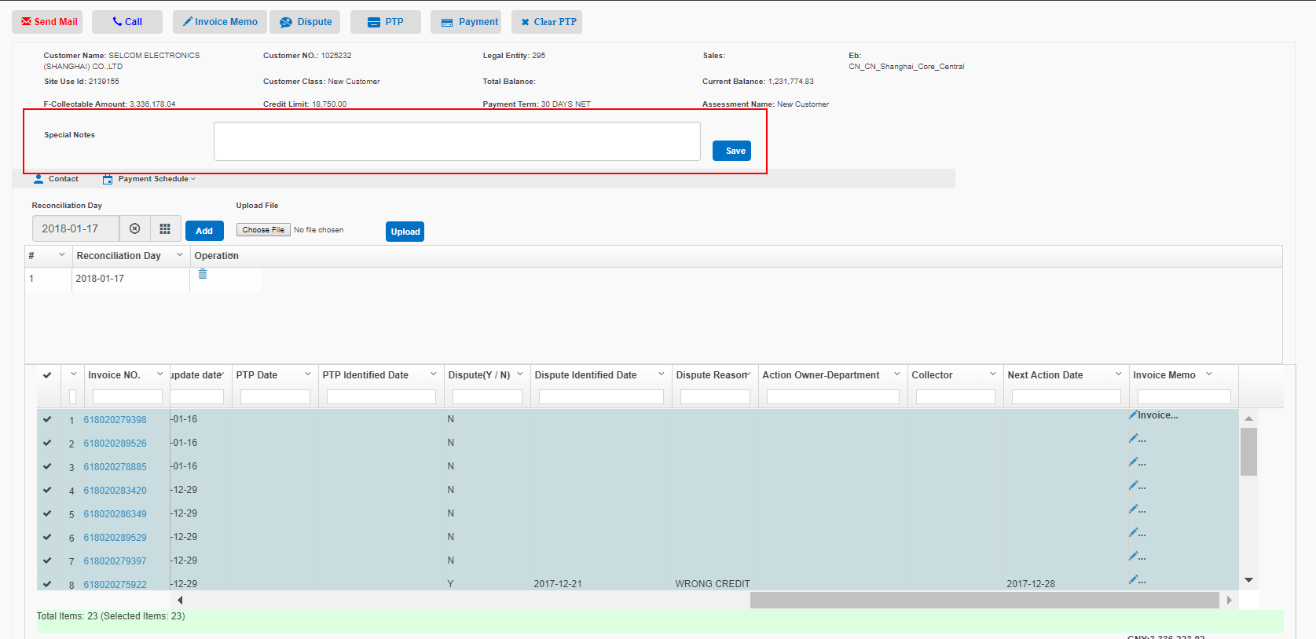

### Dispute

1. Mouse over the red box section of the head menu,Click on “Collection” in the drop-down.Click “Dispute” Icon in the left menu.
2. Click “Search” button to show the filter detail as below. After inputing the condition in the red box, click “search” button to filter cases.

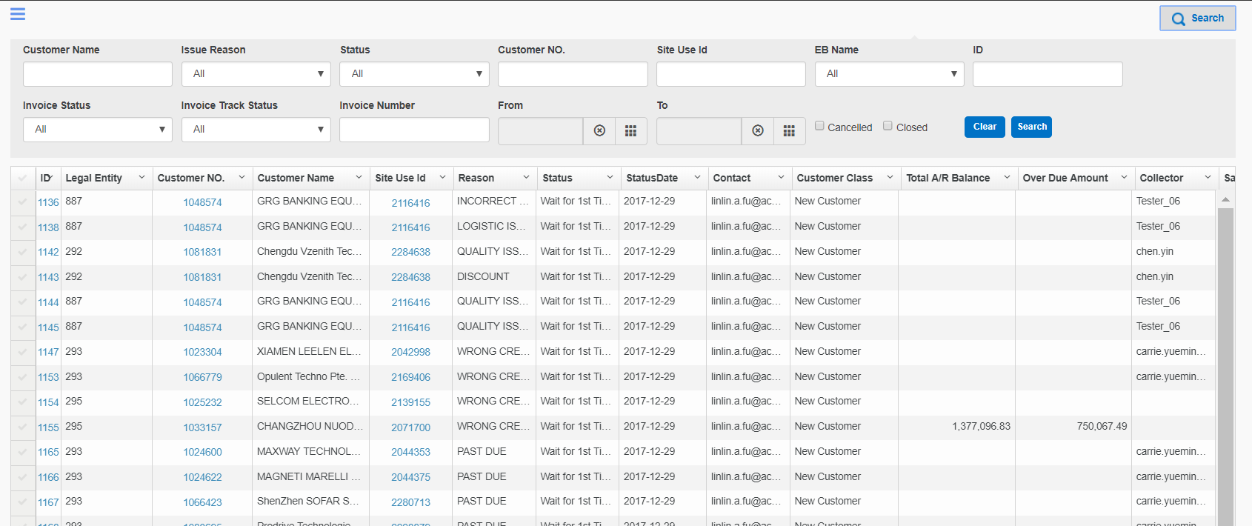

1. Click link in “Customer No.” column to navigate to the detail page as below

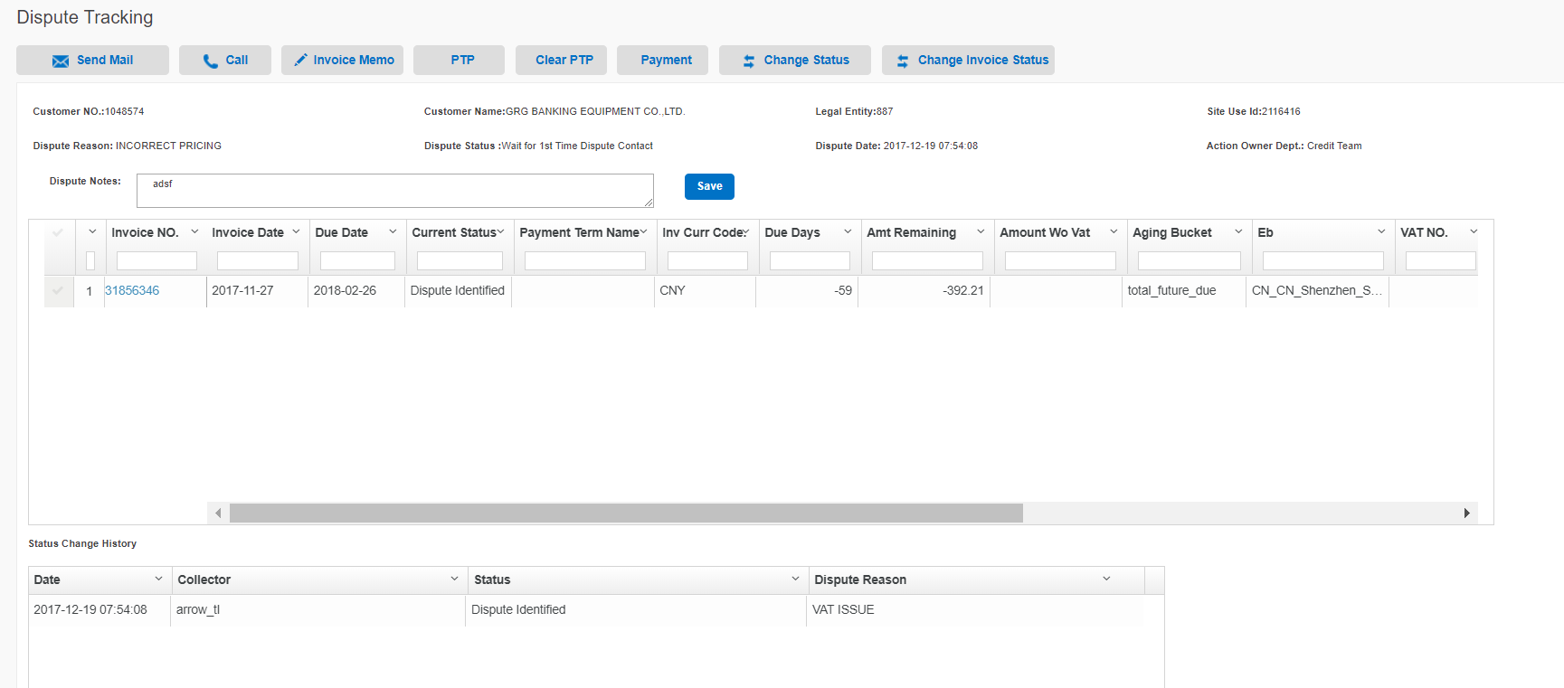

1. Click “Send Mail” button to create new dispute mail, for further operation refer to12.1.5
2. Click “Call” button to create call record, for further operation refer to12.1.6
3. Click “Invoice Memo” to record invoice memo of selected invoice, for further operation refer to12.1.7
4. Click “PTP” button to mark PTP for selected invoices, for further operation rely to 12.1.9
5. Click “Payment” button to mark payment for selected invoices, for further operation rely to 12.1.10
6. Click “Clear PTP” button to clear the PTP records of selected invoices
7. Click “Change Status” button to change current dispute case status
   1. All the invoices in current case could not be “Dispute Identified”,”Wait for 2nd Time Dispute contact”,”Wait for Dispute Response”,”Wait for 2nd Time Dispute Response”, If change status to “Closed” or “Cancelled”
   2. Click “Submit” button to save changes
   3. Click “Close” button to close current window

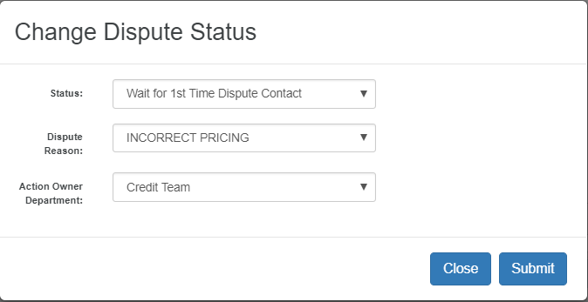

1. Click “Change Invoice Status” button to change selected invoices status
   1. Click “Submit” button to save changes
   2. Click “Close” button to close current window

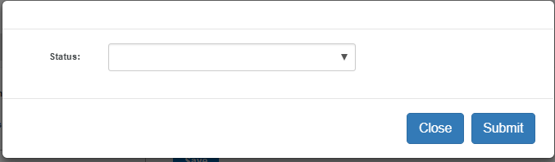

### All Invoices

1. These two CSV files need to match uploads.Mouse over the red box section of the head menu,Click on “Collection” in the drop-down.Click “All Invoices” Icon in the left menu.
2. Click “Search” button to show the filter detail as below. After inputing the condition in the red box, click “search” button to filter cases.

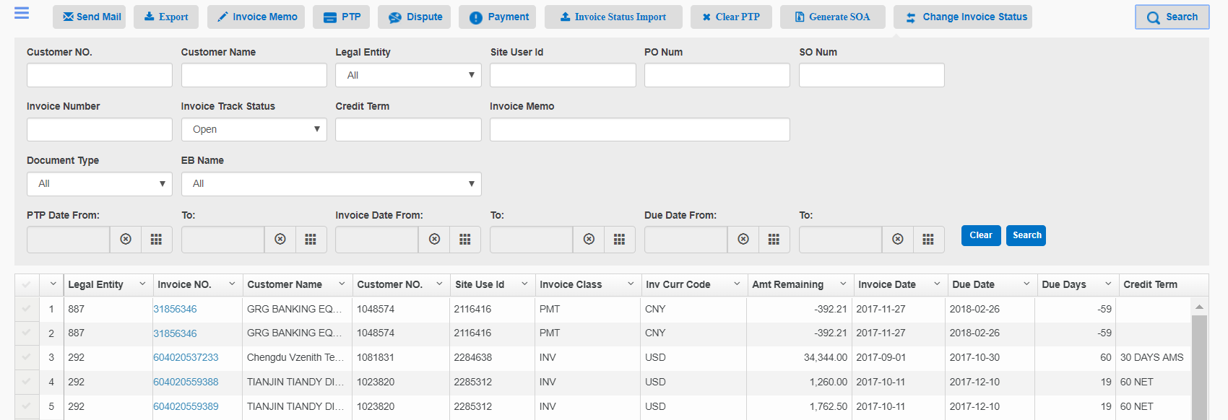

1. Click “Send Mail” button to generate new mail with SOA attachment of selected invoices, for further operation refer to12.1.5
2. Click “Export” button to export the selected invoices to excel file
3. Click “Invoice Memo” to record invoice memo of selected invoice, for further operation refer to12.1.7
4. Click “Dispute” to mark dispute for selected invoices, for further operation refer to12.1.8
5. Click “PTP” button to mark PTP for selected invoices, for further operation rely to 12.1.9
6. Click “Payment” button to mark payment for selected invoices, for further operation rely to 12.1.10
7. Click “Clear PTP” button to clear the PTP records of selected invoices
8. Click “Change Invoice Status” button to change selected invoices status, for further operation refer to12.3.11
9. Click “Generate SOA” button to generate and download SOA excel file, each customer has an independent attachment
10. Click “Invoice Status Import” button to import and update invoice status
    1. Click “VAT”,”Non VAT”,”Dispute” to change file type for uploading
    2. Click “Choose File” button to select the file path for uploading
    3. Click “Upload” button to upload selected file
    4. After uploading file, the changes of each invoice would shown in data grid
    5. Click “Submit” button to save changes
    6. Click “Close” button to close current window

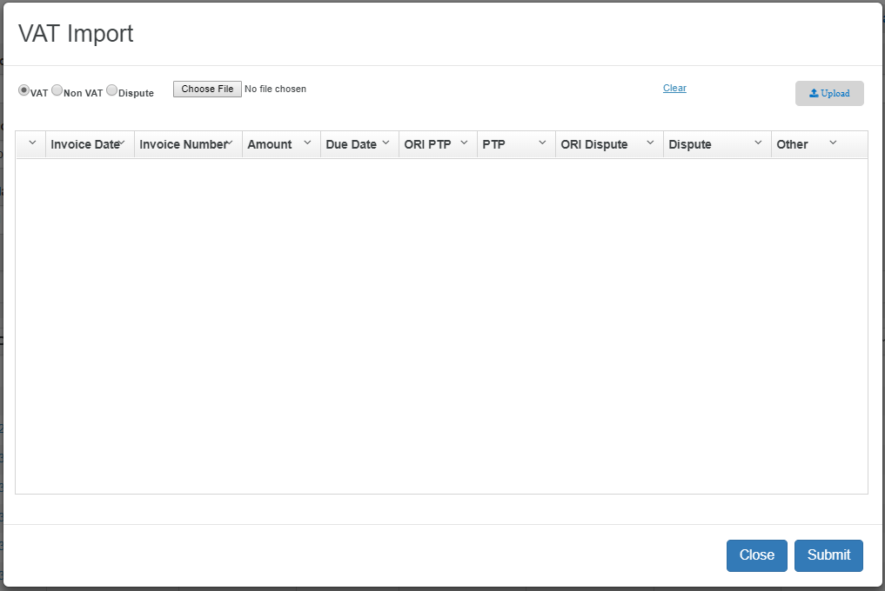

### All Accounts

1. Mouse over the red box section of the head menu,Click on “Collection” in the drop-down.Click “All Invoices” Icon in the left menu.

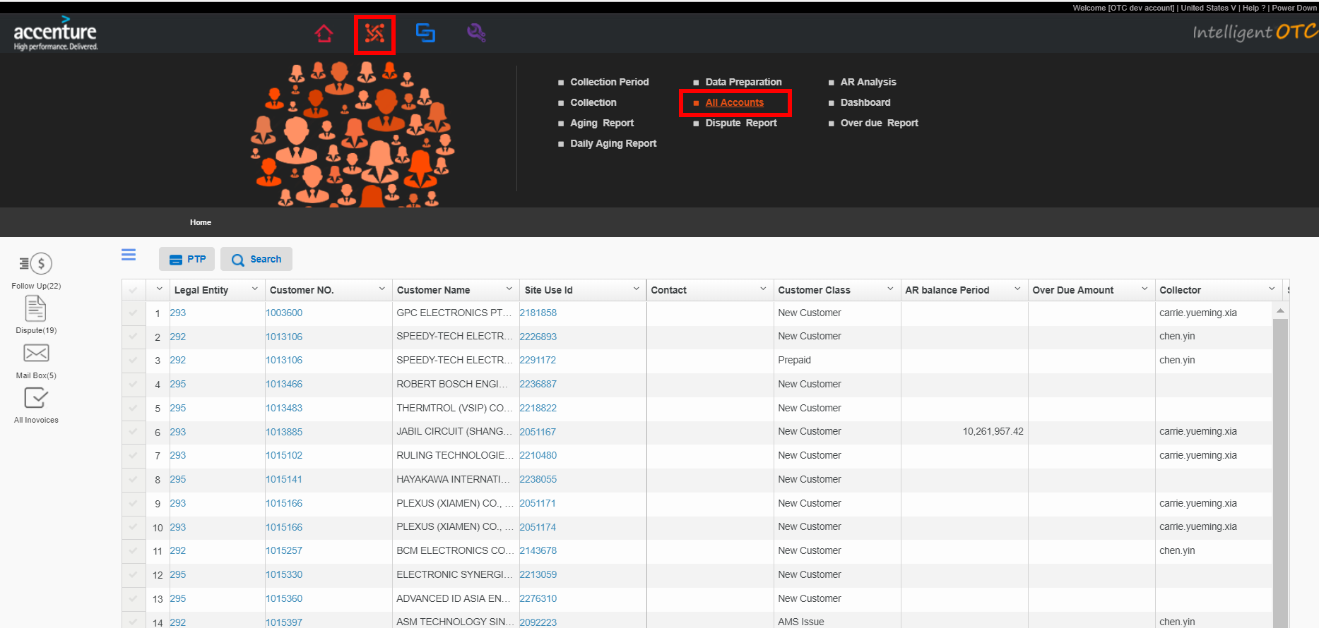

1. Click “Search” button to show the filter detail as below

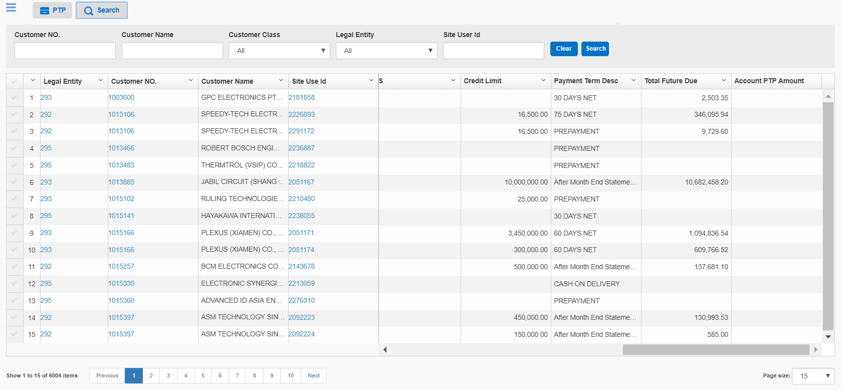

1. Click “PTP” button to mark PTP of selected account
   1. “Promise Amount” shows total over due amount of selected invoices
   2. Select “YES” in “Partial Pay”, the “Promise Amount” will be editable.
   3. Click “Submit” to save PTP
   4. Click “Close” to close current window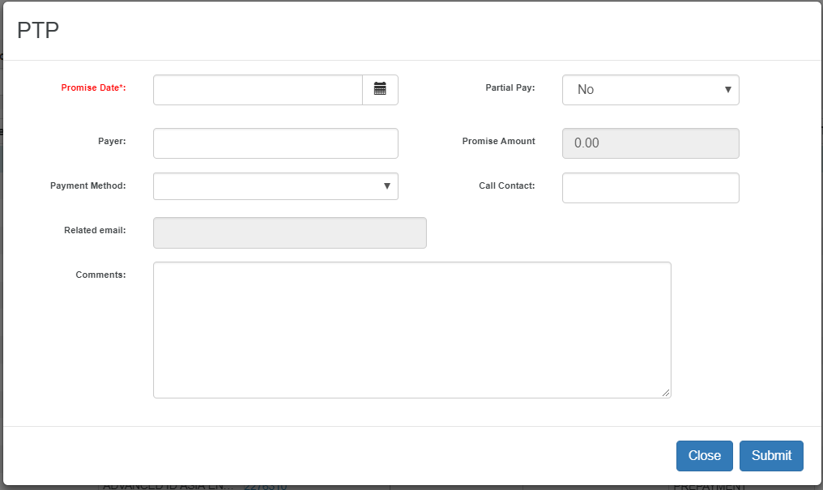

## DSO Report

1. Mouse over the “System management” section of the head menu,Click on “DSO Analysis” in the drop-down.

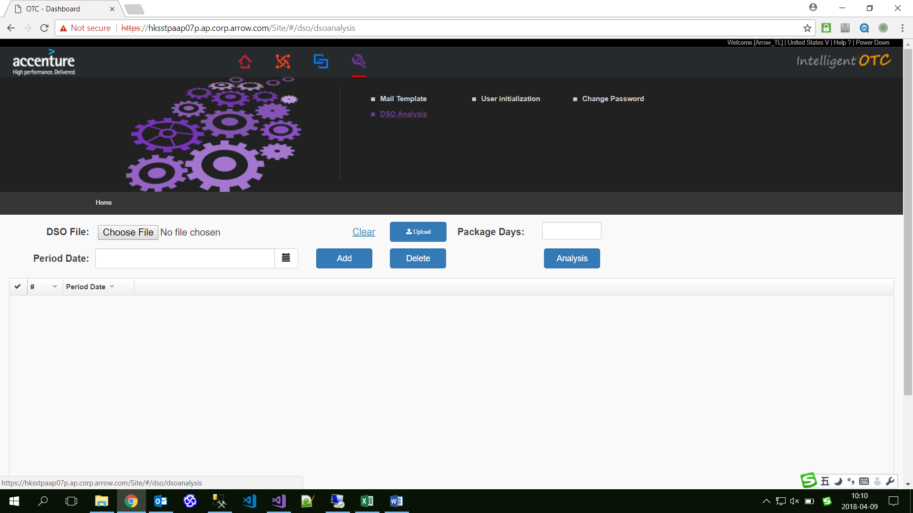

1. Click“Choose File”button，to choose DSO Package File, and click“Upload”button to upload file.

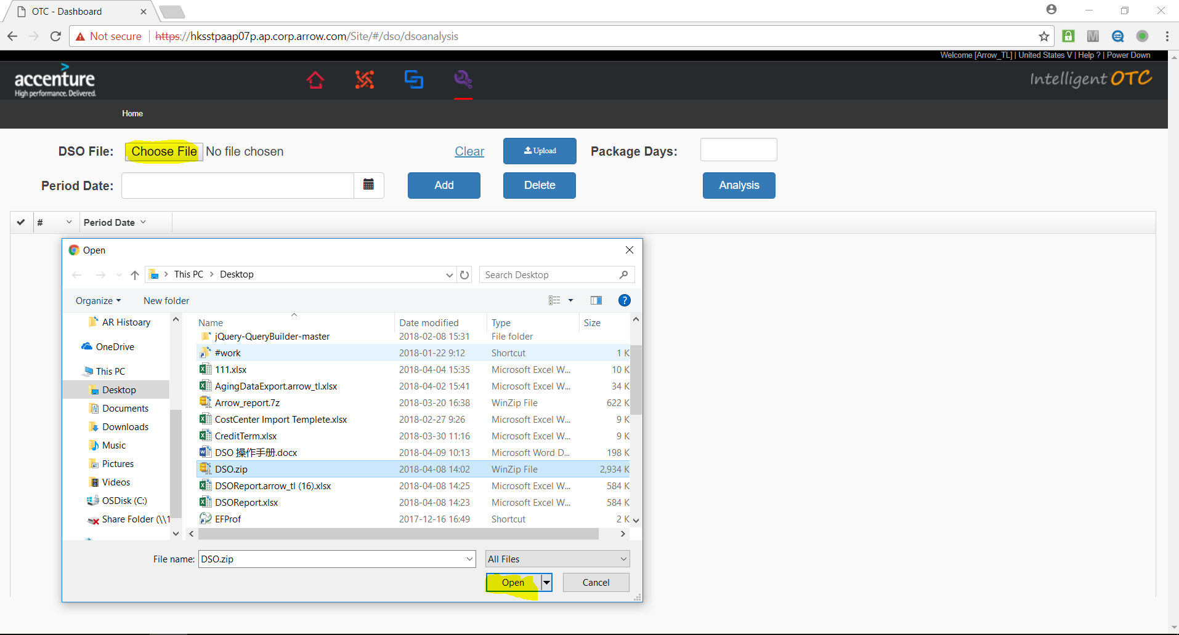

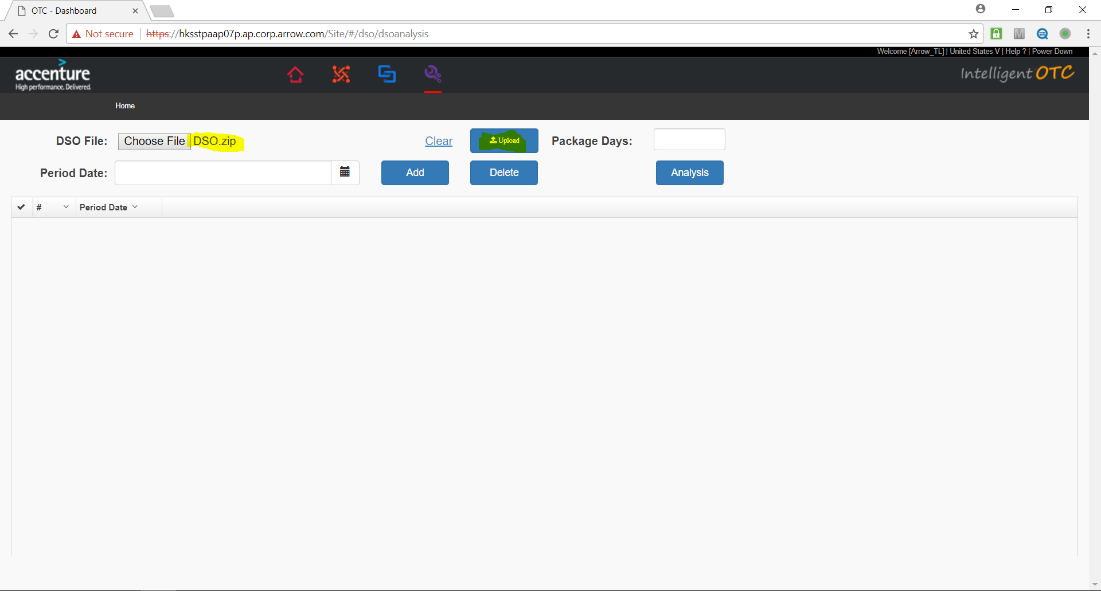

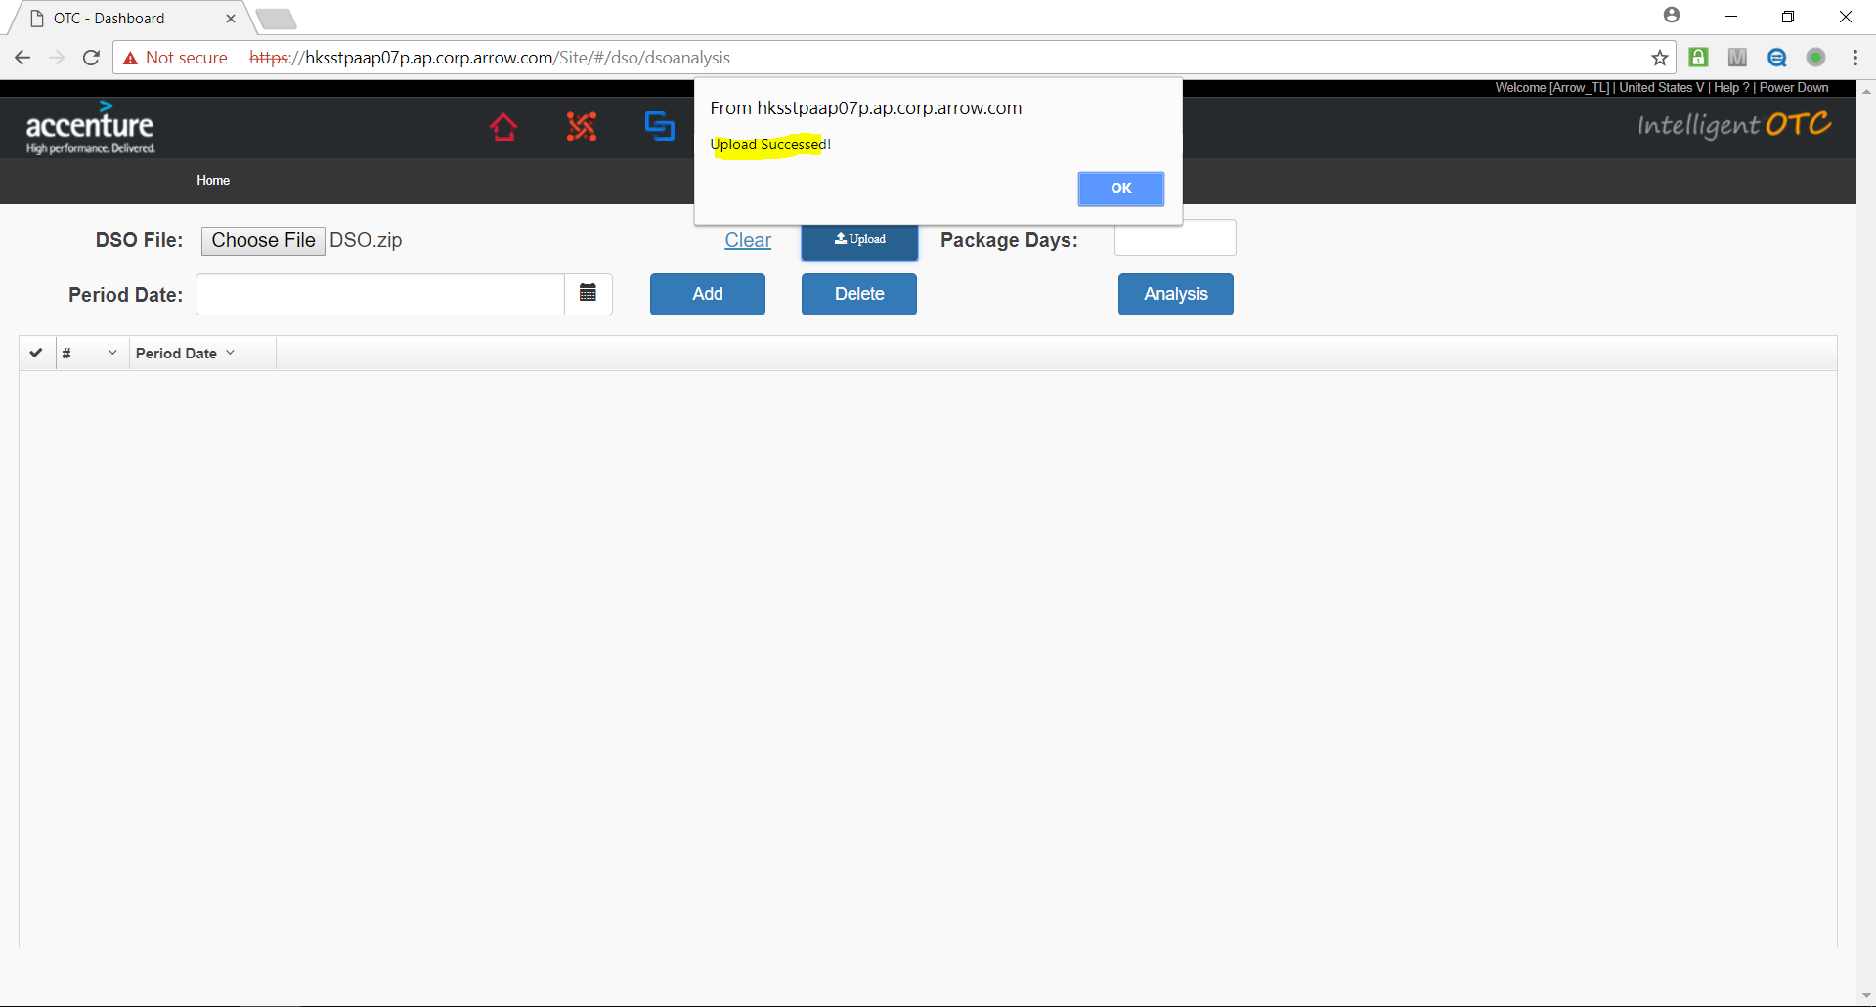

1. Set “Package Days”

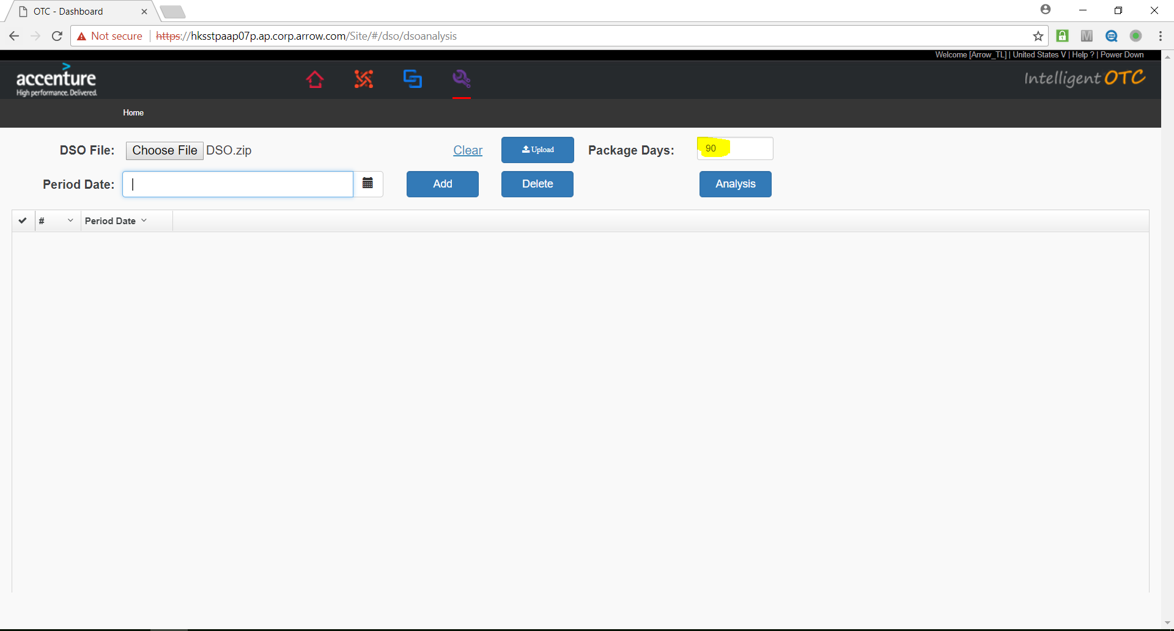

1. Add AR “Period Date”: select date，and click“Add”button

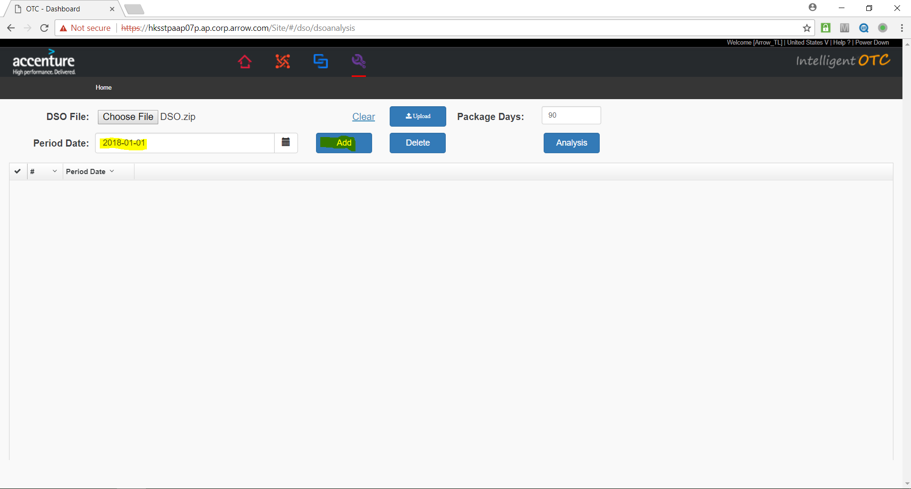

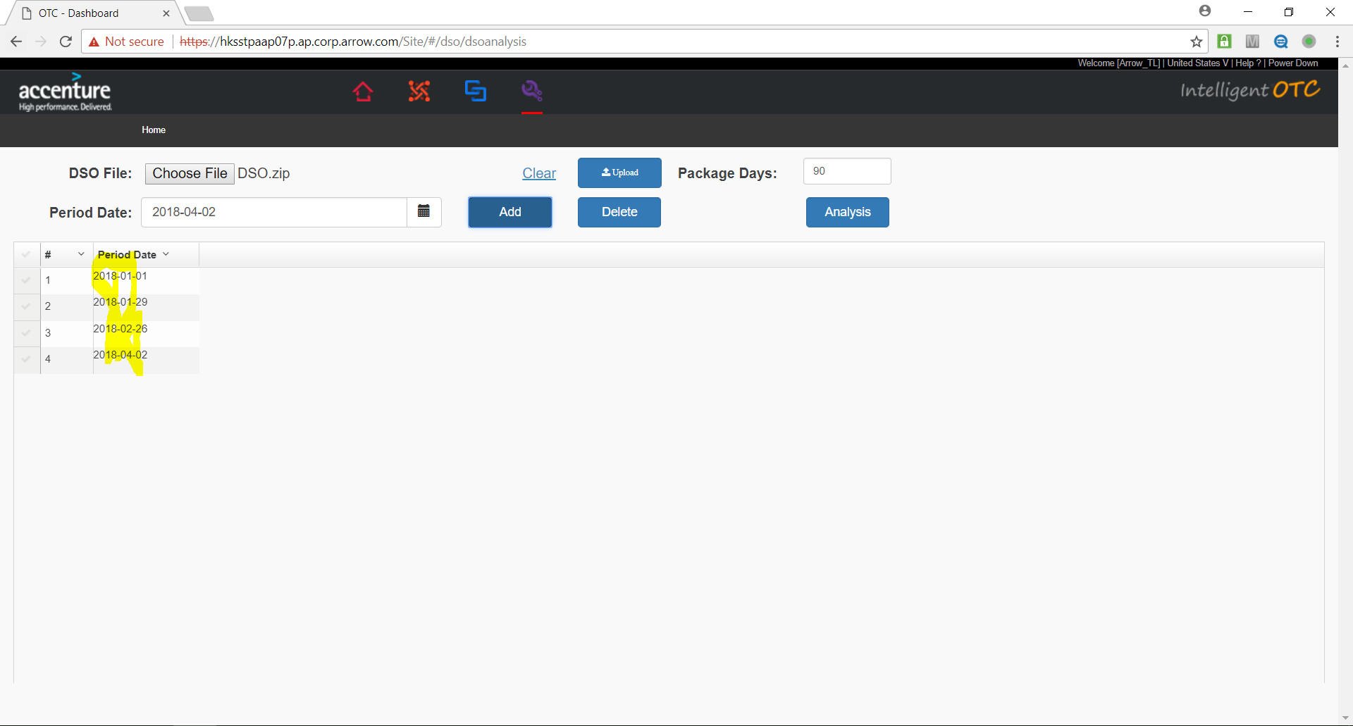

1. Delete “Period Date”: select one Period Date record witch you will delete, and click ”Delete” button

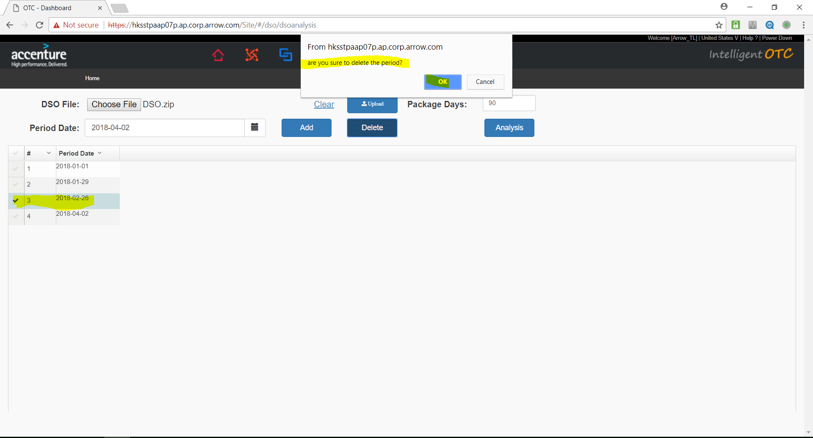

1. Do DSO Report generate: Click“Analysis”button

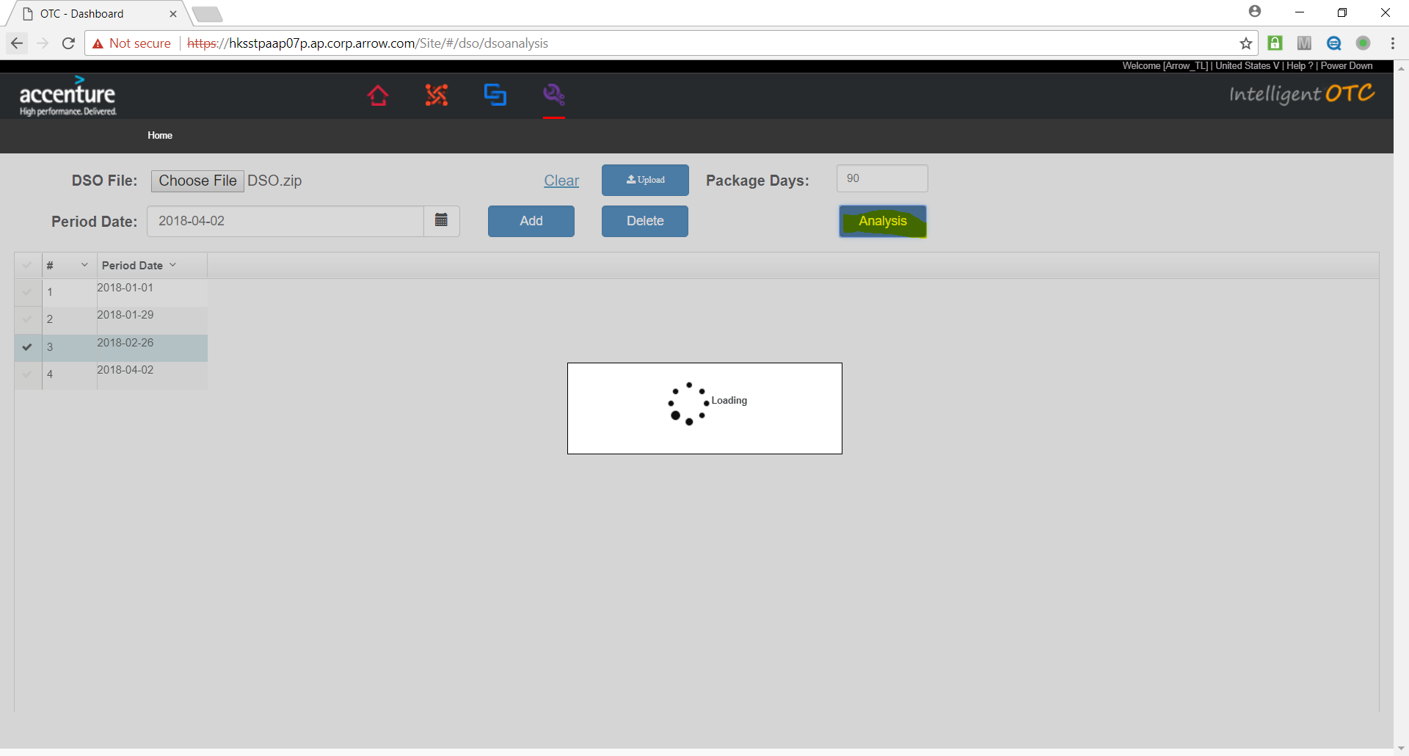

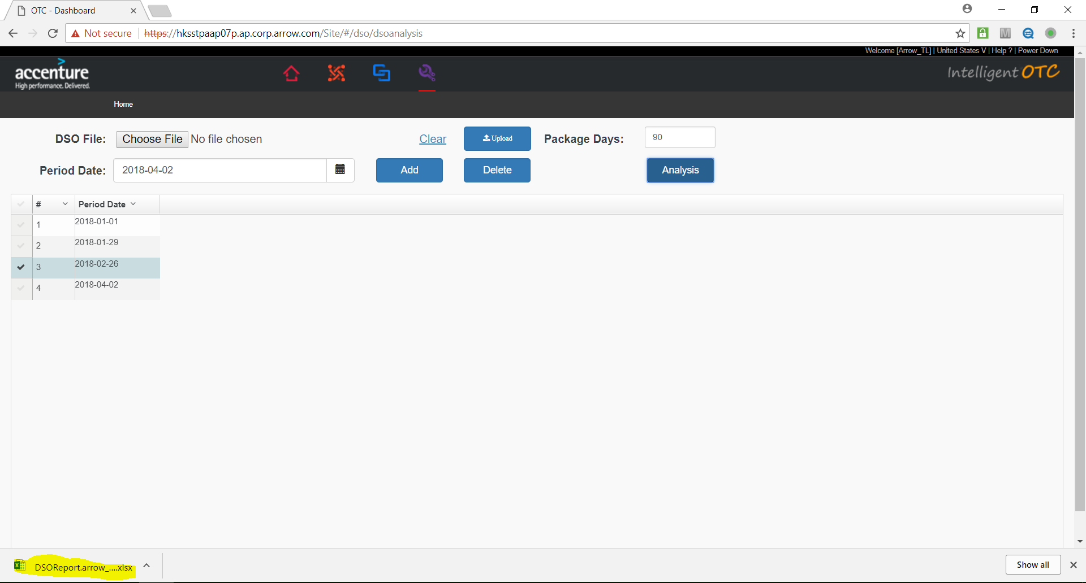

1. Open DSO Report: click the generated file

